Word of Life: January 2019
Recommended dates are provided, but you are welcome to use these materials at any time!
9 Days for Life: January 14-22, 2019
www.9daysforlife.com
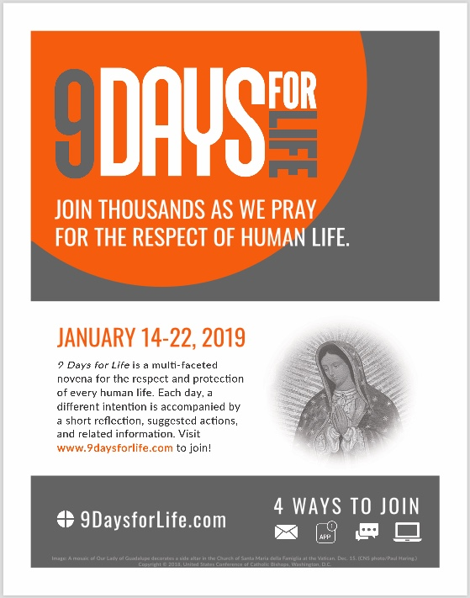
9 Days for Life is a multi-faceted novena for the respect and protection of every human life. Each day, a different intention is accompanied by a short reflection, suggested actions, and related information.
Participants can receive the novena by downloading the free 9 Days for Life app, or by subscribing to daily emails or text messages. (A printable version will also be made available online.)
Visit www.9daysforlife.com to sign up. Leaders’ resources will also be made available from this website.
- Flyer
- Novena (Word / PDF)
- Graphic

Day of Prayer for the Legal Protection of Unborn Children January 22, 2019
The General Instruction of the Roman Missal (GIRM), no. 373, designates January 22 as a particular day of prayer and penance, called the “Day of Prayer for the Legal Protection of Unborn Children”: “In all the Dioceses of the United States of America, January 22 (or January 23, when January 22 falls on a Sunday) shall be observed as a particular day of prayer for the full restoration of the legal guarantee of the right to life and of penance for violations to the dignity of the human person committed through acts of abortion.”
- Overview
- Choices of Readings for Mass (and additional resources)
- Sample Intercessions and Homily Helps (with suggested readings)

Intercessions for Life
January 1st  May every expectant mother  encounter loving support  as she awaits the birth of her child;  We pray to the Lord: | The Octave Day of Christmas; Solemnity of the Blessed Virgin Mary, Mother of God
January 6th  For civic leaders,  that by their words and actions,  they might defend life  and work to preserve respect for  the life of every human being;  We pray to the Lord: | The Epiphany of the Lord
January 13th  For all Christians:  May we live out our baptismal call  to proclaim the Gospel  and be messengers of God’s love for every human life;  We pray to the Lord: | The Baptism of the Lord
January 20th  For all women with difficult pregnancies:  Through the intercession of Our Lady,  may they be lovingly supported  in welcoming the mystery of life within them;  We pray to the Lord: | Second Sunday in Ordinary Time
January 22nd  For the legal protection of unborn children  and for loving support for mothers  before and after birth;  We pray to the Lord: | Day of Prayer for the Legal Protection of Unborn Children
January 27th  For all who suffer from  participation in abortion:  May they find healing and peace  in God’s loving forgiveness;  We pray to the Lord: | Third Sunday in Ordinary Time

Word of Life – January 2019

Bulletin Quotes
January 6th  “Never tire of firmly speaking out in defense of life from its conception and do not be deterred from the commitment to defend the dignity of every human person with courageous determination. Christ is with you: be not afraid!”  “Address of John Paul II to the Bishops and Apostolic Administrators of Albania on their ‘Ad Limina’ Visit, February 3, 2001” © 2001, Libreria Editrice Vaticana. Used with permission. All rights reserved. | 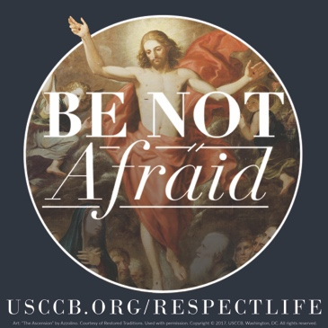  Download
January 13th  “When we encounter Christ, experience his love, and deepen our relationship with him, we become more aware of our own worth and that of others. His love for each person is cause for great joy, and growing understanding of this priceless treasure motivates us to share his love with others.”  USCCB Secretariat of Pro-Life Activities  “How to Build a Culture of Life,” www.usccb.org/culture-of-life | 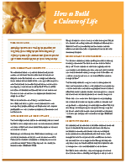  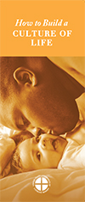  Order Download
January 20th  “We are created to walk with and support one another; we don't need to fear reaching out in love. Help your friend experience the strength of God's message that resounds throughout time: ‘Do not fear: I am with you’ (Isaiah 41:10).”  USCCB Secretariat of Pro-Life Activities  “What to Do When a Friend Is Considering Abortion”, www.usccb.org/l-o-v-e  NABRE © 2010 CCD. Used with permission. | Order Download
January 27th  “While many Catholics want to help women and men heal from past abortions, most don't know how to begin.” Learn how you can become an instrument of God’s mercy at www.usccb.org/bridges-of-mercy.  USCCB Secretariat of Pro-Life Activities,  “Bridges of Mercy for Post-Abortion Healing”, www.usccb.org/bridges-of-mercy | 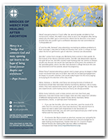  Order | Download

Word of Life - January 2019

Bulletin Art
You are welcome to use these and other downloadable images from the online Respect Life image gallery, provided they are not altered in any way, other than the size. Thank you!

Sunday, January 13th, 2019
- Download Image
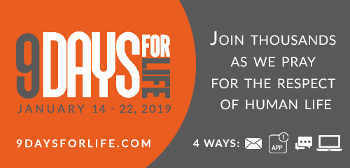

Sunday, January 20th, 2019
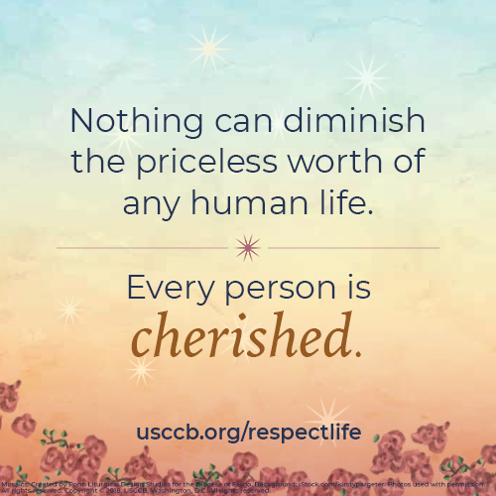
- English / en español

