Social Media Toolkit

Post 1: Before the Collection
The link in the posts leads to a video. Be sure to copy the whole link and the video will automatically be linked on Facebook and Twitter!

Facebook:
Check out life at the poverty line. Support the Catholic Campaign for Human Development Collection at Mass. #PowerOfCCHD #1church1mission https://goo.gl/MFO7fn
Twitter:
See life at the margins. Help the CCHD collection at Mass. #PowerOfCCHD https://goo.gl/MFO7fn

Post 2: Before the Collection
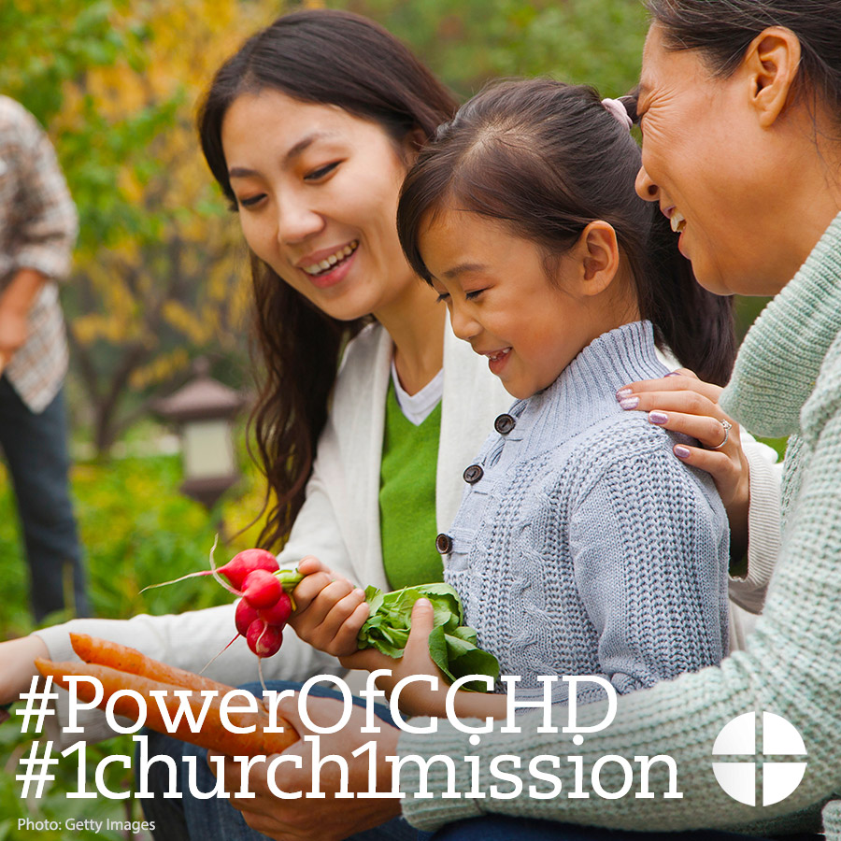

Facebook/Instagram:
Did you know that over 43 million Americans live below the poverty line? You can help by supporting the collection for the Catholic Campaign for Human Development at Mass! #PowerOfCCHD #1church1mission www.povertyusa.org
Twitter:
DYK over 43 million Americans live below the poverty line? Learn about it @EndPovertyUSA #PowerOfCCHD www.povertyusa.org

Post 3: Before the Collection
The link in the posts leads to a video. Be sure to copy the whole link and the video will automatically be linked on Facebook and Twitter!
Facebook:
Have three minutes? Why not use them to learn about how the USCCB addresses issues of poverty in this interview with CCHD Director Ralph McCloud? #PowerOfCCHD #1church1mission https://goo.gl/UMoEIz
Twitter:
Have three minutes? Use them to learn about how CCHD addresses issues of poverty with Director Ralph McCloud. https://goo.gl/UMoEIz

Post 4: Before the Collection
Facebook/Instagram:
The Collection for the Catholic Campaign for Human Development helps those who are working to end poverty in the United States. Support the collection at Mass! #PowerOfCCHD #1church1mission http://goo.gl/I6FqfW
Twitter:
The collection for the Catholic Campaign for Human Development helps those who are working to end poverty in the US: http://goo.gl/I6FqfW

Post 5: Before the Collection
The link in the posts leads to the newsletter information page. Be sure to copy the whole link and it will automatically be linked on Facebook and Twitter!

Facebook:
Want to stay up-to-date on how the Catholic Campaign for Human Development is working to break the cycle of poverty? Sign up for the quarterly newsletter, "Helping People Help Themselves." #PowerOfCCHD #1church1mission http://goo.gl/iktA5H
Twitter:
Stay up-to-date on how CCHD breaks cycles of poverty. Sign up for the newsletter! #PowerOfCCHD http://goo.gl/iktA5H

Post 6: Week of the Collection
The link in the posts leads to a video. Be sure to copy the whole link and the video will automatically be linked on Facebook and Twitter!

Facebook:
Who receives funding from the collection for the Catholic Campaign for Human Development? Watch our "Meet Mary" video and see how your donations break the cycle of poverty. #PowerOfCCHD #1church1mission https://goo.gl/OouOcF
Twitter:
Who receives funding from @EndPovertyUSA collection? Watch "Meet Mary." #PowerOfCCHD https://goo.gl/OouOcF

Post 7: Week of the Collection
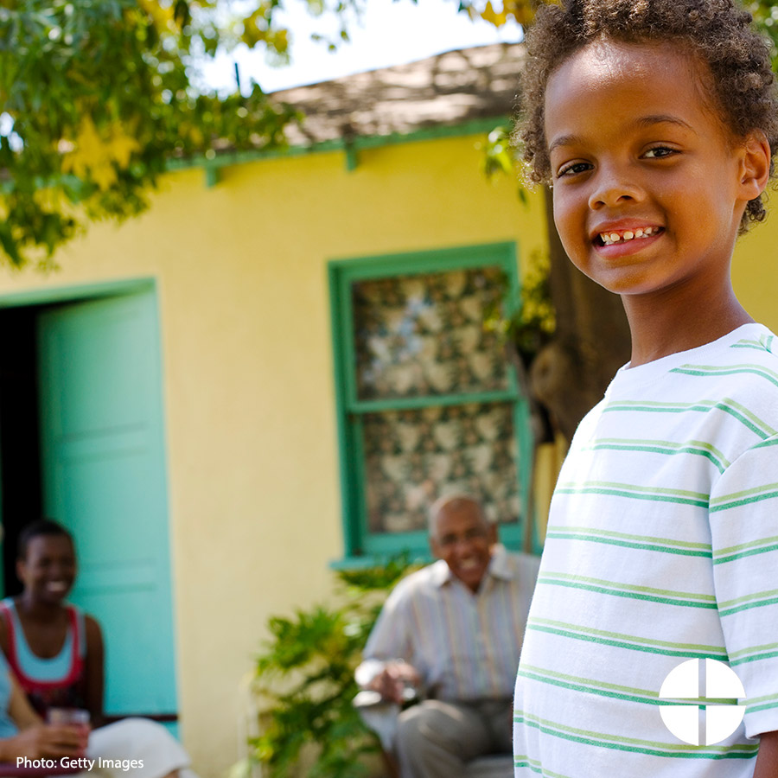
Facebook/Instagram:
This weekend is the collection for the Catholic Campaign for Human Development! Be part of the effort to break the cycle of poverty in the United States. #PowerOfCCHD #1church1mission http://goo.gl/I6FqfW
Twitter:
This weekend is the CCHD collection! Help break the cycle of poverty in the US. #PowerOfCCHD http://goo.gl/I6FqfW

Post 8: Week of the Collection
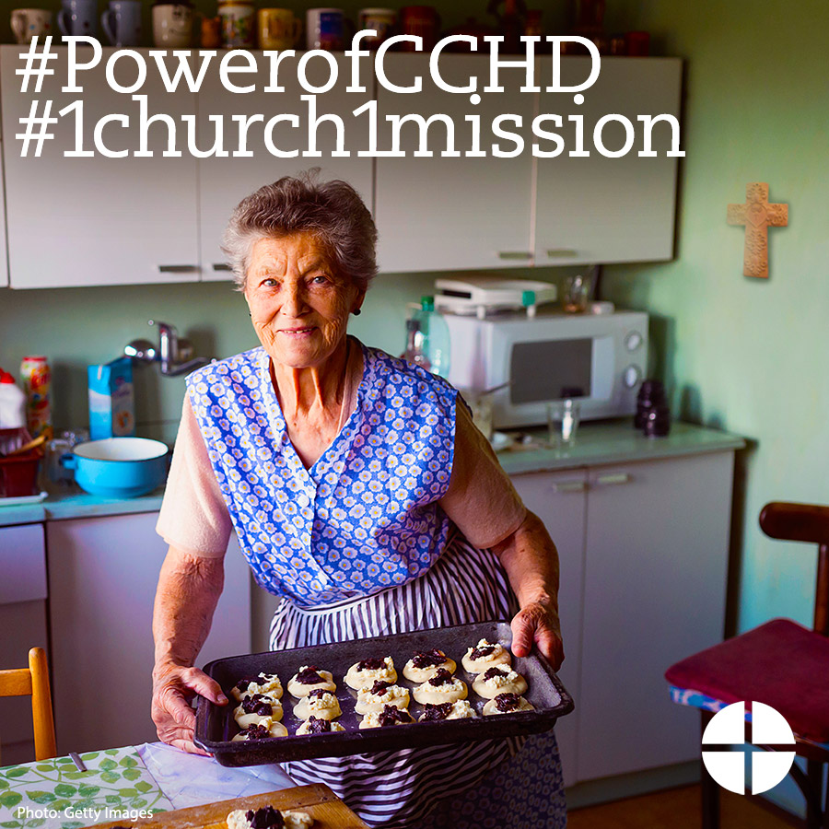
Facebook/Instagram:
This weekend our second collection is for the Catholic Campaign for Human Development. DYK 25% of funds collected will stay here in the diocese for anti-poverty projects? Please be generous! #PowerofCCHD http://goo.gl/I6FqfW
Twitter:
DYK 25% of funds from the CCHD collection stay in our diocese? #PowerOfCCHD http://goo.gl/I6FqfW

Post 9: Day of the Collection
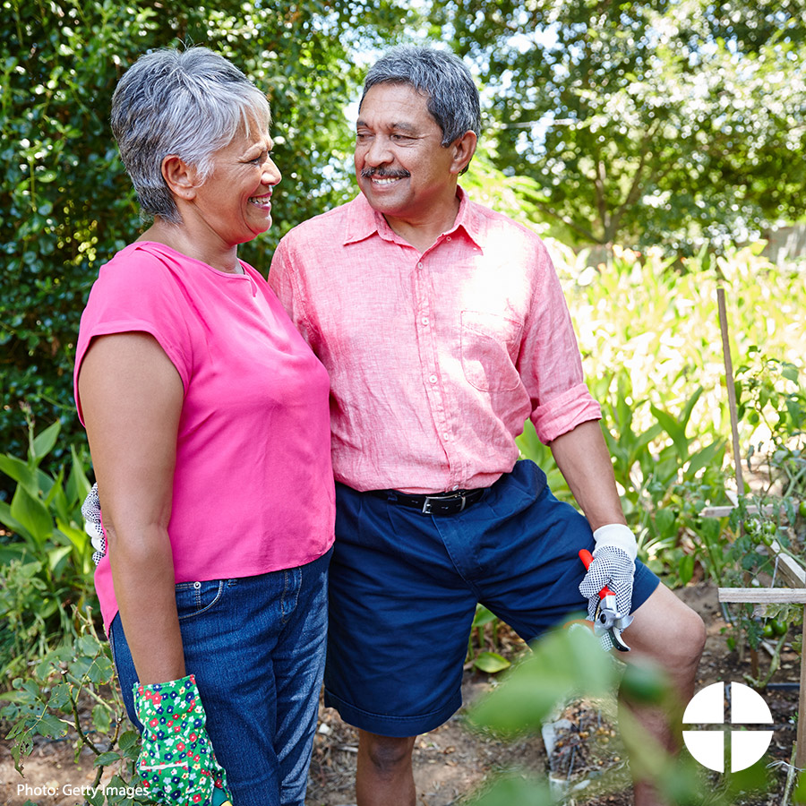
Facebook/Instagram:
Today our second collection is for the Catholic Campaign for Human Development! Please be generous and help end the cycle of poverty in the United States. #PowerofCCHD #1church1mission www.povertyusa.org
Twitter:
Today our second collection is for the Catholic Campaign for Human Development! Please be generous. www.povertyusa.org

