
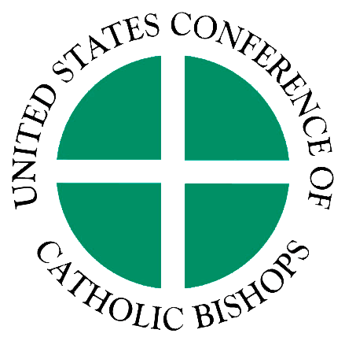
List of Relationships & Strategic Partnerships

Organization:

This form is to be used for Economic Development Applications ONLY. For each section, please add lines as needed.

List here all the names of your organization’s partners, collaborators, and supporters (other than funders). These are typically organizations and institutions whose work helps you achieve your goals and who may share a similar mission or a target market.

PARTNERS & COLLABORATORS
Name, Location
1.
2.
3.
4.
5.
6.
7.
8.
9.
10.

List here the names of the professional networks, associations or trade groups, and other organizations that you participate with for the purpose of gaining expertise and support:

NETWORKS & ASSOCIATIONS
Name, Location
1.
2.
3.
4.
5.
6.
7.
8.
9.
10.

If you are a member of any coalition engaged in other community efforts, list the coalition and the issue below:

COALITIONS
Name, Issue
1.
2.
3.
4.
5.
6.
7.
8.

