Sample Bulletin Announcements
Respect Life: January 2019

9 Days for Life (Suggested Weekends: January 5-6 & 12-13, 2019)

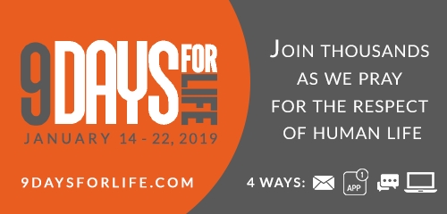
Include one of the 9 Days for Life graphics with your bulletin or newsletter announcement! www.usccb.org/pro-life-simple-steps

Option A (64 words)
Join thousands of Catholics nationwide in the annual pro-life novena, 9 Days for Life, Monday, January 14 – Tuesday, January 22. Pray for the respect of all human life with daily intentions, brief reflections, and more. Download a free mobile app, or sign up to receive the novena through daily emails or text message. (A printable version is also available online.) Sign up at www.9daysforlife.com!
Option B (24 words)
Join thousands of Catholics nationwide in the annual pro-life novena January 14-22 via email, text message, or an app. Sign up today at www.9daysforlife.com!

Day of Prayer for the Legal Protection of Unborn Children
(Suggested Weekend: January 19-20, 2019)
Option A (63 words)
This Tuesday, January 22, the Church in the United States observes the annual “Day of Prayer for the Legal Protection of Unborn Children.” This day is set aside to pray for the legal protection of human life and to do penance for the violations to human dignity through abortion. We are called to observe this day through prayer and penance. More information: www.usccb.org/january-22
Option B (38 words)
Did You Know? This Tuesday, January 22, the Church in the United States observes the annual “Day of Prayer for the Legal Protection of Unborn Children.” We are called to observe this day through prayer and penance. www.usccb.org/january-22

Visit www.usccb.org/9-days-for-life-toolkit for this and
other 9 Days for Life leaders’ resources!

