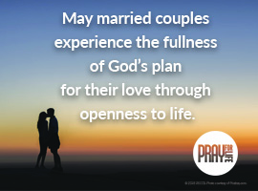
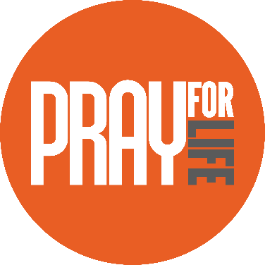
http://www.usccb.org/about/pro-life-activities/prayers/upload/pray-for-life-oct-2017-2.jpg
Copyright © 2018, United States Conference of Catholic Bishops, Washington, DC. All rights reserved.
Acts of Reparation (choose one)
- Pray a decade of the Rosary for married couples, using the pro-life reflections for the second Luminous Mystery, The Wedding Feast at Cana (www.bit.ly/pro-life-luminous).
- Participate in the 7-day virtual retreat beginning on February 7, “Marriage: School of Life and Love.” Access online at www.foryourmarriage.org or on social media: www.facebook.com/foryourmarriage www.twitter.com/foryourmarriage
- Take some time this week to learn about and prayerfully reflect upon the life of one or more married saints. What speaks to you? How might you be called to follow his or her example? Suggestions: St. Gianna Molla, who ultimately gave her life for her unborn child; Saints Louis & Zelie Martin, the parents of St. Therese of Lisieux.
One Step Further
“Marriage, the Sanctuary of Life” presents, in a fascinating and compelling way, the Catholic vision of marriage, drawing from Scripture, Pope Saint John Paul II, and social research. (www.bit.ly/life-matters-marriage)
Did You Know?
The National Marriage Week is Wednesday, February 7 – Wednesday, February 14. Archbishop Chaput, Chairman of the USCCB Committee on Laity, Marriage, Family Life and Youth, wrote: “It is an opportunity to focus on building a culture of life and love that begins with supporting and promoting marriage and the family.”
Visit www.foryourmarriage.org, an initiative of the U.S. Conference of Catholic Bishops, for blog posts, stories, tips, FAQs, and more for dating, engaged, and married couples.

Prayers
Our Father, 3 Hail Marys, Glory Be
Reflection
“A husband and wife express their committed love not only with words, but with the language of their bodies. That ‘body language’—what a husband and wife say to one another through the intimacy of sexual relations—speaks of total commitment and openness to a future together. …Married love differs from any other love in the world. By its nature, the love of husband and wife is so complete, so ordered to a lifetime of communion with God and each other, that it is open to creating a new human being they will love and care for together. …As many couples who have turned away from contraception tell us, living [the Church’s teaching] can contribute to the honesty, openness, and intimacy of marriage and help make couples truly fulfilled.”
–Married Love and the Gift of Life
U.S. Conference of Catholic Bishops
Intention

www.usccb.org/prayforlife
Pray for Life

