Word of Life: April 2018
Recommended dates are provided, but you are welcome to use these materials at any time!
Intercessions for Life

April 1st Easter Sunday
May the Risen Christ
grant us joy as we follow Him,
embracing God’s gift of life;
We pray to the Lord:

April 8th Sunday of Divine Mercy
May the Holy Spirit move our hearts
to recognize the intrinsic dignity
of every person we encounter;
We pray to the Lord:

April 15th Third Sunday of Easter
For all who feel incapable of welcoming life:
May the Lord fill their hearts with peace
and strengthen them to receive this gift;
We pray to the Lord:

April 22nd Fourth Sunday of Easter
May Jesus, the Good Shepherd,
inspire all hearts to care for
the most vulnerable members of society;
We pray to the Lord:

April 29th Fifth Sunday of Easter
May Christ remain in us and we in him,
so a culture that welcomes life takes root;
We pray to the Lord:

Word of Life – April 2018

Bulletin Quotes

April 1st  “Reflecting on the healed wounds of the Risen Christ, we see that even our most difficult trials can be the place where God manifests his victory. He makes all things beautiful. He makes all things new.”  USCCB Secretariat of Pro-Life Activities  2017-18 Respect Life Reflection, www.usccb.org/be-not-afraid | 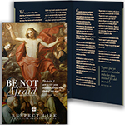  Order Download
April 8th  “While many Catholics want to help women and men heal from past abortions, most don't know how to begin.” Learn how you can become an instrument of mercy at www.usccb.org/bridges-of-mercy.  USCCB Secretariat of Pro-Life Activities,  “Bridges of Mercy for Post-Abortion Healing” | 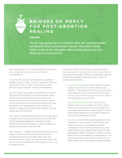  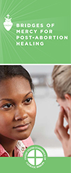  Order | Download
April 15th  “A model of care has been developed specifically for families whose infant is likely to die before or after birth. Often called ‘perinatal hospice,’ it's a way of caring for both the baby and the baby's family before, as well as after, birth.”  USCCB Secretariat of Pro-Life Activities,  “Supporting Families Who Receive a Prenatal Diagnosis”  www.usccb.org/prenatal-diagnosis | 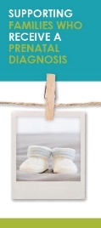  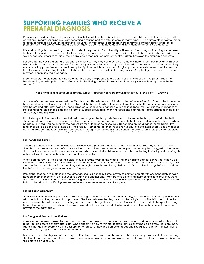  Order | Download
April 22nd  Heavenly Father…  Give us love for all people,  especially the most vulnerable,  and help us bear witness to the  truth that every life is worth living.  USCCB Secretariat of Pro-Life Activities  “Every Life is Worth Living” Prayer Card, www.usccb.org/worth-living | 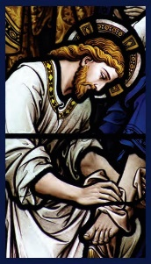  Order | Download
April 29th  “If we are filled with the love of God, a culture of encounter and solidarity will begin to bloom.”  USCCB Secretariat of Pro-Life Activities,  “Serene Attentiveness to God’s Creation”  www.bit.ly/serene-attentiveness | 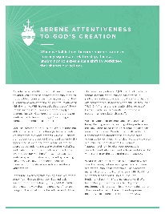  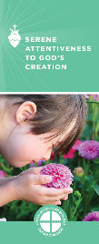  Order | Download

Word of Life - April 2018

Bulletin Art
You are welcome to use these and other downloadable images from the online Respect Life image gallery, provided they are not altered in any way, other than the size. Thank you!

Sunday, April 8th, 2018
Featuring “Bridges of Mercy for Post-Abortion Healing”
- Bulletin Insert: Color | Black-and-White | Grayscale
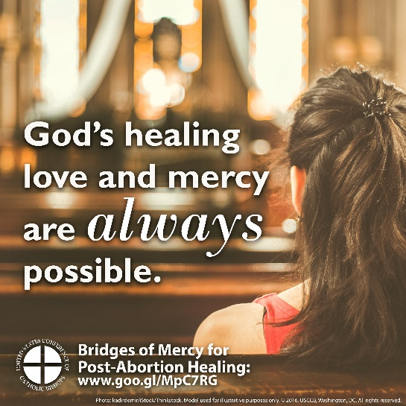
- Download Image: English | Spanish

Sunday, April 22nd, 2018
Featuring “Every Life is Worth Living” Prayer Card
- Prayer Card: Order | Download | Text
- Download Image: English

