Word of Life: February 2018
Recommended dates are provided, but you are welcome to use these materials at any time!
Featured this Month…
Wednesday, February 7 – Wednesday, February 14: National Marriage Week
ForYourMarriage.org Resources
- Celebrate National Marriage Week 2018
- Marriage Resource Center: For Parishes & Press

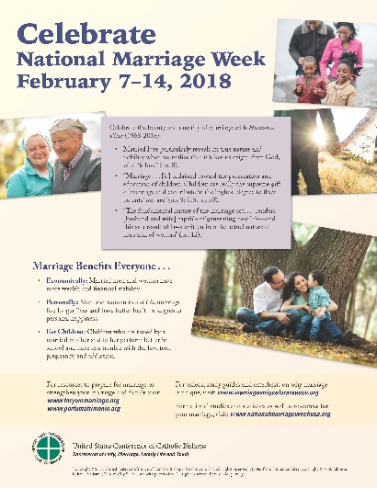
Bulletin Inserts
- Celebrate National Marriage Week (Color)
- Seven Considerations While Navigating Infertility (Color / Grayscale)
- Healing within Marriage from an Abortion (Color)

Sunday, February 11, 2018: 26th World Day of the Sick
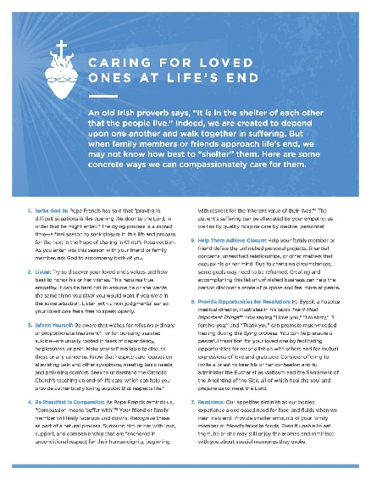
Prayer Resources
- Blessing of the Sick
- Prayers for Those Who Are Sick (Includes prayers, litanies, and intercessions)
Bulletin Inserts
- Caring for Loved Ones at Life’s End
(Color / Grayscale)
- Supporting Families Who Receive a Prenatal Diagnosis (Color / Grayscale)

Word of Life – February 2018
Intercessions for Life

February 4th Fifth Sunday in Ordinary Time
For those nearing the end of life:
May God grant them strength
to have faith in his loving mercy;
We pray to the Lord:

February 11th Sixth Sunday in Ordinary Time
For those who suffer from illness:
May they be comforted and cared for
by loved ones following Christ’s example;
We pray to the Lord:

February 18th First Sunday of Lent
In this Lenten season,
may God show us the way
of compassionate respect
for all human life;
We pray to the Lord:

February 25th Second Sunday of Lent
For our culture:
May we listen to God
and follow His call
to cherish every person’s life;
We pray to the Lord:

Word of Life – February 2018

Bulletin Quotes

February 4th  “The dying process is a sacred time—a final season to seek closure in this life and prepare for the next in the hope of sharing in Christ's Resurrection. As you enter into this season with your friend or family member, ask God to accompany both of you.”  USCCB Secretariat of Pro-Life Activities  “Caring for Loved Ones at Life’s End,” www.usccb.org/endoflifecare | 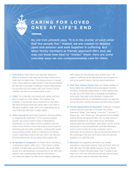  Order Download
February 11th  “The Church affirms the inviolable dignity of every person, regardless of the duration or extent of the person's incapacity or dependency. Nothing diminishes the unchangeable dignity and sanctity of a person's life, or the obligation to protect and care for it.”  USCCB Secretariat of Pro-Life Activities  “Catholic Considerations for Our Earthly Passing”  www.usccb.org/end-of-life-considerations | 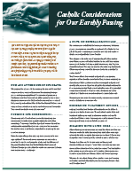  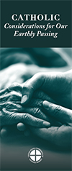  Order Download
February 18th  “Many parents want perfect children. Our culture is obsessed with perfection—a superficial perfection. Photos are airbrushed, and social media sites depict seemingly perfect lives. God calls us to seek perfection, too. He does not call us, however, to perfection of appearance or abilities, but to perfection in love.”  USCCB Secretariat of Pro-Life Activities  “A Perfect Gift,” www.usccb.org/perfect-gift | 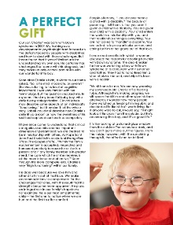  Order Download
February 25th  “Sometimes our actions speak for themselves; other times, words are needed. Whatever the situation, Jesus knows how to speak to each person's heart; we simply need to follow where he leads.”  USCCB Secretariat of Pro-Life Activities  “How to Build a Culture of Life,” www.usccb.org/culture-of-life | 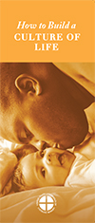  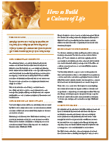  Order Download

Word of Life - February 2018

Bulletin Art
You are welcome to use these and other downloadable images from the online Respect Life image gallery, provided they are not altered in any way, other than the size. Thank you!

Sunday, February 4th, 2018
Featuring “Caring for Loved Ones at Life’s End”
- Bulletin Insert: Color | Grayscale
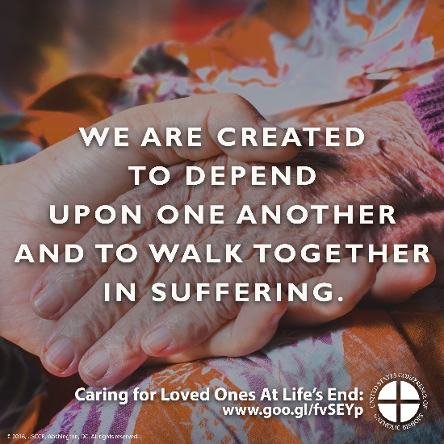
- Download Image: English | Spanish

Sunday, February 18th, 2018
Featuring “A Perfect Gift”
- Bulletin Insert: Color | Grayscale
- Download Image: English | Spanish

