Word of Life: March 2019
Recommended dates are provided, but you are welcome to use these materials at any time!
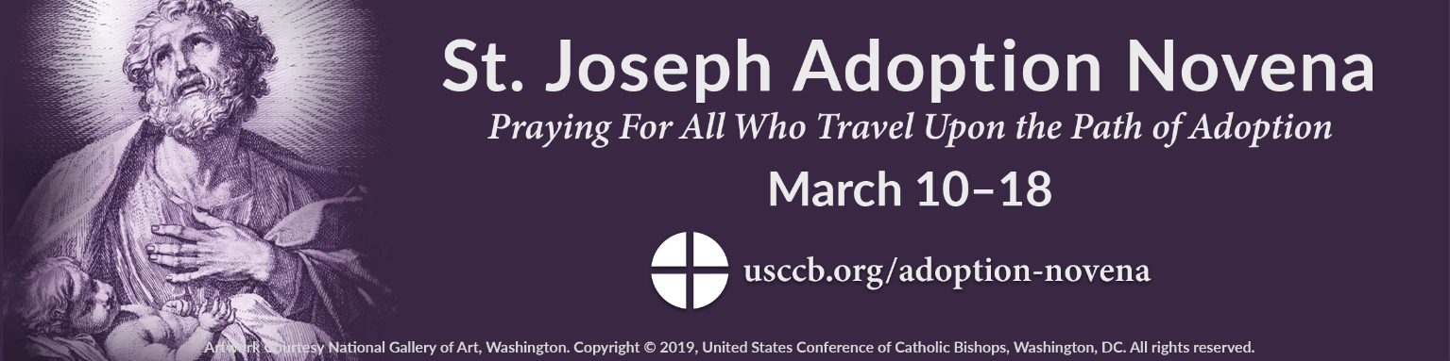
Featured this Month…
We celebrate the Solemnity of Saint Joseph, husband of the Blessed Virgin Mary, on March 19th. This occasion is an opportunity to highlight the gift of adoption by seeking the intercession of St. Joseph for the many people whose lives are touched by adoption.
Resources are available to assist you with inviting parishioners to join in prayer leading up to the solemnity March 10–18, 2019. The novena, promotional graphics, and an introductory prayer guide can be found at www.usccb.org/adoption-novena.

Sample Bulletin Announcements
Option A (54 words)
Leading up to the Solemnity of St. Joseph on March 19, join us in praying the St. Joseph Adoption Novena. Invoking the intercession of St. Joseph, foster father of Jesus, we will pray the Lord blesses all who travel upon the path of adoption. Visit usccb.org/adoption-novena for the novena, which begins Sunday, March 10.
Option B (27 words)
All are invited to join the St. Joseph Adoption Novena March 10-18 as we pray for all those who travel upon the path of adoption. Visit usccb.org/adoption-novena.

Sample Pulpit Announcements
Option A (55 words)
All are invited to join the St. Joseph Adoption Novena from March 10th through the 18th. Seeking St. Joseph’s intercession as foster father of Jesus, we’ll pray for all those who travel upon the path of adoption. The novena concludes ahead of his feast day, which is March 19th. Please see the bulletin for details.
Option B (40 words)
Please join us in praying the St. Joseph Adoption Novena from March 10th through the 18th. We will seek St. Joseph’s intercession in praying for all those who travel upon the path of adoption. Please see the bulletin for details.
Option C (31 words)
All are invited to pray the St. Joseph Adoption Novena from March 10th through the 18th for all whose lives are touched by adoption. Please see the bulletin for more details.

Intercessions for Life
March 3rd  May we know God as our loving Father  and always give thanks  for the gift of our lives;  We pray to the Lord: | Eighth Sunday in Ordinary Time
March 10th  For expectant mothers  placing their children for adoption:  May they receive loving support  as they walk this journey;  We pray to the Lord: | First Sunday of Lent
March 17th  For adoptive fathers:  May they reflect God’s constant, steady love  as they embrace their roles  of guardian, father, and protector;  We pray to the Lord: | Second Sunday of Lent
March 24th  For all Christians:  May we live out our baptismal call  to proclaim the Gospel  and be messengers of God’s love for every human life;  We pray to the Lord: | Third Sunday of Lent
March 31st  For civic leaders:  That by their words and actions,  they might work to preserve respect for  the life of every human being;  We pray to the Lord: | Fourth Sunday of Lent

Word of Life – March 2019

Bulletin Quotes
March 3rd  “Heavenly Father, thank you for the precious gift of life. Give us love for all people, especially the most vulnerable, and help us bear witness to the truth that every life is worth living.”  USCCB Secretariat of Pro-Life Activities  “Every Life is Worth Living” Prayer, www.usccb.org/worth-living | 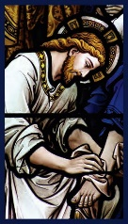  Order | Download
March 10th  “Maya discovered she was pregnant six months into her freshman year of college. When her son was born, she placed him with a very kind adoptive family; she ‘just knew they were the right choice.’ Now, years later, Maya emphasizes the importance of offering ongoing support to expectant mothers considering adoption.” Learn how at www.usccb.org/women-considering-adoption.  USCCB Secretariat of Pro-Life Activities  “Accompanying Expectant Mothers Considering Adoption” | 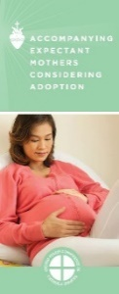  Order | Download
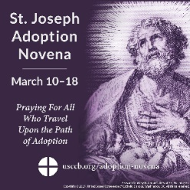
March 17th
“Fatherhood has its origins in God, and so we pray to you, Father Almighty, for those men who have adopted a child. Give them a mind receptive to your guidance, a patient voice, and a loving heart.”
USCCB Secretariat of Pro-Life Activities
“Novena to St. Joseph: For Those on the Path of Adoption”
Download Novena
www.usccb.org/adoption-novena
March 24th  “Ira Byock, a hospice medical director, illustrates in his book The 4 Most Important Things how saying ‘I love you,’ ‘I’m sorry,’ ‘I forgive you,’ and ‘Thank you’ can promote much-needed healing during the dying process. You can help ensure a peaceful transition for your loved one by facilitating opportunities for reconciliation with others and for mutual expressions of love and gratitude.”  USCCB Secretariat of Pro-Life Activities  “Caring for Loved Ones at Life’s End,” www.usccb.org/endoflifecare | 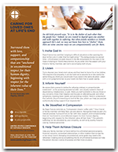  Order | Download
March 31st  “Because life is our first and most basic gift from an infinitely loving God, it deserves our utmost respect and protection. Direct attacks on innocent human life are always gravely wrong.”  United States Conference of Catholic Bishops  On Embryonic Stem Cell Research |  | 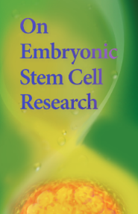  Order | Download

Word of Life - March 2019

Bulletin Art
You are welcome to use these and other downloadable images from the online Respect Life image gallery, provided they are not altered in any way, other than the size. Thank you!

Sunday, March 10, 2019
- Image: English | Spanish
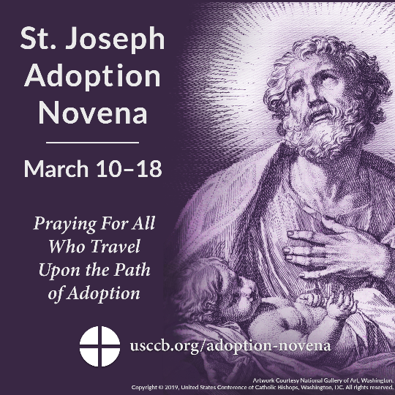
- Novena & Toolkit: www.usccb.org/adoption-novena

Sunday, March 17, 2019
- Image: English | Spanish
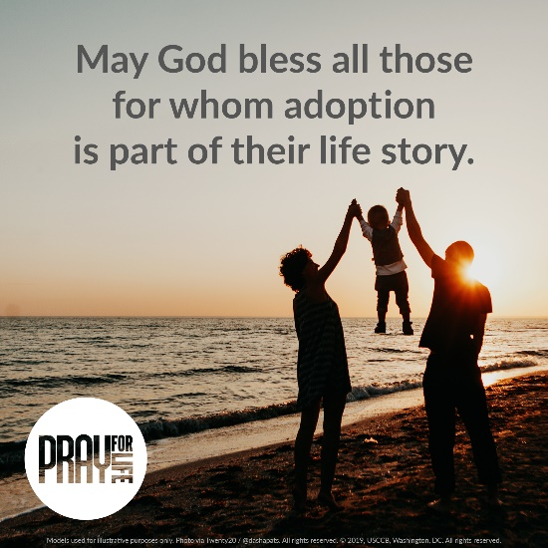
- March 2019 Pray for Life: Adoption Prayer Guide

