Word of Life: July 2019
Recommended dates are provided, but you are welcome to use these materials at any time!

Featured this Month…

National NFP Awareness Week (July 21–27)
Graphics are available online.
The dates of National Natural Family Planning Awareness Week highlight the anniversary of the papal encyclical Humanae vitae (July 25), which articulates Catholic beliefs about human sexuality, conjugal love, and responsible parenthood. The dates also mark the feast of Saints Joachim and Anne (July 26), the parents of the Blessed Mother. Couples’ stories, sample intercessions, a media kit and more can be found online.
Poster
- PDF: English | Spanish
- JPG: English | Spanish
Homily Notes 2019 (July 21-27)
- Sunday, July 21, 2019
- Weekdays and Saturday, July 22-27

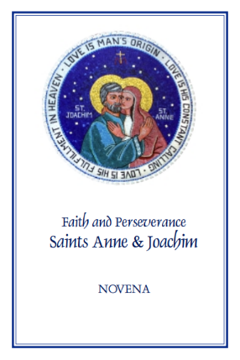
Memorial of Saints Joachim and Anne, parents of the Blessed Virgin Mary (July 26)
Saints Anne and Joachim, parents of the Blessed Virgin Mary, are powerful intercessors for all married couples, expectant mothers, and married couples who are having difficulty conceiving, as well as those who are aging. You can download or purchase hard copies of the “Faith and Perseverance” Novena to Saints Anne and Joachim.
- Download: (English | Spanish)
- Order: (English | Spanish)

Word of Life – July 2019
Intercessions for Life
July 7th  For all unborn children:  That they may be lovingly welcomed into the world,  and receive protection and comfort from their mothers;  We pray to the Lord: | Fourteenth Sunday in Ordinary Time
July 14th  That our nation and its people  may come to recognize the image of Christ,  the firstborn of creation, in every human life;  We pray to the Lord: | Fifteenth Sunday in Ordinary Time
July 21st  For our parish community:  That we may always be ready to extend generous hospitality to those in need,  such as mothers facing unexpected pregnancies;  We pray to the Lord: | Sixteenth Sunday in Ordinary Time
July 28th  For all who suffer because of participation in abortion:  May they come to know the mercy of God,  who longs to forgive all our transgressions  through the saving power of the Cross;  We pray to the Lord: | Seventeenth Sunday in Ordinary Time

Word of Life – July 2019

Bulletin Quotes
July 7th  “Father and maker of all, you adorn all creation with splendor and beauty,  and fashion human lives in your image and likeness. Awaken in every heart  reverence for the work of your hands, and renew among your people a readiness to nurture and sustain your precious gift of life.”  Catholic Household Blessings & Prayers  “A Prayer for Life” | 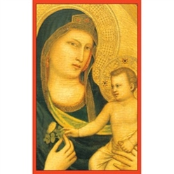  Order | Download
July 14th  “To understand more fully how to defend and protect human life, we must first consider who we are, at the deepest level. God creates us in his image and likeness, which means we are made to be in loving relationship with him. The essence of our identity and worth, the source of our dignity, is that we are loved by God.”  USCCB Secretariat of Pro-Life Activities  “How to Build a Culture of Life” | 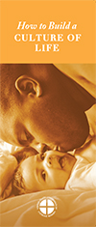  Order | Download
July 21st  “As a mom who had my first baby in college, I know that an unexpected pregnancy can sometimes bring fear, shame, and doubt. However, I also know that an unexpected pregnancy can bring joy, excitement, awe, gratitude, and deeper love than I knew was possible—not to mention the little bundle who inspires these sentiments!”  USCCB Secretariat of Pro-Life Activities  “10 Ways to Support Her When She's Unexpectedly Expecting” | 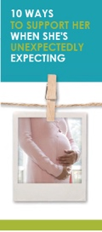  Order | Download
July 28th  “O God, you are faithful, and you never abandon those who hope in you. I know that my redemption from sin and death has been purchased at the cost of your Son’s blood. In return for this priceless gift, I resolve today to renew my trust in your unfailing mercy.”  USCCB Secretariat of Pro-Life Activities  “Trust in God’s Mercy” Prayer | 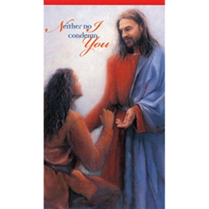  Order | Full Prayer

Word of Life - July 2019

Bulletin Art
You are welcome to use these and other downloadable images from the online Respect Life image gallery, provided they are not altered in any way, other than the size. Thank you!

Sunday, July 21st, 2019
- Image: English | Spanish
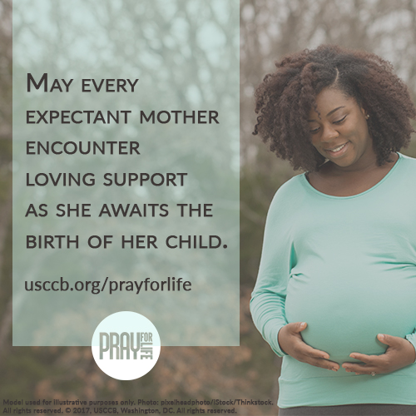
- Bulletin Insert: 10 Ways to Support Her When She's Unexpectedly Expecting (Spanish)

Sunday, July 28th, 2019
- Image: English | Spanish
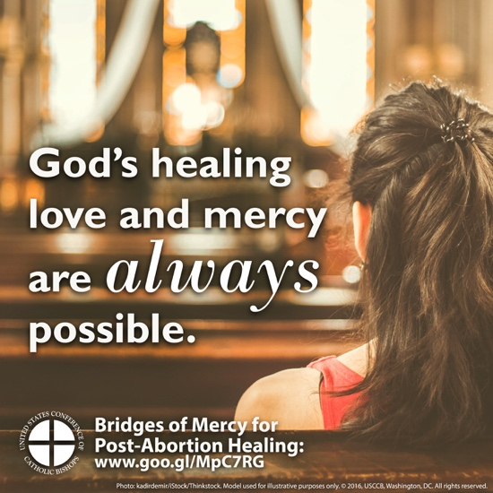
- Bulletin Insert: Bridges of Mercy for Healing after Abortion (Spanish)

