Word of Life: December 2019
Recommended dates are provided, but you are welcome to use these materials at any time!
Featured this Month…
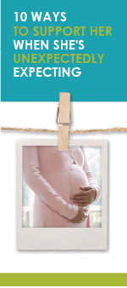
- Advent
The season of Advent is a time of preparation that directs our hearts and minds to preparing for the celebration of the Lord’s birth on Christmas and for Christ’s second coming at the end of time. During this time of preparation and expectant waiting, we also remember expectant mothers who are preparing for the birth of their children. This Advent season, consider highlighting the article “10 Ways to Support Her When She’s Unexpectedly Expecting.” (It is available in a variety of formats at the bottom of this webpage.)

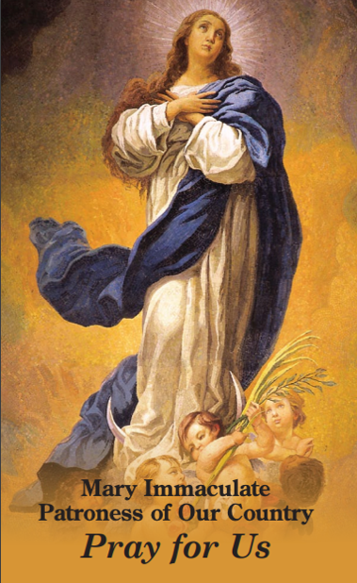
- Solemnity of the Immaculate Conception of the Blessed Virgin Mary Patronal feast day of the United States of America (December 9, 2019)
Since December 8 falls on a Sunday this year, the Solemnity of the Immaculate Conception of the Blessed Virgin Mary is transferred to December 9. (It is normally a holyday of obligation, but it is not obligatory this year). In this feast, we celebrate Mary’s conception free from the stain of Original Sin, and we recognize that Mary’s life began at the moment she was conceived in the womb of St. Anne. So, too, does every human life begin at the moment of conception, lovingly knit together by God the Father.

The Immaculate Conception is sometimes confused with the Annunciation. This bulletin insert can be used to help differentiate these two important celebrations. On this Solemnity, consider praying Pope Francis’ Prayer for the Immaculate Conception: “We are in need of your immaculate gaze, to rediscover the ability to look upon persons and things with respect and awareness.” You can also offer this prayer for religious liberty to Mary Immaculate.

Word of Life – December 2019
Intercessions for Life
December 1st  For all the faithful:  May the Lord help us build a culture of life  in vigilant expectation of His return;  We pray to the Lord: | First Sunday of Advent
December 8th  May God move us to act  with tenderness and compassion  for the most vulnerable among us;  We pray to the Lord: | Second Sunday of Advent
December 9th  For women facing an unexpected pregnancy:  May they be filled with trust in God’s providence  and lovingly welcome the gift of their child;  We pray to the Lord: | Solemnity of the Immaculate Conception of the Blessed Virgin Mary
December 15th  For all who have lost a loved one:  As we prepare for the coming of Christ,  may they find peace in the hope of eternal life;  We pray to the Lord: | Third Sunday of Advent
December 22nd  For all fathers awaiting the births of their children:  May they look to Saint Joseph and follow his example  of cherishing and protecting the Holy Family;  We pray to the Lord: | Fourth Sunday of Advent
December 25th  For all Christians:  That the wondrous birth of Our Lord Jesus Christ  will awaken our hearts to the priceless gift of every child;  We pray to the Lord: | The Nativity of the Lord (Christmas)
December 29th  For all families:  That, with great faith, they will joyfully respond  to all that God asks of them,  and be given the strength to always persevere in love;  We pray to the Lord: | Feast of the Holy Family of Jesus, Mary and Joseph

Word of Life – December 2019

Bulletin Quotes
December 1st  “When we encounter Christ, experience his love, and deepen our relationship with him, we become more aware of our own worth and that of others.”  USCCB Secretariat of Pro-Life Activities  “How to Build a Culture of Life” | 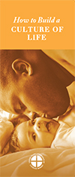  Order | Download
December 8th  “Perhaps one of your friends has become pregnant unexpectedly. As someone who has been there, I encourage you to support your friend in her new journey of being a mother.” Learn ten tips at respectlife.org/support-her.  USCCB Secretariat of Pro-Life Activities  “10 Ways to Support Her When She’s Unexpectedly Expecting” | 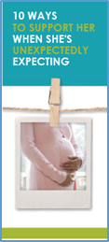  Order | Download
December 15th  “Those who die in God's grace and friendship live forever with Christ. Heaven is not an abstract idea, but a true and lasting relationship with God that is beyond all earthly description and understanding. We look forward to the resurrection of the dead and everlasting life by preparing now, in hope, for our passage from this life into eternal life.”  USCCB Secretariat of Pro-Life Activities  “Catholic Considerations for Our Earthly Passing” | 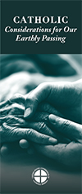  Order | Download
December 22nd  “God's love is generous, sacrificial, life-giving, and forever. As humans made in God's image, we are called to imitate the eternal giving and receiving of love that is the Holy Trinity.”  USCCB Secretariat of Pro-Life Activities  “Another Look at Contraception” | 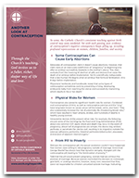  Order | Download
December 29th  “Like Our Blessed Mother welcomed Jesus, we are called to cherish and protect the gift of human life, at every stage and in every circumstance.”  USCCB Secretariat of Pro-Life Activities  “Living Out Christmas in the New Year” | 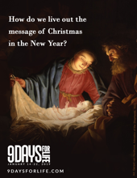  Download

Word of Life - December 2019

Bulletin Art
You are welcome to use these and other downloadable images from the online Respect Life image gallery, provided they are not altered in any way, other than the size. Thank you!
Sunday, December 8th, 2019
Featuring “10 Ways to Support Her When She’s Unexpectedly Expecting”
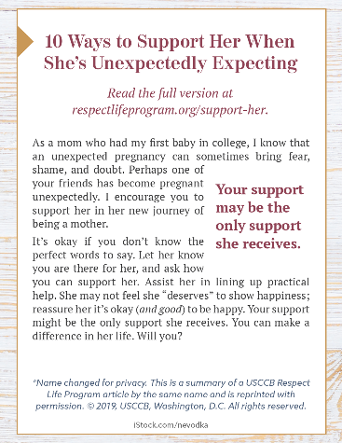
- Bulletin Box: English | Spanish

Sunday, December 22nd, 2019
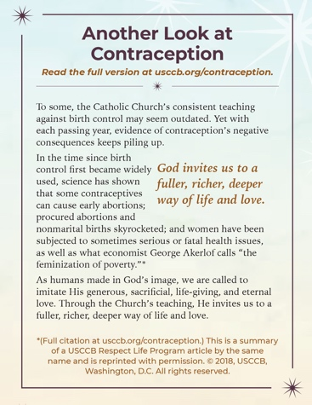
Featuring “Another Look at Contraception”
- Bulletin Box: English | Spanish

Sunday, December 29th, 2019
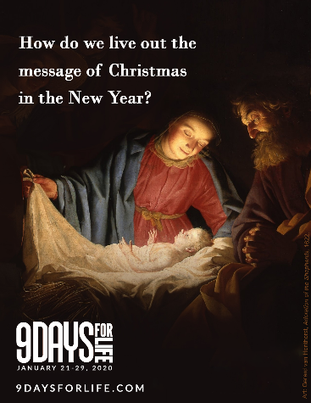
Featuring “Living Out Christmas in the New Year”
- Image: English | Spanish
- Reflection

