Word of Life: January 2020
Recommended dates are provided, but you are welcome to use these materials at any time!
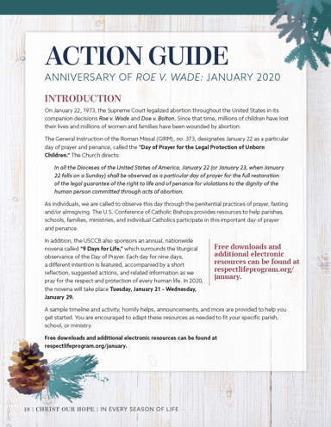
Featured this Month…
- Anniversary of Roe v. Wade
On January 22, 1973, the Supreme Court legalized abortion throughout the United States in its companion decisions Roe v. Wade and Doe v. Bolton. Since that time, millions of children have lost their lives and millions of women and families have been wounded by abortion. Our January Action Guide is available to help parishes, schools, and ministries commemorate this tragic anniversary throughout the month and pray for the protection of unborn children.
- Day of Prayer for the Legal Protection of Unborn Children
(January 22, 2020)
The Catholic bishops of the United States have designated January 22 as a particular day of prayer and penance, called the “Day of Prayer for the Legal Protection of Unborn Children.” The General Instruction of the Roman Missal (GIRM), no. 373, directs:
In all the Dioceses of the United States of America, January 22 (or January 23, when January 22 falls on a Sunday) shall be observed as a particular day of prayer for the full restoration of the legal guarantee of the right to life and of penance for violations to the dignity of the human person committed through acts of abortion.
Choices of Readings for Mass and other resources are available online.
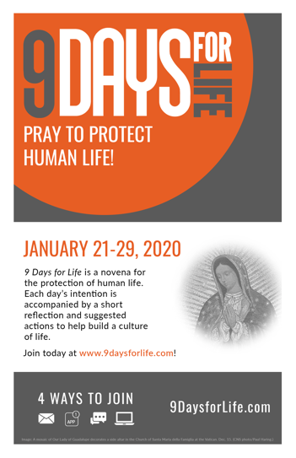
- 9 Days for Life
(January 21 – 29, 2020)
9 Days for Life is a novena for the protection of human life. Each day’s intention is accompanied by a short reflection and suggested actions to help build a culture of life. Participants can receive the novena by downloading the free 9 Days for Life app, or by subscribing to daily emails or text messages. (A printable version will also be made available online.)
Leaders’ resources are available for download, including graphics, sample announcements, and novena printables.
Sign up for the novena at www.9daysforlife.com.

Word of Life – January 2020
Intercessions for Life
January 1st  May friends and families of women  with difficult pregnancies  provide loving, life-affirming support  for both mother and child;  We pray to the Lord: | The Octave Day of the Nativity of the Lord: Solemnity of Mary, the Holy Mother of God
January 5th  For public servants:  May God grant them the humility, wisdom,  and courage to defend all human life;  We pray to the Lord: | The Epiphany of the Lord
January 12th  For all Christians:  May we live out our baptismal call  to proclaim the Gospel  and be messengers of God’s love for every human life;  We pray to the Lord: | The Baptism of the Lord
January 19th  May every expectant mother  encounter loving support  as she awaits the birth of her child;  We pray to the Lord: | Second Sunday in Ordinary Time
January 22nd  For the legal protection of unborn children  and for loving support for their mothers  before and after their births;  We pray to the Lord: | Day of Prayer for the Legal Protection of Unborn Children
January 26th  May all who suffer  from participating in abortion  turn to God’s loving forgiveness;  We pray to the Lord: | Third Sunday in Ordinary Time

Word of Life – January 2020

Bulletin Quotes
January 5th  “When I meet another parent of a child with Down syndrome, there is usually a moment of instant recognition and understanding. Our eyes meet, and we smile conspiratorially, as if we’re in on the same secret: the fundamental truth that every life is a good and perfect gift. …Our love for our children has nothing to do with their abilities. We love them simply because of who they are, and understanding this teaches us how to truly love everyone.”  USCCB Secretariat of Pro-Life Activities  “A Perfect Gift” (www.respectlife.org/a-perfect-gift) | 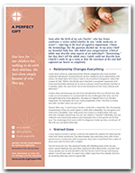  Order | Download
January 12th  “An unexpected pregnancy can be a difficult and frightening time, and it’s important that your friend knows you are thinking of her and supporting her. … don’t forget the most important thing is to pray. Even if it’s just a quick two-second prayer, prayer is the most effective way we can help. Pray for her, for her child, and for guidance in how you can give her the best possible support.”  USCCB Secretariat of Pro-Life Activities  “10 Ways to Support Her When She’s Unexpectedly Expecting” (www.respectlife.org/support-her) | 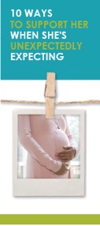  Order | Download
January 19th  “If someone shared with you she was pregnant and hadn't ruled out having an abortion, would you know how to respond? … When a woman is facing a difficult pregnancy, the reaction of the first person she tells tends to set the tone for her decision-making. How do we respond to our friend in a loving way that is life-affirming for both her and her baby?” Consider the four steps of the L.O.V.E. Approach™*: Listen and Learn, Open Options, Vision and Value, and Extend and Empower.” Read more at www.respectlife.org/l-o-v-e.  USCCB Secretariat of Pro-Life Activities  “What to Do When a Friend is Considering Abortion” (www.respectlife.org/l-o-v-e)  *The L.O.V.E. Approach™ is trademarked by Heartbeat International, Inc. and may not be adapted or modified. The L.O.V.E. Approach™ is used in "What to Do When a Friend Is Considering Abortion" with permission from Heartbeat International, Inc. | Order | Download
January 26th  Abortion affects countless marriages, more than many people recognize. But God’s grace can bring true healing in relationships. Learn more at respectlife.org/healing-in-marriage or find help via goo.gl/XPyrMb.  USCCB Secretariat of Pro-Life Activities  “Healing Within Marriage from an Abortion” | 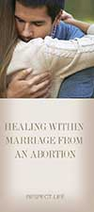  Order | Download

Word of Life – January 2020

Bulletin Art
You are welcome to use these and other downloadable images from the online Respect Life image gallery, provided they are not altered in any way, other than the size. Thank you!
Sunday, January 12, 2020
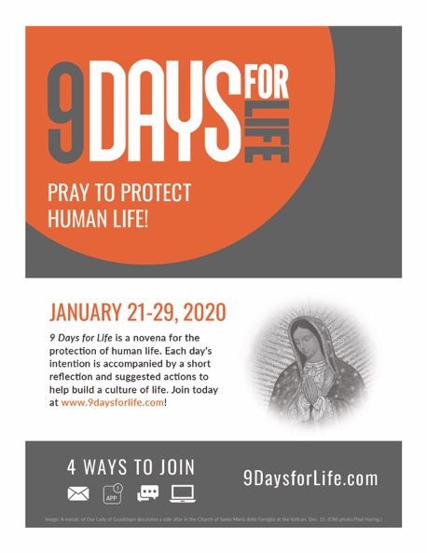
- Download: English | Spanish

Sunday, January 19, 2020
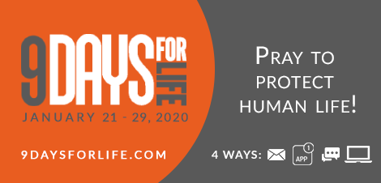
- Download: English | Spanish

Sunday, January 26, 2020
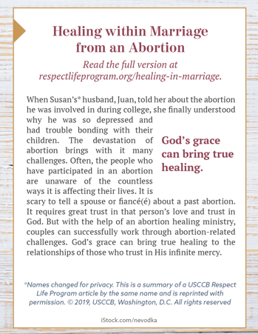
Featuring “Healing within Marriage from an Abortion”
- Bulletin Box: English | Spanish

