Word of Life: March 2020
Recommended dates are provided, but you are welcome to use these materials at any time!
Featured this Month…
25th Anniversary of Evangelium vitae (The Gospel of Life)
Solemnity of the Annunciation: March 25, 2020
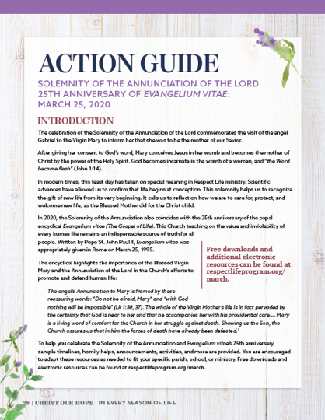
This month we celebrate the 25th anniversary of the papal encyclical Evangelium vitae (The Gospel of Life). This Church teaching on the value and inviolability of every human life remains an indispensable source of truth for all people. Written by Pope St. John Paul II, Evangelium vitae was appropriately given in Rome on the Solemnity of the Annunciation on March 25, 1995.
Our March Action Guide features sample timelines, homily helps, announcements, activities, and more to assist in celebrating and educating within your parish community. Additional resources for celebrating the 25th anniversary of Evangelium vitae are available online.
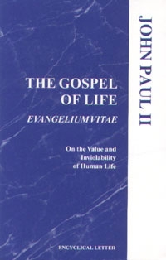
Walking with Moms in Need: A Year of Service
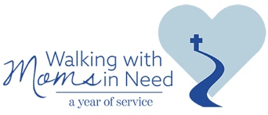
Pregnant and parenting moms in need are in our parishes and our neighborhoods. As Pope Francis reminded us in his message for Lent 2015, our parishes need to be “islands of mercy in the midst of a sea of indifference.” Everyone in a parish community should know where to refer a pregnant woman in need.
The 25th anniversary year of Evangelium vitae gives us a wonderful opportunity to assess, expand, and communicate resources to pregnant moms and families in need. We are inviting parishes, through the support of their bishops and pastors, to join a nationwide effort from March 25, 2020 to March 25, 2021 entitled, “Walking with Moms in Need: A Year of Service.”
The Year of Service launches this March. To learn more about how your parish can take part in this effort, visit us at www.walkingwithmoms.com. You are also encouraged to share this information with your pastor so your parish can discern how it can better reach out to mothers in need.

Word of Life – March 2020
Intercessions for Life
March 1st  For any expectant mother considering abortion:  May the Lord protect her  and give her the grace and resolve  to choose life for her child;  We pray to the Lord: | First Sunday of Lent
March 8th  For those nearing the end of life:  May they be given the grace to persevere in faith  and place their trust in God,  as they prepare for eternity with Christ;  We pray to the Lord: | Second Sunday of Lent
March 15th  May all who have been wounded by abortion  be filled with the hope that does not disappoint,  and be healed by Christ;  We pray to the Lord: | Third Sunday of Lent
March 22nd  As we prepare to celebrate the 25th anniversary  of Pope St. John Paul II’s encyclical, the Gospel of Life,  may we recommit ourselves to protecting human life  in all stages and circumstances;  We pray to the Lord: | Fourth Sunday of Lent
March 25th  Inspired by the example of the Blessed Mother,  may we, like Mary, have the courage  to say “yes” to life in all circumstances,  from conception to natural death;  We pray to the Lord: | Solemnity of the Annunciation  of the Lord
March 29th  May any mother facing an unexpected pregnancy  be lovingly accompanied as she prepares  to encounter Christ anew  through the gift of her child;  We pray to the Lord: | Fifth Sunday of Lent

Word of Life – March 2020
Bulletin Quotes
In honor of the 25th anniversary of Evangelium vitae, the bulletin quotes for this month all come from this historic document. Additional artwork is provided for each bulletin quote this month.
Credit: Pope Saint John Paul II, Evangelium vitae. © 1995 Libreria Editrice Vaticana. Used with permission.
March 1st  “[The Gospel of Life] is therefore meant to be a precise and vigorous reaffirmation of the value of human life and its inviolability, and at the same time a pressing appeal addressed to each and every person, in the name of God: respect, protect, love and serve life, every human life! Only in this direction will you find justice, development, true freedom, peace and happiness!” (The Gospel of Life 5) | 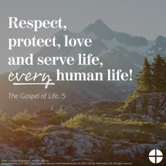  English | Spanish
March 8th  “We are facing an enormous and dramatic clash between good and evil, death and life, the "culture of death" and the "culture of life". We find ourselves not only "faced with" but necessarily "in the midst of" this conflict: we are all involved and we all share in it, with the inescapable responsibility of choosing to be unconditionally pro-life” (The Gospel of Life 28). | 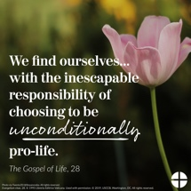  English | Spanish
March 15th  “To celebrate the Gospel of life means to celebrate the God of life, the God who gives life… In every child which is born and in every person who lives or dies we see the image of God's glory. We celebrate this glory in every human being, a sign of the living God, an icon of Jesus Christ” (The Gospel of Life 84). | 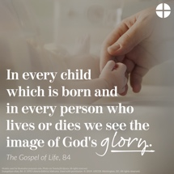  English | Spanish
March 22nd  “There is an everyday heroism, made up of gestures of sharing, big or small, which build up an authentic culture of life… Part of this daily heroism is also the silent but effective and eloquent witness of all those ‘brave mothers who devote themselves to their own family without reserve, who suffer in giving birth to their children and who are ready to make any effort, to face any sacrifice, in order to pass on to them the best of themselves’… We thank you, heroic mothers, for your invincible love! We thank you for your intrepid trust in God and in his love. We thank you for the sacrifice of your life” (The Gospel of Life 86). | 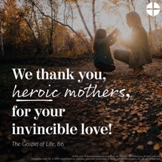  English | Spanish
March 29th  “With great openness and courage, we need to question how widespread is the culture of life today among individual Christians, families, groups and communities in our Dioceses. With equal clarity and determination we must identify the steps we are called to take in order to serve life in all its truth” (The Gospel of Life 95). | 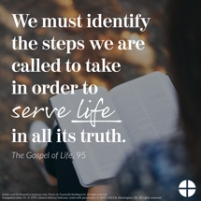  English | Spanish

Word of Life – March 2020

Bulletin Art
You are welcome to use these and other downloadable images from the online Respect Life image gallery, provided they are not altered in any way, other than the size. Thank you!
Sunday, March 1, 2020
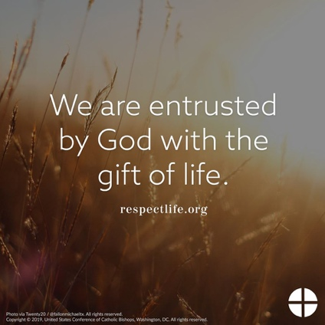
Download: English | Spanish

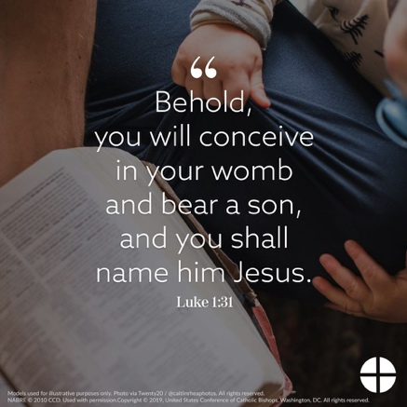
Sunday, March 22, 2020

Download: English | Spanish

Sunday, March 29, 2020
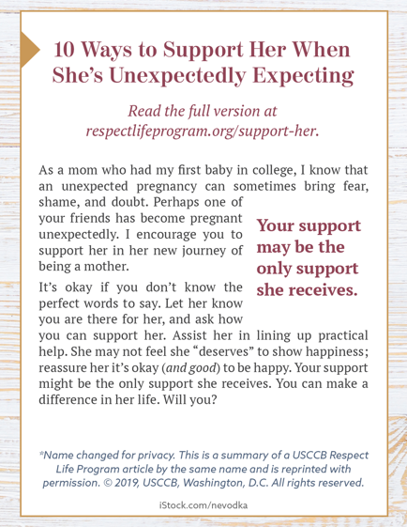
Bulletin Box: English | Spanish

