Social Media Tool Kit

Facebook
- Did you know that almost half of the United States is considered mission territory? Check out this map, and learn more! Support the Catholic Home Missions Appeal at Mass! #ChurchAtHome #1church1mission http://goo.gl/mtTxts
- Many dioceses right here in the United States do not have enough priests to serve their parishes. Your support of the Catholic Home Missions Appeal helps provide seminary formation for the next generation of priests. Support the collection at Mass! #ChurchAtHome #1church1mission http://goo.gl/mE2wWF
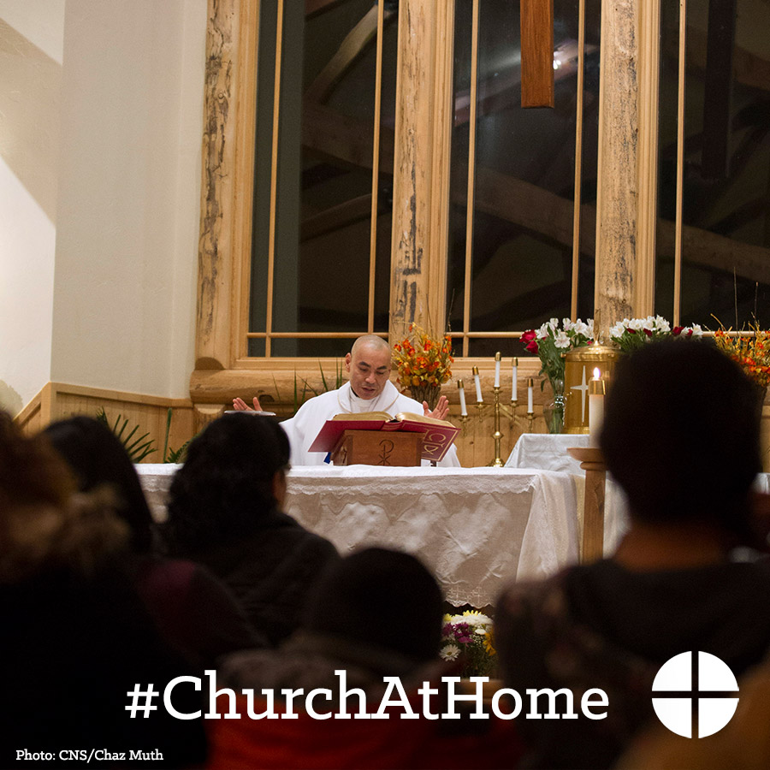

- Want to learn more about mission dioceses here in the U.S.? Check out the Neighbors newsletter and support the appeal at Mass! #ChurchAtHome #1church1mission www.usccb.org/home-missions
- This weekend is the Catholic Home Missions Appeal! Support the second collection this week at Mass! #ChurchAtHome #1church1mission www.usccb.org/home-missions
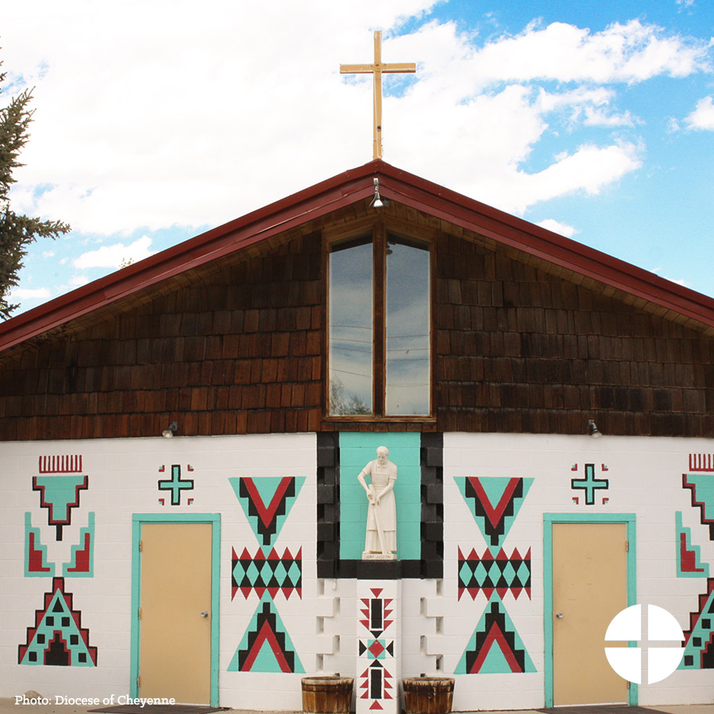

- Thank you for supporting the Catholic Home Missions Appeal last weekend. Your generosity will help Catholics across the United States! #ChurchAtHome #1church1mission www.usccb.org/home-missions

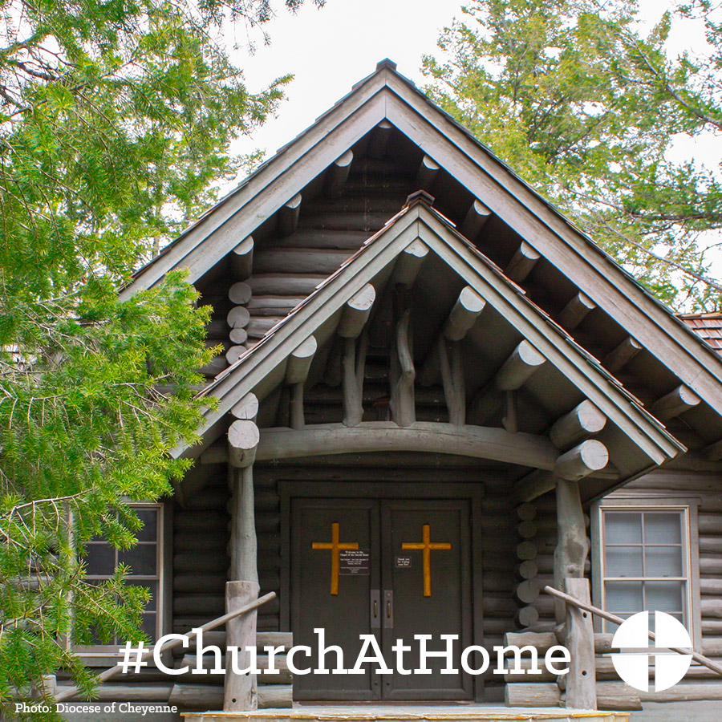

Twitter
- DYK almost half the US is mission territory? Support the Catholic Home Missions Appeal! #ChurchAtHome http://goo.gl/mtTxts
- Support the Catholic Home Missions Appeal at Mass & provide seminary formation for the next generation of priests. #ChurchAtHome
- Sign up for the Neighbors newsletter and learn more about Mission Territory, USA! #ChurchAtHome http://goo.gl/mE2wWF

- This weekend is the Catholic Home Missions Appeal! Support the second collection at Mass! #ChurchAtHome http://goo.gl/mE2wWF
- Thank you for supporting the Catholic Home Missions Appeal at Mass. Your generosity will help Catholics across the US! #ChurchAtHome

Instagram
- Did you know that almost half of the United States is considered mission territory? Support the Catholic Home Missions Appeal at Mass! #ChurchAtHome #1church1mission
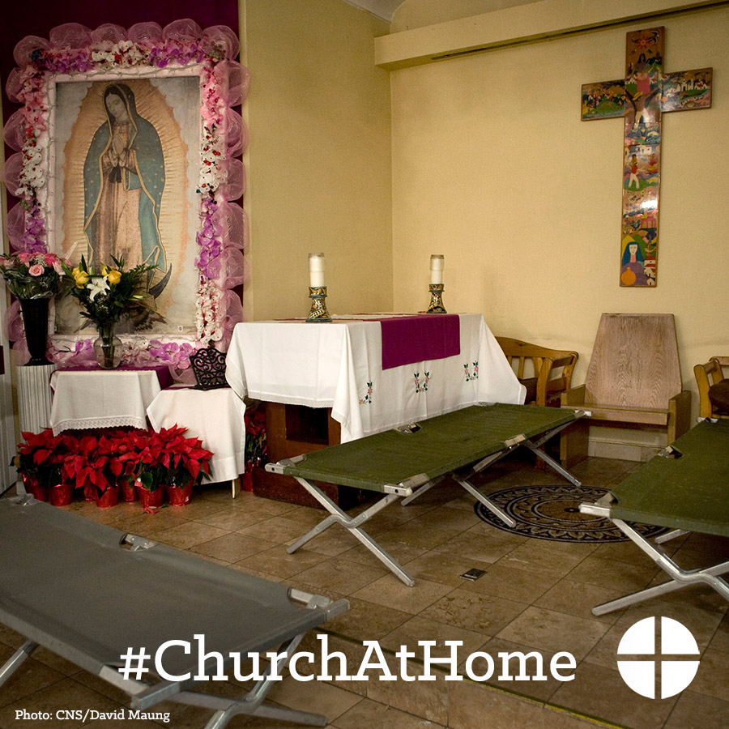
- Many dioceses right here in the United States do not have enough priests to serve their parishes. Your support of the Catholic Home Missions Appeal helps provide seminary formation for the next generation of priests. Support the collection at Mass! #ChurchAtHome #1church1mission

- This weekend is the Catholic Home Missions Appeal! Please be generous and support the second collection at Mass #ChurchAtHome #1church1mission
- Thank you for supporting the Catholic Home Missions Appeal last weekend. Your generosity will help Catholics across the United States! #ChurchAtHome

