Social Media Tool Kit

Post 1: Week Before the Collection
The link in the post directs one to the USCCB interactive home missions map. Be sure to copy the whole link!

Facebook/Twitter:
Did you know that almost half of the United States is considered mission territory? Check out this map, learn more, and support the Catholic Home Missions Appeal at Mass! #ChurchAtHome #1church1mission http://goo.gl/mtTxts

Post 2: Week of the Collection
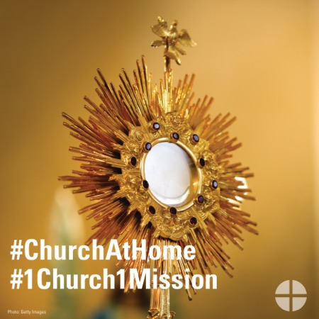
Facebook/Instagram:
Many dioceses in the U.S. do not have enough priests to serve their parishes. Your support of the Catholic Home Missions Appeal helps provide seminary formation for the next generation of priests. #ChurchAtHome #1church1mission http://goo.gl/mE2wWF

Post 3: Week of the Collection

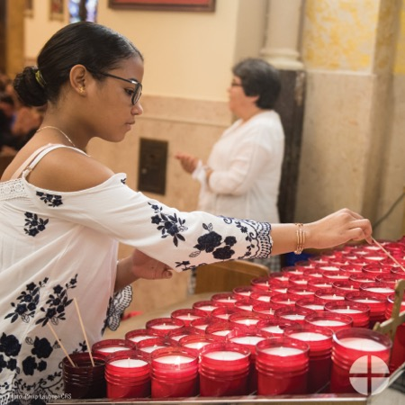

Facebook/Instagram/Twitter:
The Catholic Home Missions Appeal strengthens the #ChurchAtHome and supports pastoral projects here in the United States. Read more: www.usccb.org/home-missions

Post 4: Week of the Collection

Facebook/Instagram/Twitter:
Your support of the Catholic Home Missions Appeal strengthens the #ChurchAtHome. Prayerfully consider supporting the collection at Mass! #1church1mission www.usccb.org/home-missions

Post 5: Day of the Collection

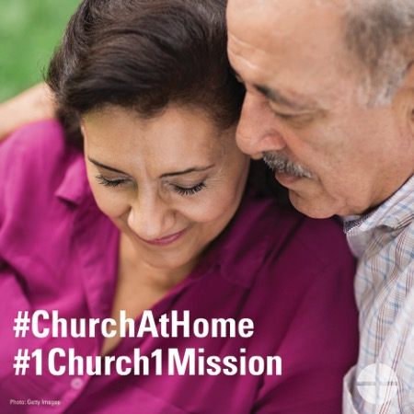

Facebook/Instagram:
This weekend is the Catholic Home Missions Appeal! Support the special collection this weekend at Mass! #ChurchAtHome #1church1mission: www.usccb.org/home-missions

