Social Media Toolkit

Post 1: Week Before the Collection
The link in the post directs one to the USCCB interactive home missions map. Be sure to copy the whole link!

Facebook:
Did you know that almost half of the United States is considered home mission territory? Check out this map, and learn more! Support the Catholic Home Missions Appeal at Mass! #ChurchAtHome #1church1mission http://goo.gl/mtTxts
Twitter:
DYK almost half the US is home mission territory? Support the Catholic Home Missions Appeal! #ChurchAtHome http://goo.gl/mtTxts

Post 2: Week of the Collection
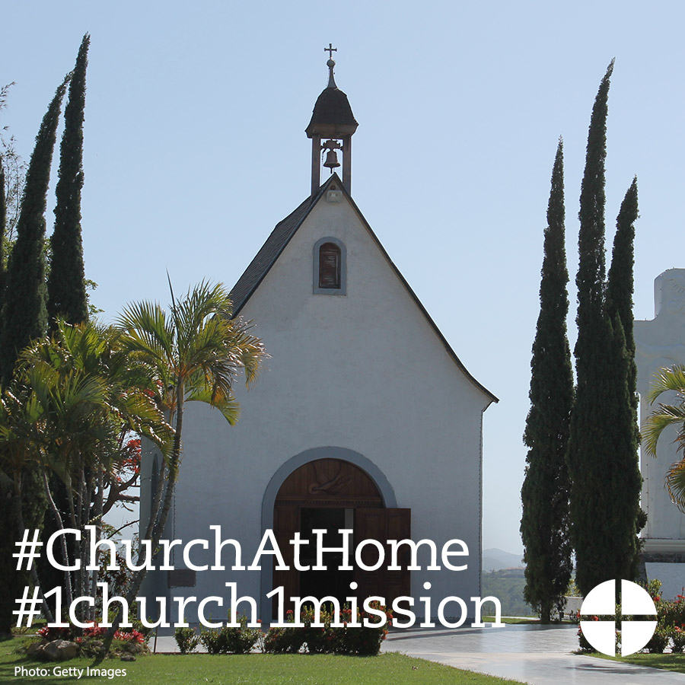
Facebook/Instagram:
Many dioceses right here in the United States do not have enough priests to serve their parishes. Your support of the Catholic Home Missions Appeal helps provide seminary formation for the next generation of priests. Support the collection at Mass! #ChurchAtHome #1church1mission http://goo.gl/mE2wWF
Twitter:
Support the Catholic Home Missions Appeal & provide seminary formation for the next generation of priests! #ChurchAtHome

Post 3: Week of the Collection
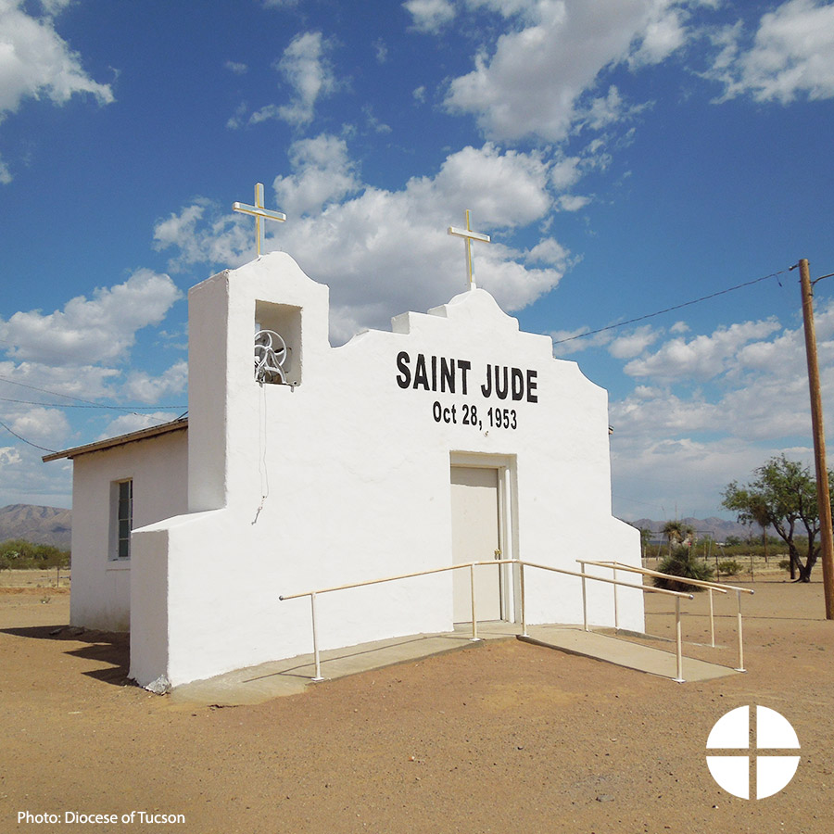
Facebook/Instagram:
The Catholic Home Missions Appeal strengthens the #ChurchAtHome and supports pastoral projects in needy dioceses here in the United States. Read more: www.usccb.org/home-missions
Twitter:
The Catholic Home Missions Appeal strengthens the #ChurchAtHome and supports pastoral projects in the US. www.usccb.org/home-missions

Post 4: Week of the Collection
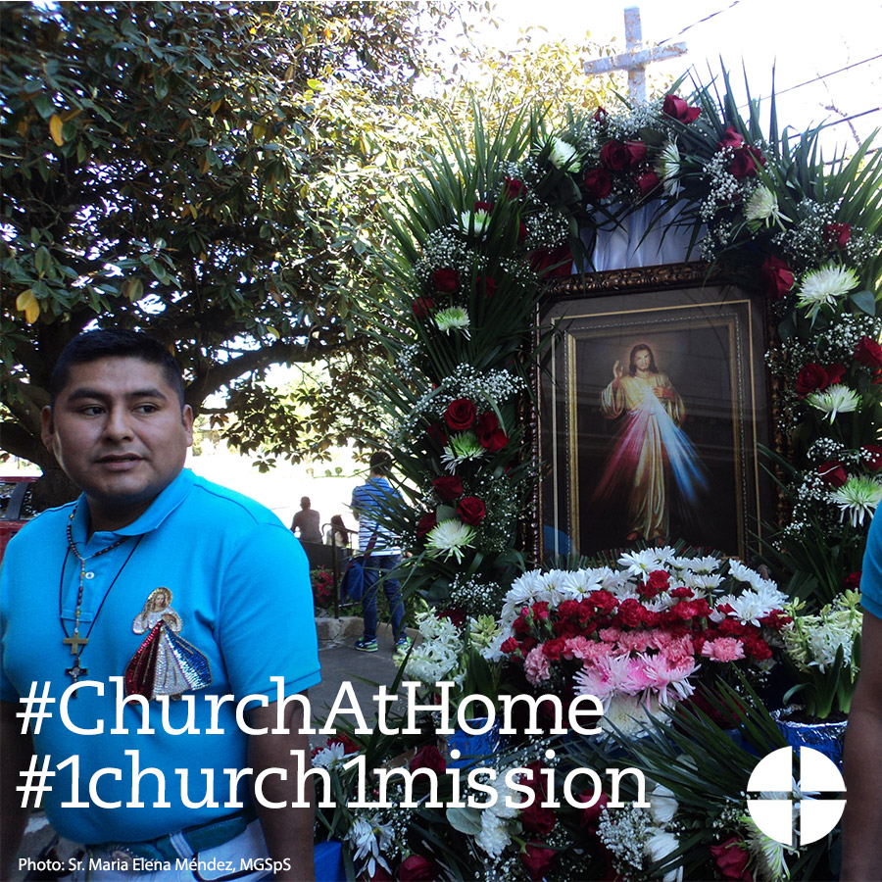
Facebook/Instagram:
Your support to the Catholic Home Missions Appeal strengthens the #ChurchAtHome. Prayerfully consider supporting the collection at Mass!
Twitter:
Your support to the Catholic Home Missions Appeal strengthens the #ChurchAtHome. Learn more: www.usccb.org/home-missions

Post 5: Day of the Collection

Facebook/Instagram:
This weekend is the Catholic Home Missions Appeal! Support the second collection this weekend at Mass! #ChurchAtHome #1church1mission www.usccb.org/home-missions
Twitter:
This weekend is the Catholic Home Missions Appeal! Support the second collection at Mass! #ChurchAtHome http://goo.gl/mE2wWF

