Social Media Toolkit

Facebook Profile Image
Facebook Banner Image

Post 1: Before the Collection

Facebook/Instagram:
The Catholic Relief Services collection supports six Catholic agencies that serve the vulnerable and marginalized at home and abroad. Support the collection at Mass! #JesusInDisguise #1church1mission http://goo.gl/943fOW
Twitter:
DYK donations to The Catholic Relief Services Collection support 6 organizations? #JesusInDisguise http://goo.gl/gbgmrk

Post 2: Before the Collection
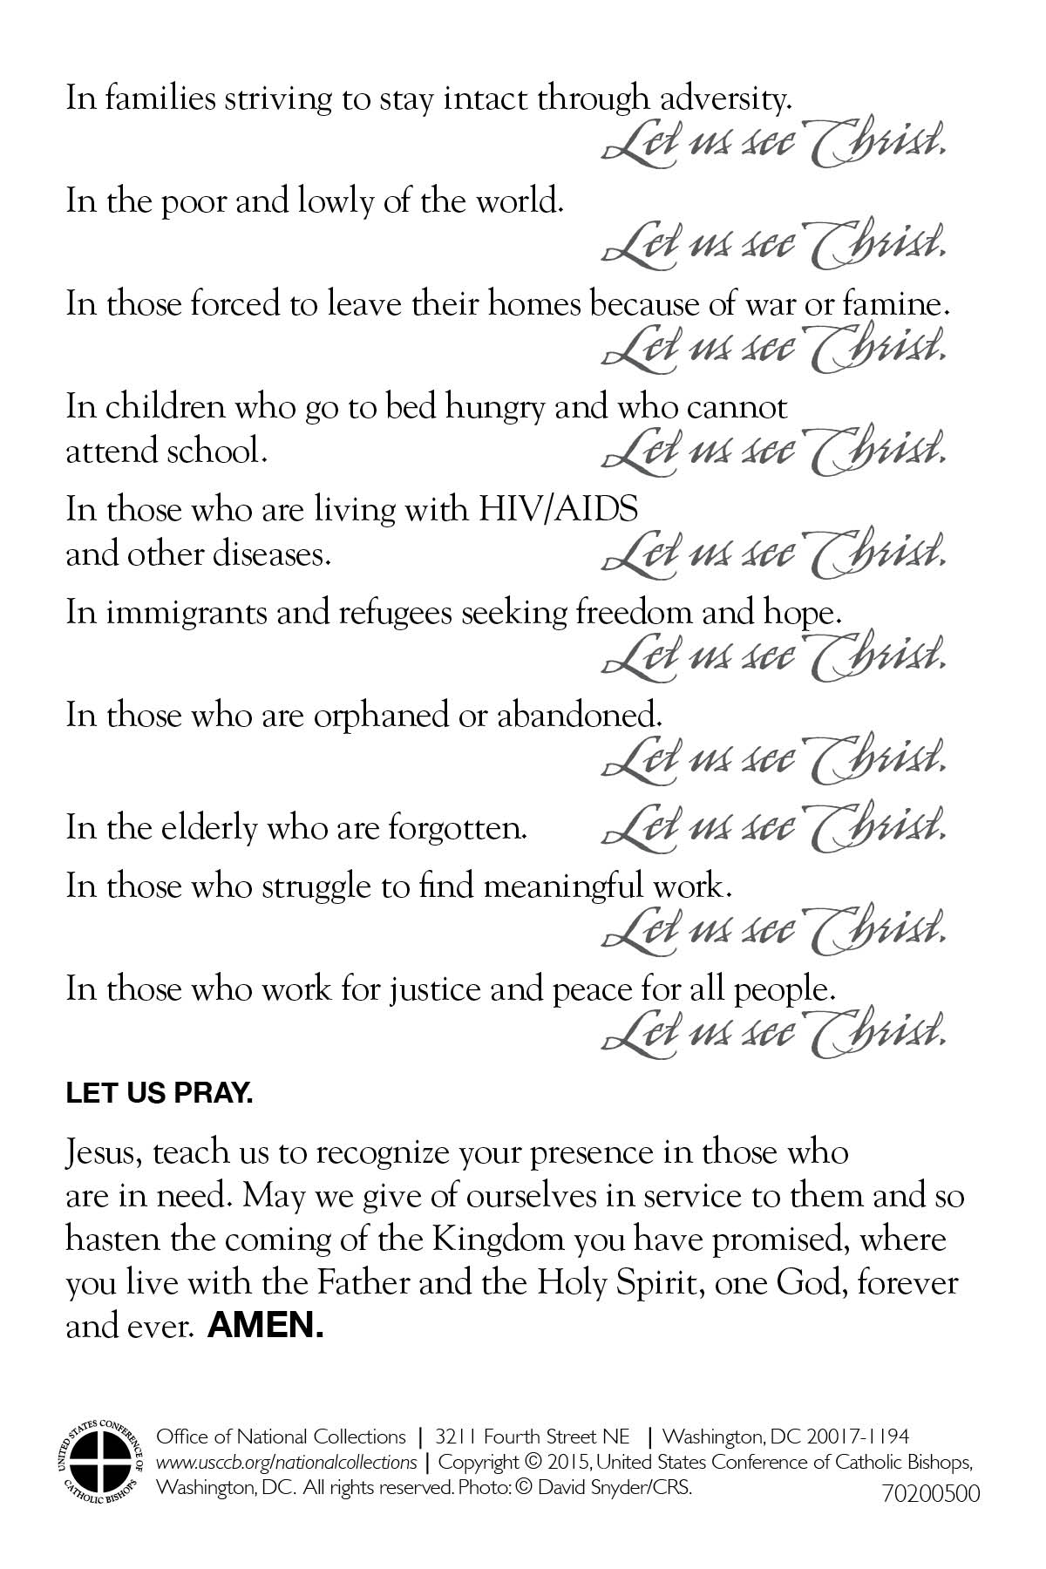
Facebook/Instagram:
Join us in praying for all those who benefit from The Catholic Relief Services Collection:
"Jesus, teach us to recognize your presence in those who are in need. May we give of ourselves in service to them and so hasten the coming of the Kingdom you have promised, where you live with the Father and the Holy Spirit, one God, forever and ever." #JesusInDisguise #1church1mission http://goo.gl/943fOW
Twitter:
Join us in praying for all those who benefit from The Catholic Relief Services Collection: http://goo.gl/943fOW

Post 3: Before the Collection
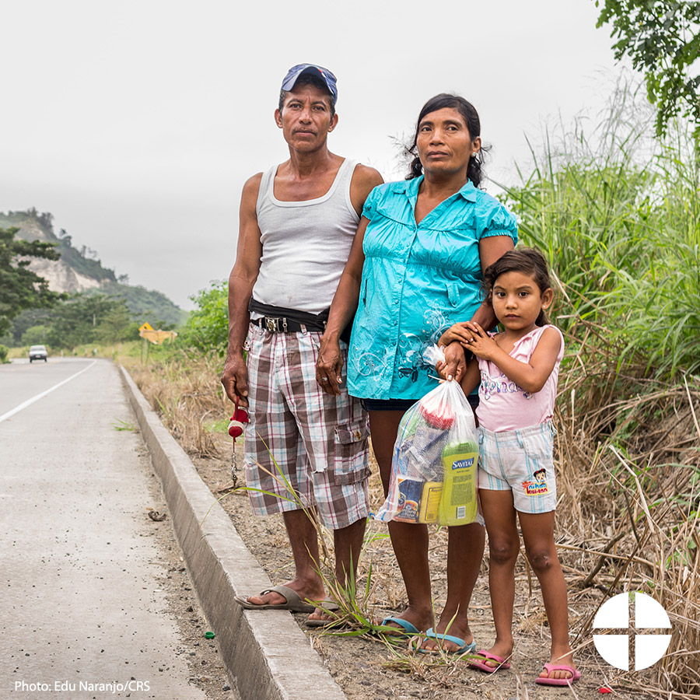
Facebook/Instagram:
In families trying to stay intact through adversity, let us see Christ. Support The Catholic Relief Services Collection at Mass! #JesusInDisguise #1church1mission http://goo.gl/943fOW
Twitter:
In families striving to stay intact through adversity, let us see Christ. Catholic Relief Services Collection is this week! #JesusInDisguise

Post 4: Before the Collection
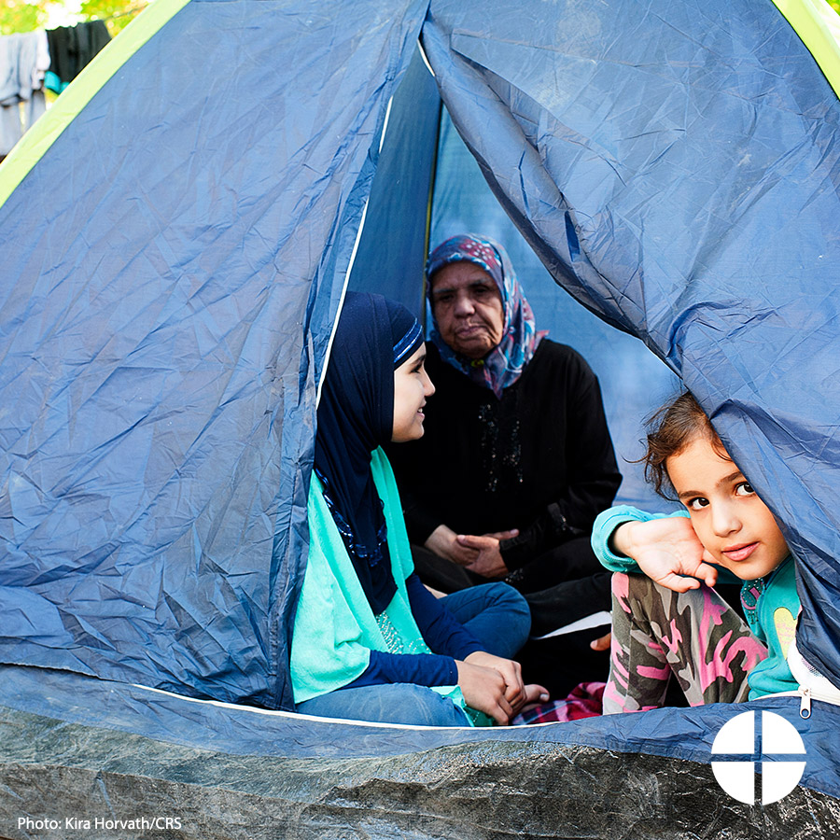
Facebook/Instagram:
In the poor and lowly of the world, let us see Christ. Support The Catholic Relief Services Collection at Mass, and help #JesusInDisguise #1church1mission http://goo.gl/943fOW
Twitter:
In the poor and lowly of the world, let us see Christ. Help #JesusInDisguise with The Catholic Relief Services Collection at Mass!

Post 5: Before the Collection
Facebook/Instagram:
In those forced to leave their homes because of war or famine, let us see Christ. Support The Catholic Relief Services Collection at Mass! #JesusInDisguise #1church1mission http://goo.gl/943fOW
Twitter:
In those forced to leave their homes because of war or famine, let us see Christ. #JesusInDisguise http://goo.gl/943fOW

Post 6: Before the Collection
Facebook/Instagram:
In children who go to bed hungry and who cannot attend school, let us see Christ. Help #JesusInDiguise, and support The Catholic Relief Services Collection at Mass! #1church1mission http://goo.gl/943fOW
Twitter:
In children who go to bed hungry and who cannot attend school, let us see Christ. Help #JesusInDiguise: http://goo.gl/943fOW

Post 7: Before the Collection
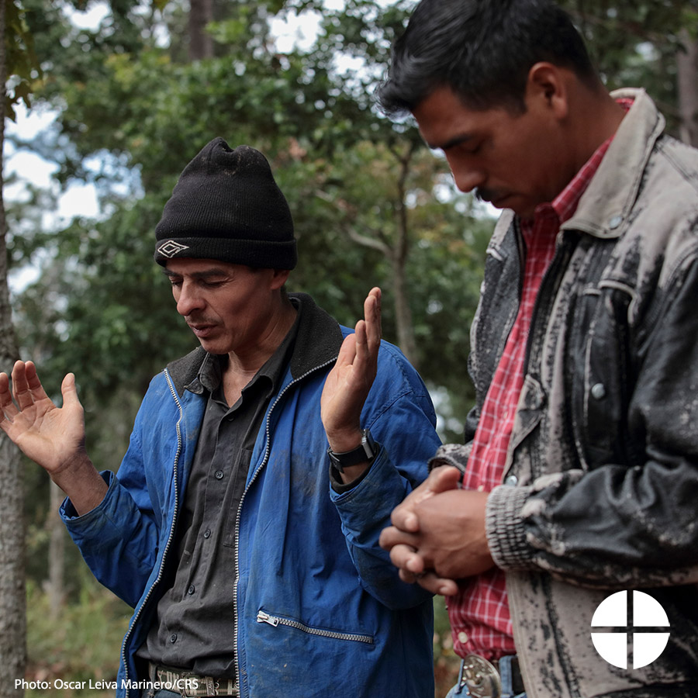
Facebook/Instagram:
In immigrants and refugees, seeking freedom and hope, let us see Christ. Help #JesusInDisguise, and support The Catholic Relief Services Collection at Mass. #1church1mission http://goo.gl/943fOW
Twitter:
In immigrants and refugees seeking freedom and hope, let us see Christ. Support the Catholic Relief Services Collection #JesusInDisguise

Post 8: Before the Collection
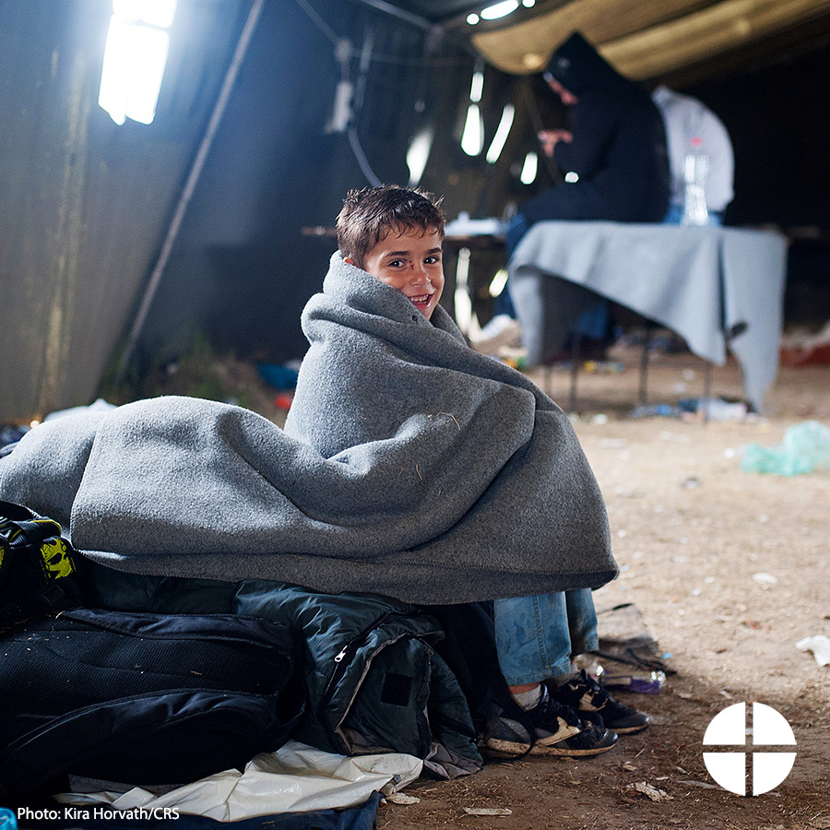
Facebook/Instagram:
In those who are orphaned or abandoned, let us see Christ. Support the Catholic Relief Services Collection at Mass! #JesusInDisguise #1church1mission http://goo.gl/943fOW
Twitter:
In those who are orphaned or abandoned, let us see Christ. Help #JesusInDisguise with The Catholic Relief Services Collection at Mass!

Post 9: Before the Collection
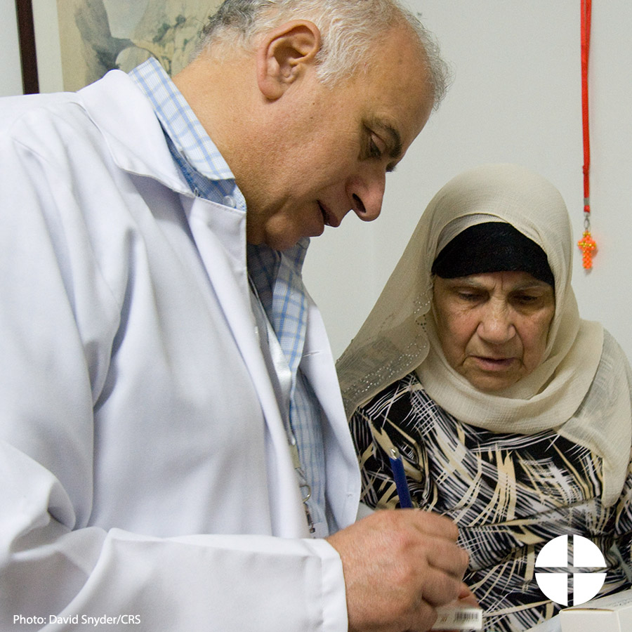
Facebook/Instagram:
In the elderly who are forgotten, let us see Christ. Support The Catholic Relief Services Collection at Mass, and help #JesusInDisguise #1church1mission http://goo.gl/943fOW
Twitter:
In the elderly who are forgotten, let us see Christ. Help #JesusInDisguise this weekend, and support our second collection.

Post 10: Week of the Collection
Facebook/Instagram:
In those who struggle to find meaningful work, let us see Christ. Support The Catholic Relief Services Collection at Mass this weekend! #JesusInDisguise #1church1mission
Twitter:
In those who struggle to find meaningful work, let us see Christ. Help #JesusInDisguise at Mass this weekend!

Post 11: Week of the Collection
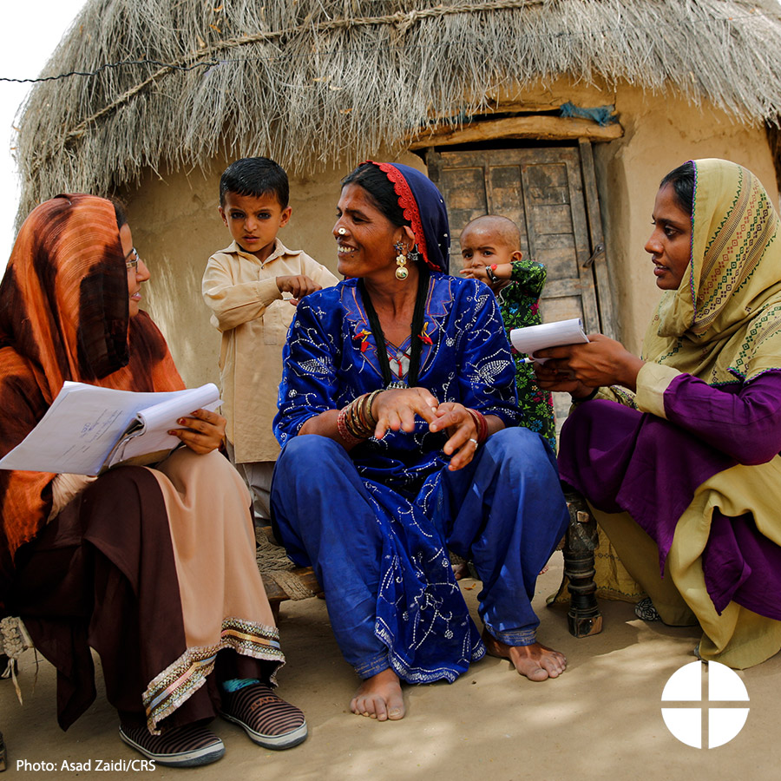
Facebook/Instagram:
In those who work for justice and peace for all people, let us see Christ. Please be generous to The Catholic Relief Services Collection at Mass! #JesusInDisguise #1church1mission
Twitter:
This weekend is the Catholic Relief Services Collection! Please be generous. #JesusInDisguise www.usccb.org/catholic-relief

Post 12: Week of the Collection
Facebook/Instagram:
Next week, we will be taking up The Catholic Relief Services Collection. Please prayerfully consider supporting this collection at Mass! #JesusInDisguise
Twitter:
Next week, we will be taking the Catholic Relief Services Collection. Please be generous. #JesusInDisguise www.usccb.org/catholic-relief

Post 13: Week of the Collection
Facebook/Twitter/Instagram:
We are taking The Catholic Relief Services Collection this weekend. Learn more, and help #JesusInDiguise http://goo.gl/gbgmrk

Post 14: Week of the Collection
Facebook/Twitter/Instagram:
The Catholic Relief Services Collection is this weekend! Support this collection, and help #JesusInDisguise www.usccb.org/catholic-relief

Post 15: Day of the Collection
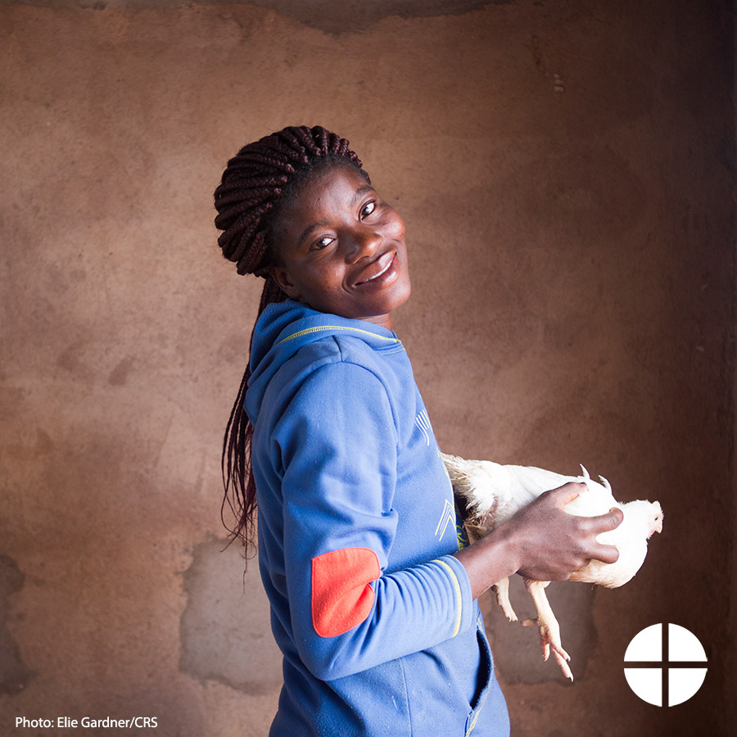
Facebook/Twitter/Instagram:
Today is The Catholic Relief Services Collection! Thank you for helping #JesusInDisguise www.usccb.org/catholic-relief

