Social Media Tool Kit

Meme Image

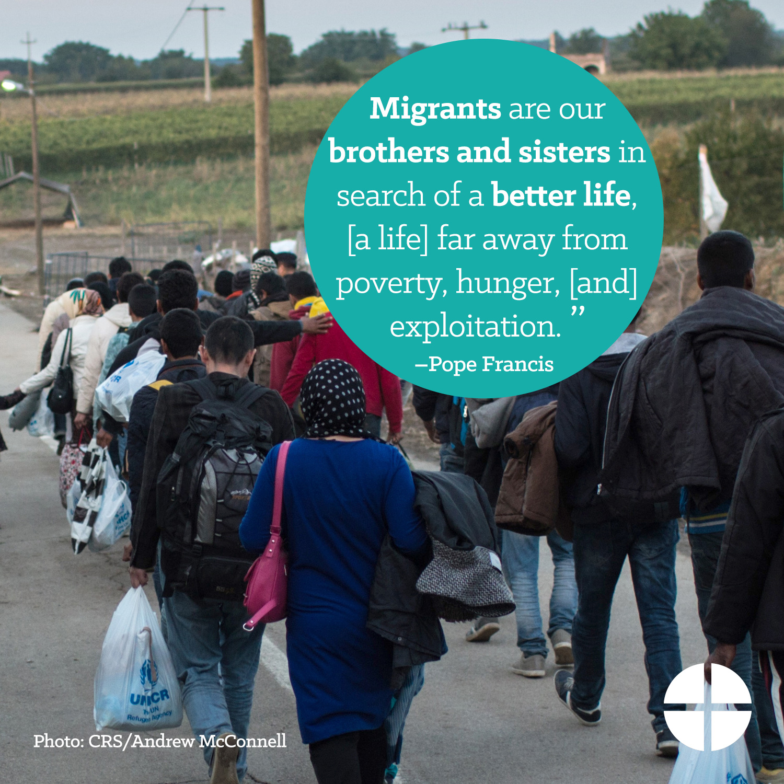

Facebook Profile Image

Facebook Banner Image

Facebook
- The Catholic Relief Services collection supports six Catholic agencies that serve the vulnerable and marginalized at home and abroad. Support the collection at Mass! #JesusInDisguise #1church1mission http://goo.gl/943fOW

- Join us in praying for all those who benefit from The Catholic Relief Services Collection:

“Jesus, teach us to recognize your presence in those who are in need. May we give of ourselves in service to them and so hasten the coming of the Kingdom you have promised, where you live with the Father and the Holy Spirit, one God, forever and ever.” #JesusInDisguise #1church1mission http://goo.gl/943fOW

- In families trying to stay intact through adversity, let us see Christ. Support The Catholic Relief Services Collection at Mass! #JesusInDisguise #1church1mission http://goo.gl/943fOW
- In the poor and lowly of the world, let us see Christ. Support The Catholic Relief Services Collection at Mass and help #JesusInDisguise #1church1mission http://goo.gl/943fOW
- In those forced to leave their homes because of war or famine, let us see Christ. Support The Catholic Relief Services Collection at Mass! #JesusInDisguise #1church1mission http://goo.gl/943fOW
- In children who go to bed hungry and who cannot attend school, let us see Christ. Help #JesusInDiguise and support The Catholic Relief Services Collection at Mass! #1church1mission http://goo.gl/943fOW
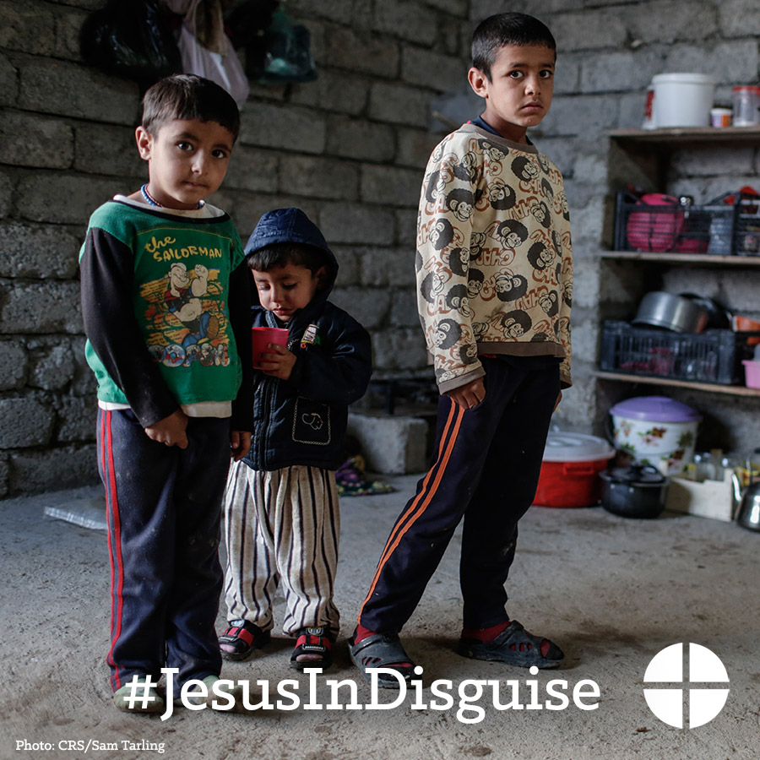
- In immigrants and refugees, seeking freedom and hope, let us see Christ. Help #JesusInDisguise and support The Catholic Relief Services Collection at Mass. #1church1mission http://goo.gl/943fOW
- In those who are orphaned or abandoned, let us see Christ. Support The Catholic Relief Services Collection at Mass! #JesusInDisguise #1church1mission http://goo.gl/943fOW
- In the elderly who are forgotten, let us see Christ. Support The Catholic Relief Services Collection at Mass and help #JesusInDisguise #1church1mission http://goo.gl/943fOW
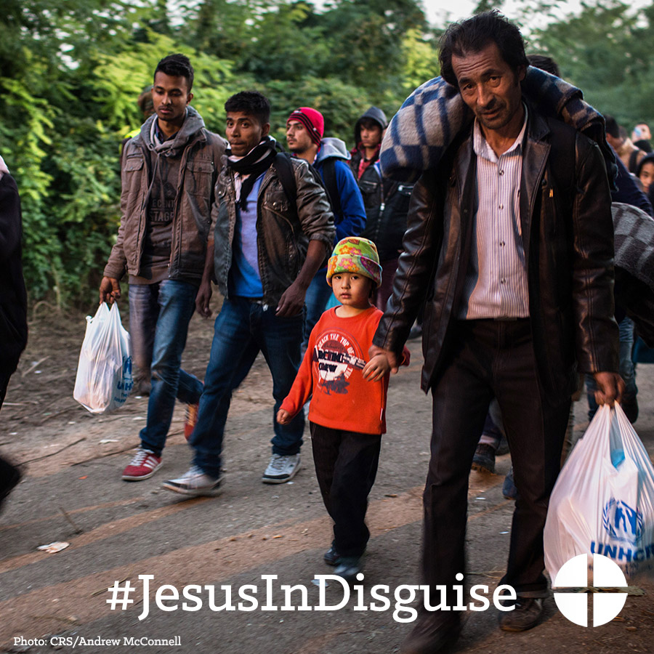
- In those who struggle to find meaningful work, let us see Christ. Support The Catholic Relief Services Collection at Mass this weekend! #JesusInDisguise #1church1mission
- In those who work for justice and peace for all people, let us see Christ. Please be generous to The Catholic Relief Services Collection at Mass! #JesusInDisguise #1church1mission
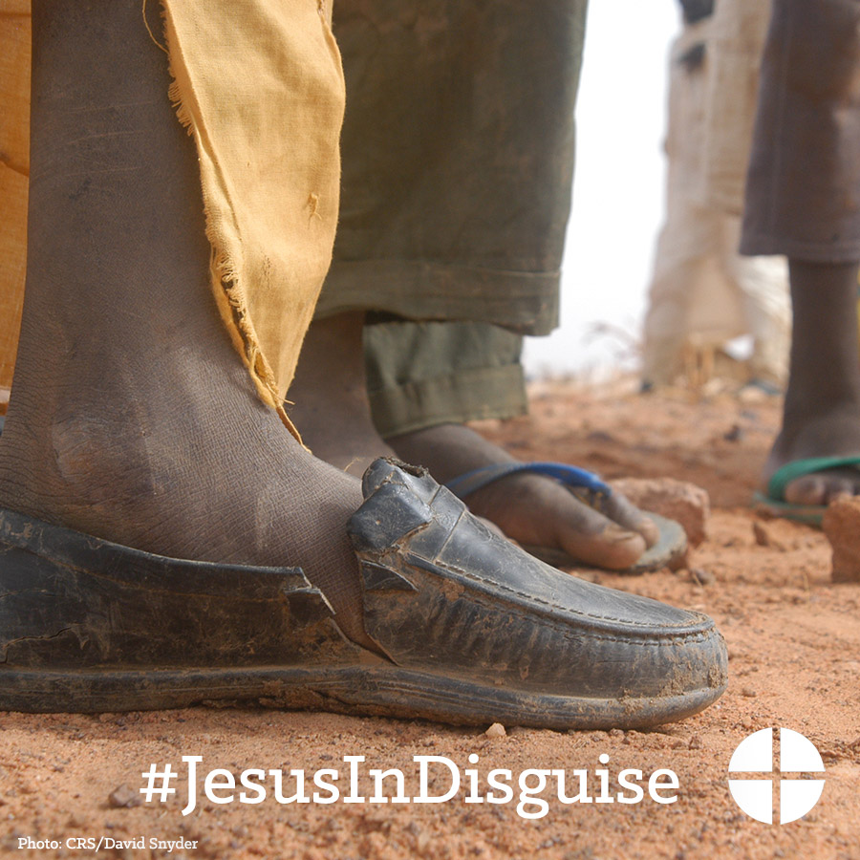
- Next week, we will be taking up The Catholic Relief Services Collection. Please prayerfully consider supporting this collection at Mass! #JesusInDisguise #1church1mission
- The Catholic Relief Services Collection is this weekend! Support this collection and help #JesusInDisguise

- Today is The Catholic Relief Services Collection! Thank you for helping #JesusInDisguise

Twitter
- DYK donations to The Catholic Relief Services Collection support 6 organizations? #JesusInDisguise http://goo.gl/gbgmrk
- In the poor and lowly of the world, let us see Christ. Help #JesusInDisguise with The Catholic Relief Services Collection at Mass!
- In immigrants and refugees seeking freedom and hope, let us see Christ. Support The Catholic Relief Services Collection. #JesusInDisguise
- In those who are orphaned or abandoned, let us see Christ. Help #JesusInDisguise with The Catholic Relief Services Collection at Mass!
- In families striving to stay intact through adversity, let us see Christ. Catholic Relief Services Collection is this week! #JesusInDisguise
- In the elderly who are forgotten, let us see Christ. Help #JesusInDisguise this weekend and support our second collection.

- In those who struggle to find meaningful work, let us see Christ. Help #JesusInDisguise at Mass this weekend!
- We are taking The Catholic Relief Services Collection this weekend, learn more and help #JesusInDiguise http://goo.gl/gbgmrk
- The Catholic Relief Services Collection is this weekend! Support this collection and help #JesusInDisguise
- Today is The Catholic Relief Services Collection! Thank you for helping #JesusInDisguise

Instagram
- The Catholic Relief Services Collection supports six Catholic agencies that serve the vulnerable and marginalized at home and abroad. Support the collection at Mass! #JesusInDisguise #1church1mission
- Join us in praying for all those who benefit from The Catholic Relief Services Collection:

“Jesus, teach us to recognize your presence in those who are in need. May we give of ourselves in service to them and so hasten the coming of the Kingdom you have promised, where you live with the Father and the Holy Spirit, one God, forever and ever.” #JesusInDisguise #1church1mission

- In families trying to stay intact through adversity, let us see Christ. Support The Catholic Relief Services Collection at Mass! #JesusInDisguise #1church1mission

- In the poor and lowly of the world, let us see Christ. Support The Catholic Relief Services Collection at Mass! #JesusInDisguise #1church1mission

- In those forced to leave their homes because of war or famine, let us see Christ. Support The Catholic Relief Services Collection at Mass! #JesusInDisguise #1church1mission
- In children who go to bed hungry and who cannot attend school, let us see Christ. Support The Catholic Relief Services Collection at Mass! #JesusInDisguise #1church1mission

- In immigrants and refugees, seeking freedom and hope, let us see Christ. Support The Catholic Relief Services Collection at Mass! #JesusInDisguise #1church1mission
- In those who are orphaned or abandoned, let us see Christ. Support The Catholic Relief Services Collection at Mass! #JesusInDisguise #1church1mission

- In the elderly who are forgotten, let us see Christ. Support The Catholic Relief Services Collection at Mass and help #JesusInDisguise #1church1mission
- In those who struggle to find meaningful work, let us see Christ. Support The Catholic Relief Services Collection at Mass this weekend! #JesusInDisguise #1church1mission

- In those who work for justice and peace for all people, let us see Christ. Support The Catholic Relief Services Collection at Mass! #JesusInDisguise #1church1mission

- Next week, we will be taking up The Catholic Relief Services Collection. Please prayerfully consider supporting this collection at Mass! #JesusInDisguise #1church1mission

