Social Media Tool Kit

Facebook
- Did you know that the Collection for the Church in Central and Eastern Europe helps the Church in over 20 countries, many of which were formerly under communist rule? Support the collection and #BuildTheFuture! #1church1mission http://goo.gl/1gbOF1
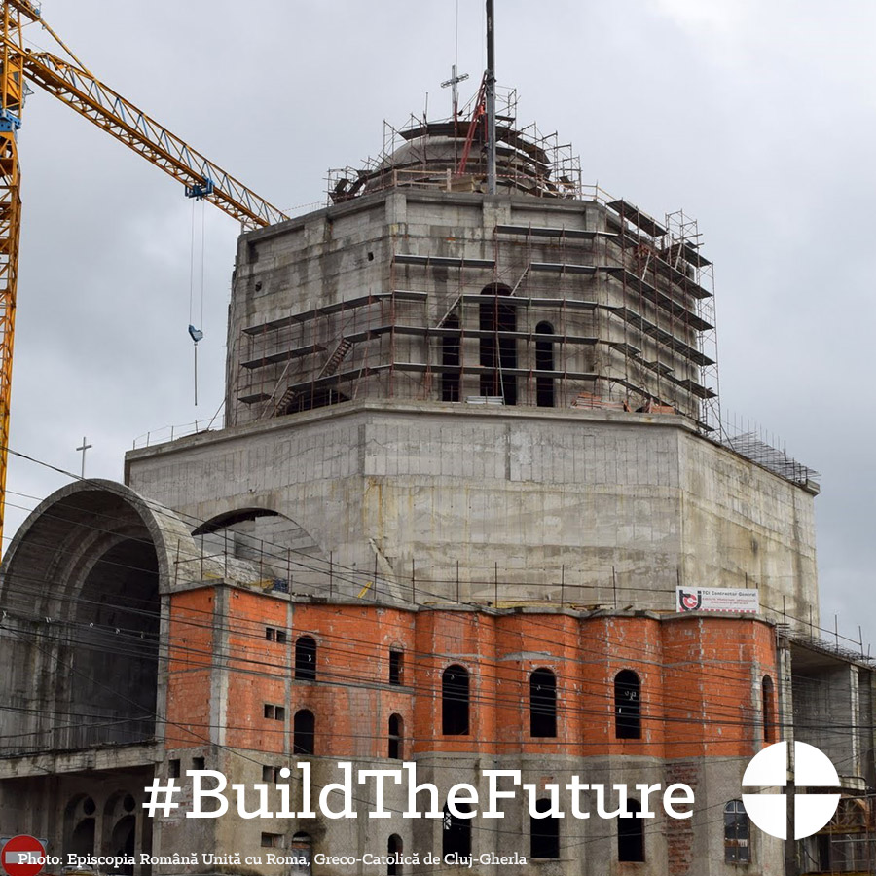

- The Church is Central and Eastern Europe has struggled to rebuild in the aftermath of communist rule. Learn more and support the collection at Mass! #BuildTheFuture #1church1mission http://goo.gl/1gbOF1
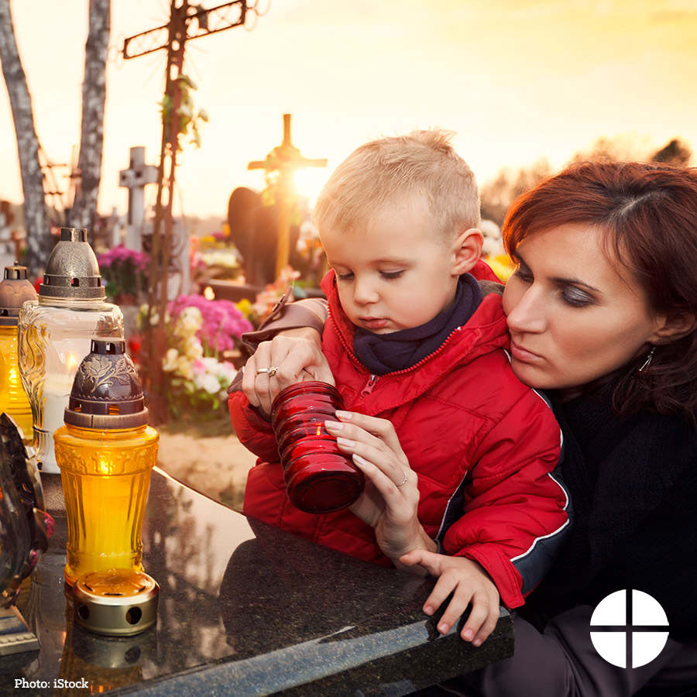

- Meet Artyom, David, Levon, Sevak, and Shoghik. These children attend Aregak Daycare Center in Armenia, a safe place for children with special needs. Construction of this center would not have been possible without the Collection for the Church in Central and Eastern Europe. Support this national collection at Mass! #BuildTheFuture #1church1mission https://goo.gl/4GStfv
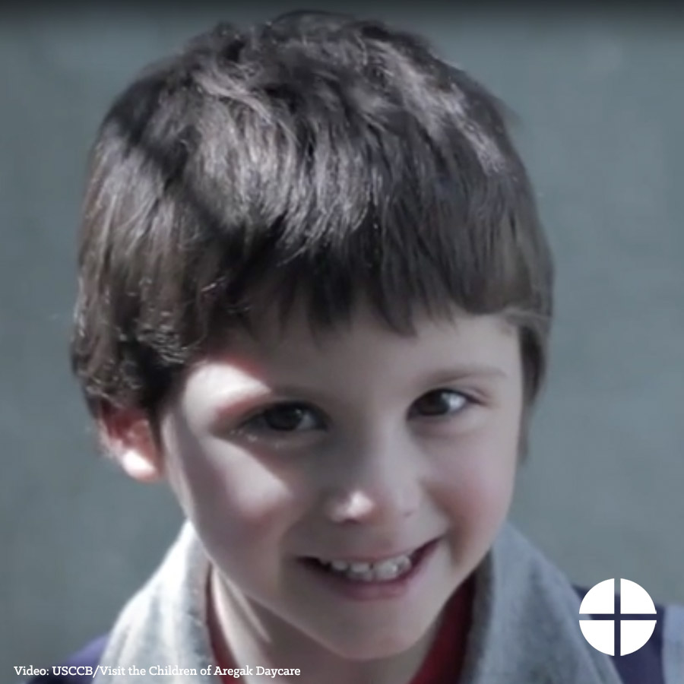

- Your gift to the Collection for the Church in Central and Eastern Europe makes a difference for those living in former communist countries. Please prayerfully consider how you can support the collection this year! #BuildTheFuture #1church1mission http://goo.gl/1gbOF1
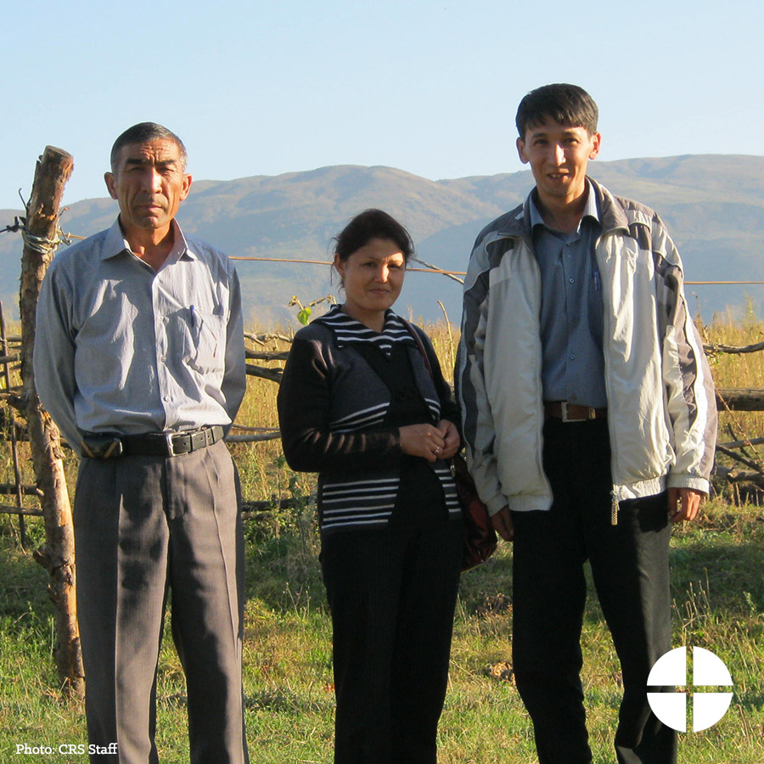

- This weekend our second collection is for the Church in Central and Eastern Europe! Please be generous. #BuildTheFuture #1church1mission http://goo.gl/1gbOF1
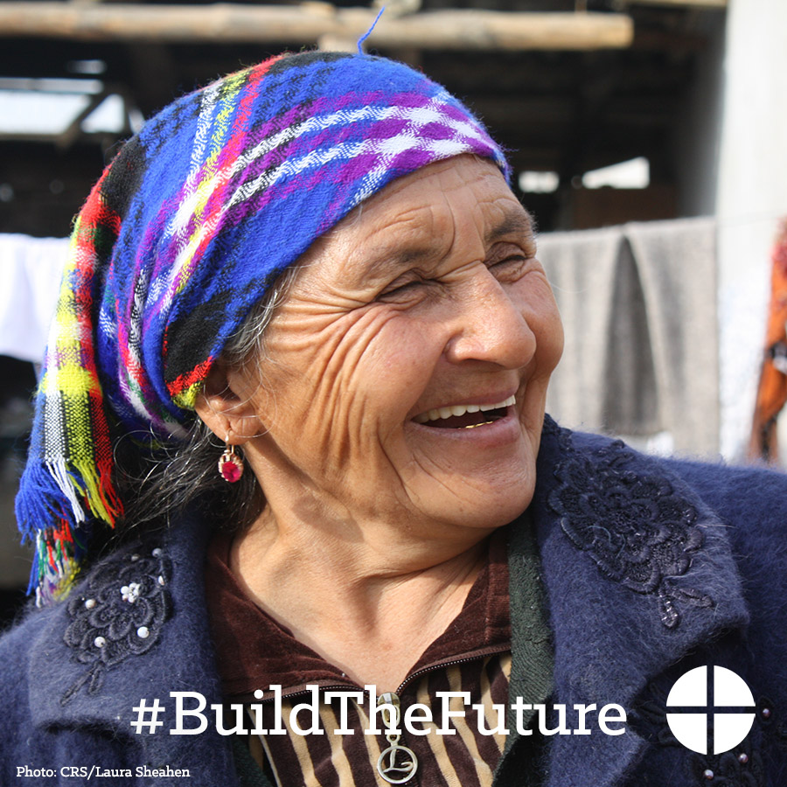

Twitter
- DYK the Collection for Church in Central & Eastern Europe helps the Church in former communist countries rebuild? http://goo.gl/1gbOF1
- Prayerfully consider supporting the Collection for the Church in Central & Eastern Europe at Mass! #BuildTheFuture http://goo.gl/1gbOF1
- Aregak Daycare Center is possible through the Collection for the Church in Central and Eastern Europe. https://goo.gl/4GStfv

- Gifts to the Collection for the Church in Central and Eastern Europe make a difference. See how: http://goo.gl/1gbOF1 #BuildTheFuture
- This weekend our 2nd collection is for the Church in Central and Eastern Europe! Please be generous #BuildTheFuture http://goo.gl/1gbOF1

Instagram
- Did you know that the Collection for the Church in Central and Eastern Europe helps the Church in over 20 countries, many of which were formerly under communist rule? Support the collection and #BuildTheFuture! #1church1mission

- The Church in Central and Eastern Europe has struggled to rebuild in the aftermath of communist rule. Support the collection at Mass! #BuildTheFuture #1church1mission

- Your gift to the Collection for the Church in Central and Eastern Europe makes a difference for those living in former communist countries. Please prayerfully consider how you can support the collection this year! #BuildTheFuture #1church1mission

- Meet the children of Aregak Daycare Center in Armenia, a safe place for children with special needs. Construction of this center would not have been possible without the Collection for the Church in Central and Eastern Europe. Support our second collection at Mass! #BuildTheFuture #1church1mission

- This weekend, our second collection is for the Church in Central and Eastern Europe! Please be generous. #BuildTheFuture #1church1mission

