Social Media Toolkit

Post 1: Before the Collection
Facebook/Instagram:
Your gift to the Collection for the Church in Central and Eastern Europe makes a difference for those living in former communist countries. Please prayerfully consider how you can support the collection this year! #BuildTheFuture #1church1mission http://goo.gl/1gbOF1

Twitter:
Gifts to the Collection for the Church in Central and Eastern Europe make a difference. See how: http://goo.gl/1gbOF1 #BuildTheFuture

Post 2: Before the Collection
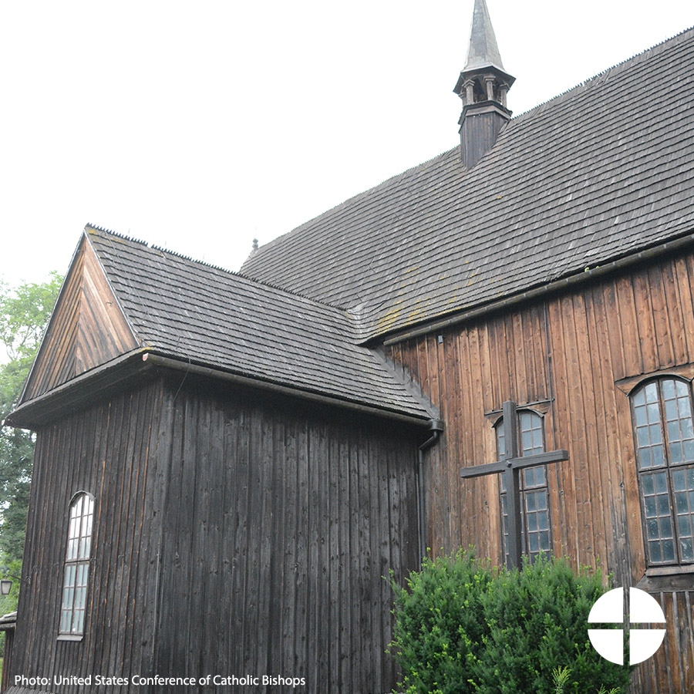
Facebook/Instagram:
Did you know that the Collection for the Church in Central and Eastern Europe helps the Church in over 25 countries, many of which were formerly under communist rule? Support the collection and #BuildTheFuture! #1church1mission http://goo.gl/1gbOF1

Twitter:
DYK the Collection for Church in Central & Eastern Europe helps the Church in former communist countries rebuild? http://goo.gl/1gbOF1

Post 3: Week of the Collection
Facebook/Instagram:
The Church in Central and Eastern Europe has struggled to rebuild in the aftermath of communist rule. Learn more and support the collection at Mass! #BuildTheFuture #1church1mission http://goo.gl/1gbOF1

Twitter:
Prayerfully consider supporting the Collection for the Church in Central & Eastern Europe at Mass! #BuildTheFuture http://goo.gl/1gbOF1

Post 4: Week of the Collection
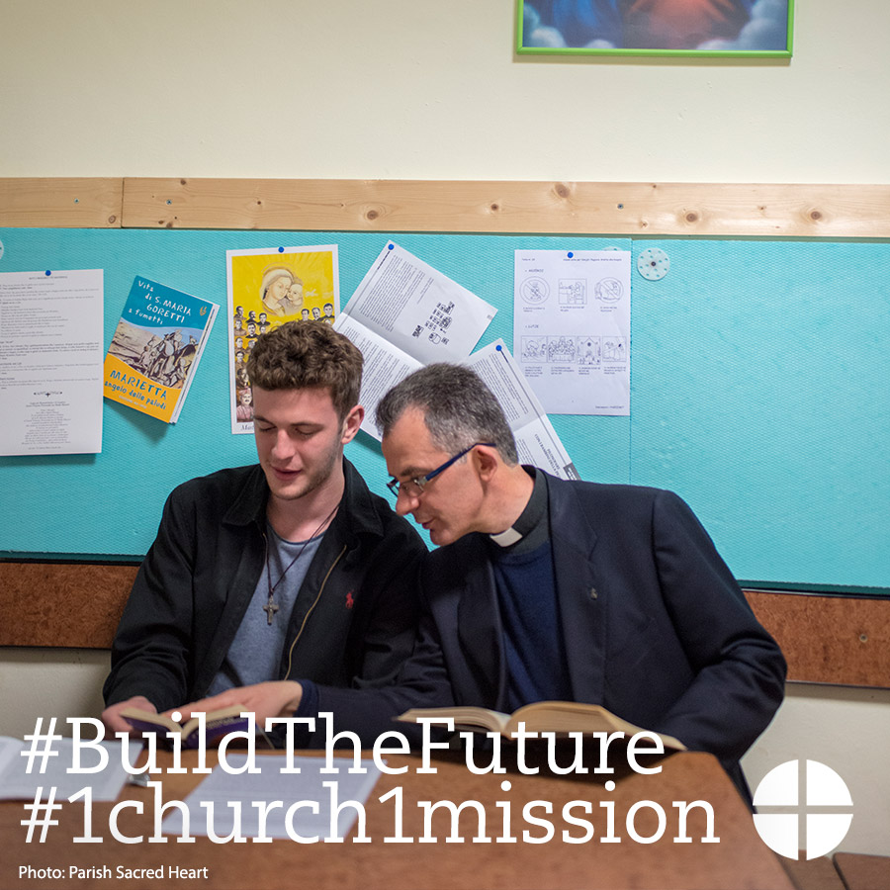
Facebook/Instagram:
Supporting the Collection for the Church in Central and Eastern Europe will help to #BuildTheFuture for generations of Catholics to come. Learn more at www.usscb.org/ccee
#1church1mission
Twitter:
Supporting the Collection for the Church in Central & Eastern Europe helps #BuildTheFuture for generations to come. www.usccb.org/ccee

Post 5: Day of the Collection
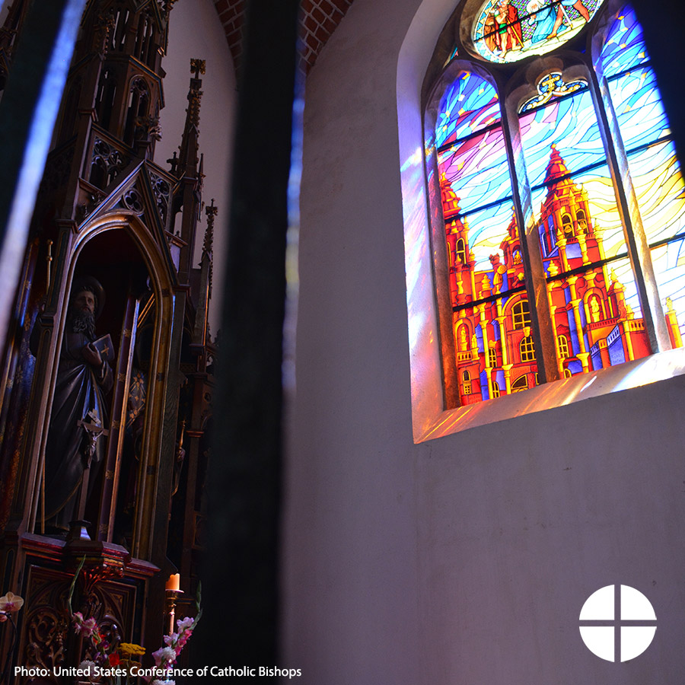
Facebook/Instagram:
This weekend our second collection is for the Church in Central and Eastern Europe! Please be generous. #BuildTheFuture #1church1mission http://goo.gl/1gbOF1

Twitter:
This weekend our 2nd collection is for the Church in Central and Eastern Europe! Please be generous #BuildTheFuture http://goo.gl/1gbOF1

