Social Media Toolkit

Post 1: Before the Collection
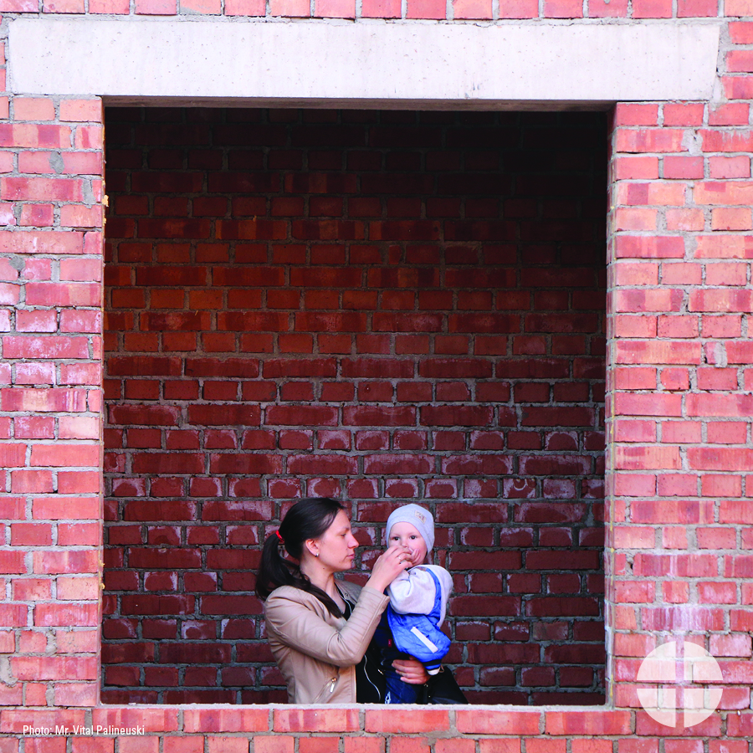
Facebook/Instagram/Twitter:
Your gift to the Collection for the Church in Central and Eastern Europe makes a difference for those living in former communist countries. Please prayerfully consider how you can support the collection this year! #BuildTheFuture #1church1mission www.usscb.org/ccee

Post 2: Before the Collection
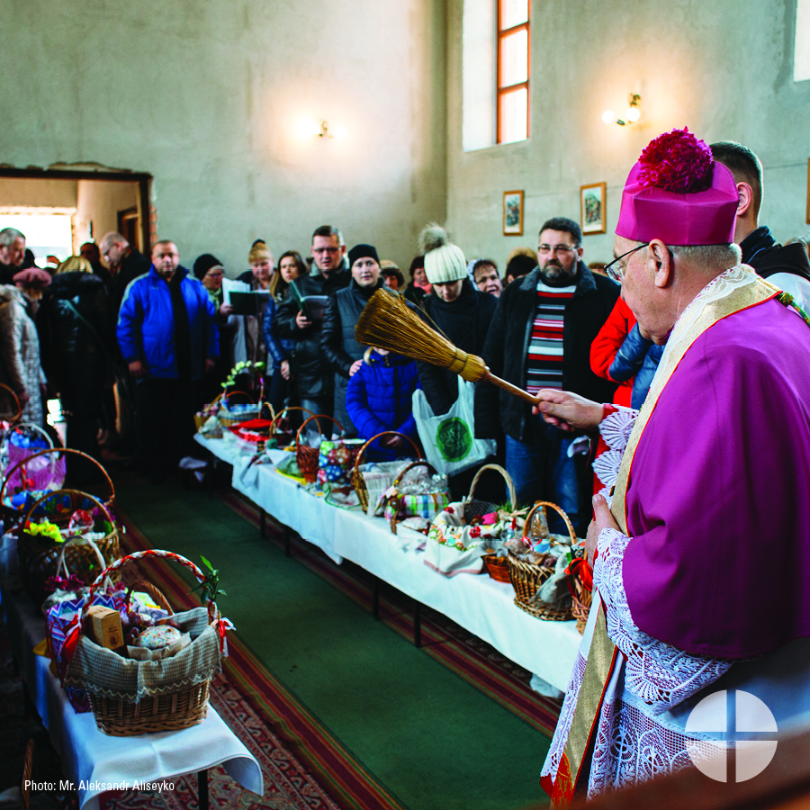
Facebook/Instagram:
Did you know that the Collection for the Church in Central and Eastern Europe helps the Church in more than 20 countries, many of which were formerly under communist rule? Support the collection and #BuildTheFuture! #1church1mission www.usscb.org/ccee

Post 3: Week of the Collection
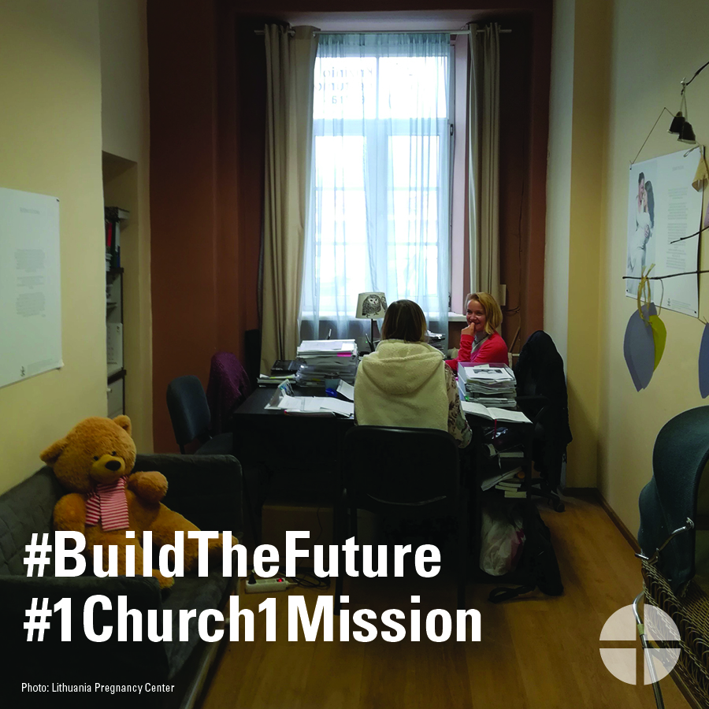
Facebook/Instagram/Twitter:
The Church in Central and Eastern Europe has struggled to rebuild in the aftermath of communist rule. Learn more and support the collection at Mass! #BuildTheFuture #1church1mission www.usscb.org/ccee

Post 4: Week of the Collection
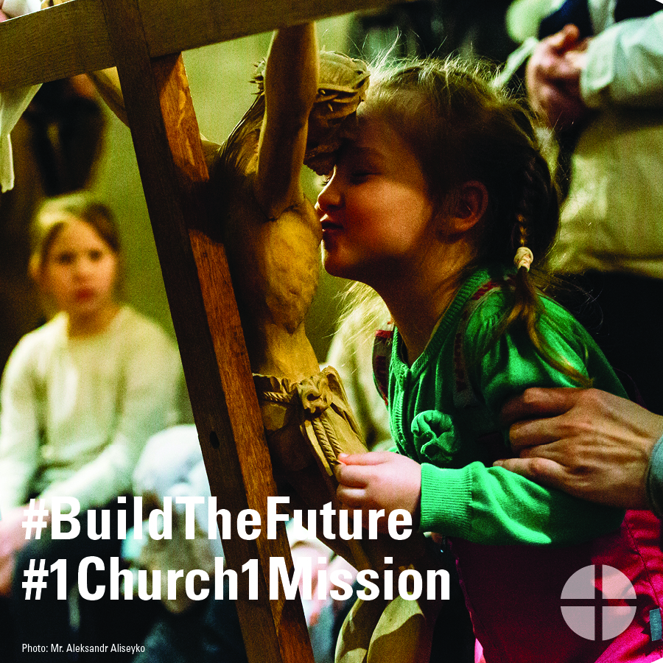
Facebook/Instagram/Twitter:
Support the Collection for the Church in Central and Eastern Europe. Help #BuildTheFuture for generations of Catholics to come. Learn more at www.usscb.org/ccee #1church1mission

Post 5: Day of the Collection
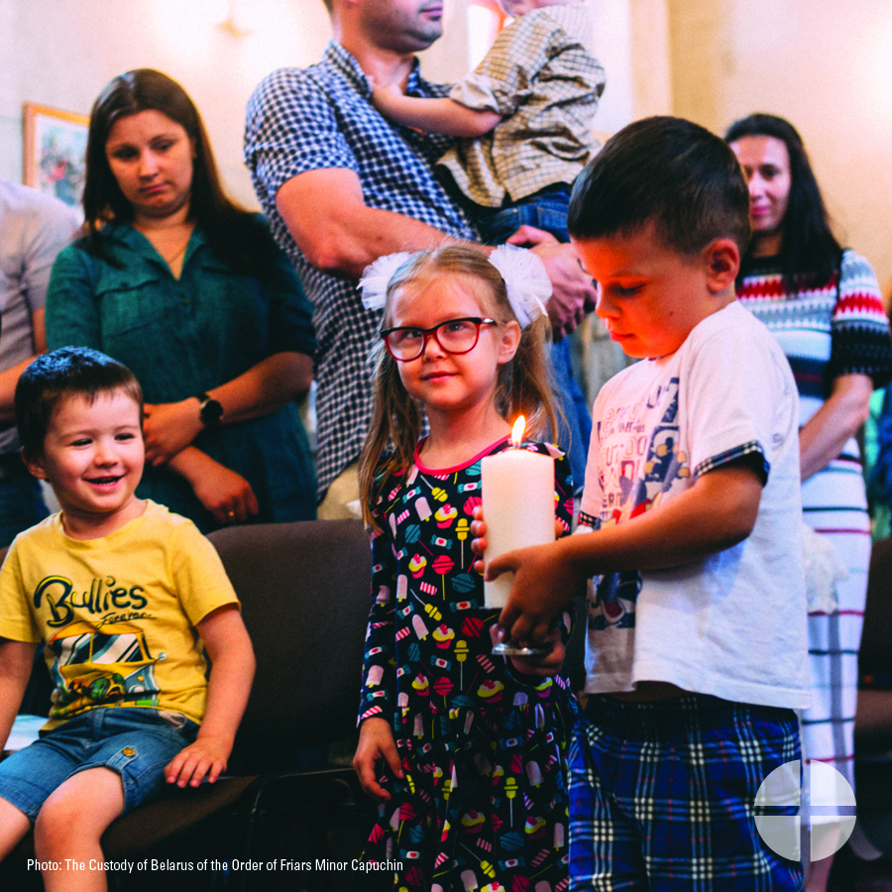
Facebook/Instagram/Twitter:
This weekend our special collection supports the Church in Central and Eastern Europe! Please be generous. #BuildTheFuture #1church1mission www.usscb.org/ccee

