Social Media Toolkit

Post 1: Before the Collection
The link in the posts leads to a video. Be sure to copy the whole link and the video will automatically be linked on Facebook and Twitter!
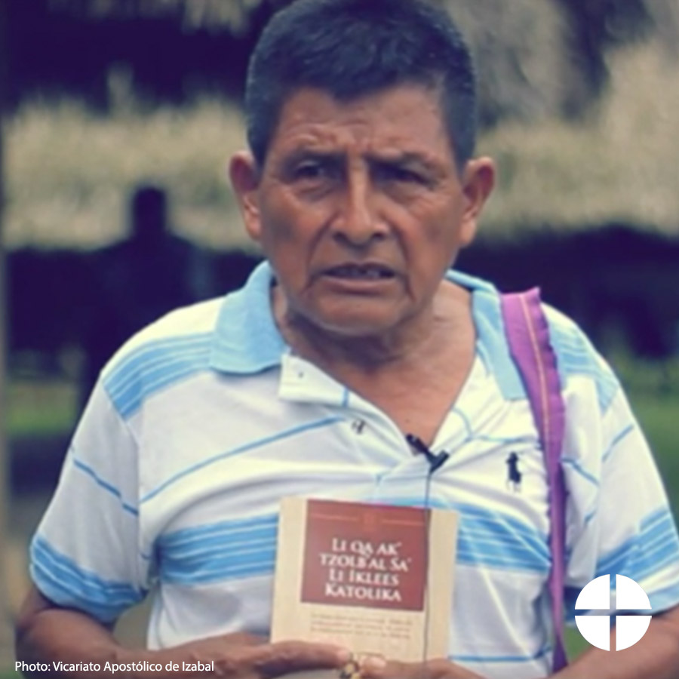
Facebook:
Check out how you helped translate the catechism into the Mayan language Q’eqchi’ for the first time through the Collection for the Church in Latin America! #ShareYourFaith #1church1mission https://goo.gl/ZTq2zZ Twitter:
You helped translate the catechism into Q’eqchi’ through the Collection for the Church in Latin America! Watch: https://goo.gl/ZTq2zZ

Post 2: Before the Collection
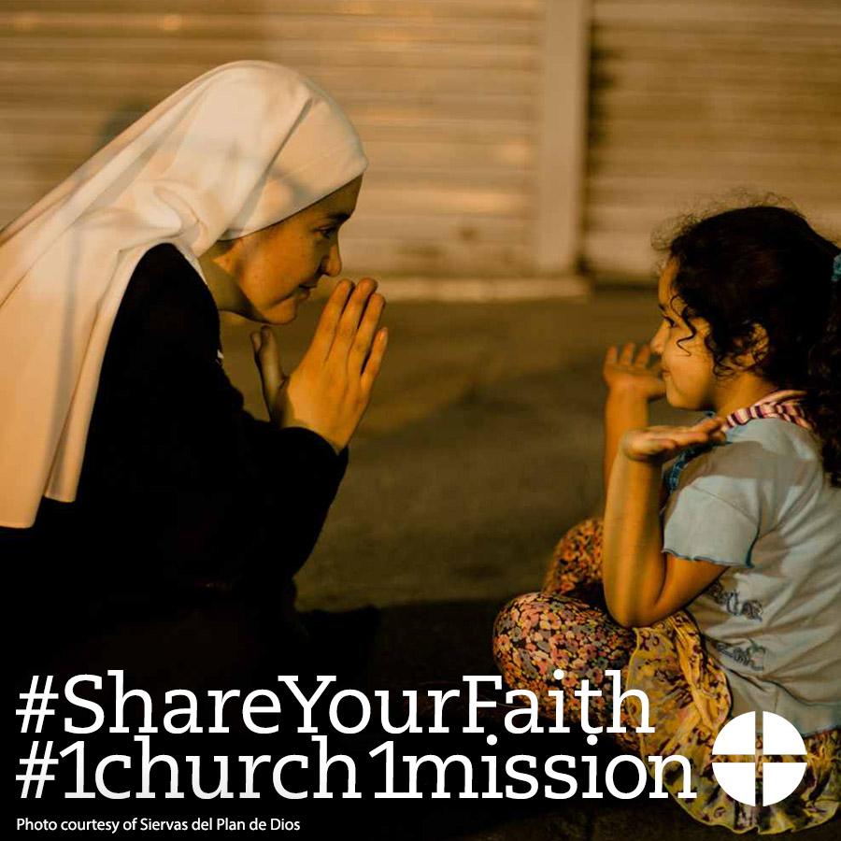
Facebook/Instagram:
For over 50 years, the Collection for the Church in Latin America has been a way for us to be in solidarity with our brothers and sisters in Latin America and the Caribbean. Support the collection in whatever way you can! #ShareYourFaith #1church1mission www.usccb.org/latin-america
Twitter:
The Collection for the Church in Latin America helps build solidarity with our brothers and sisters to our south. www.usccb.org/latin-america

Post 3: Before the Collection
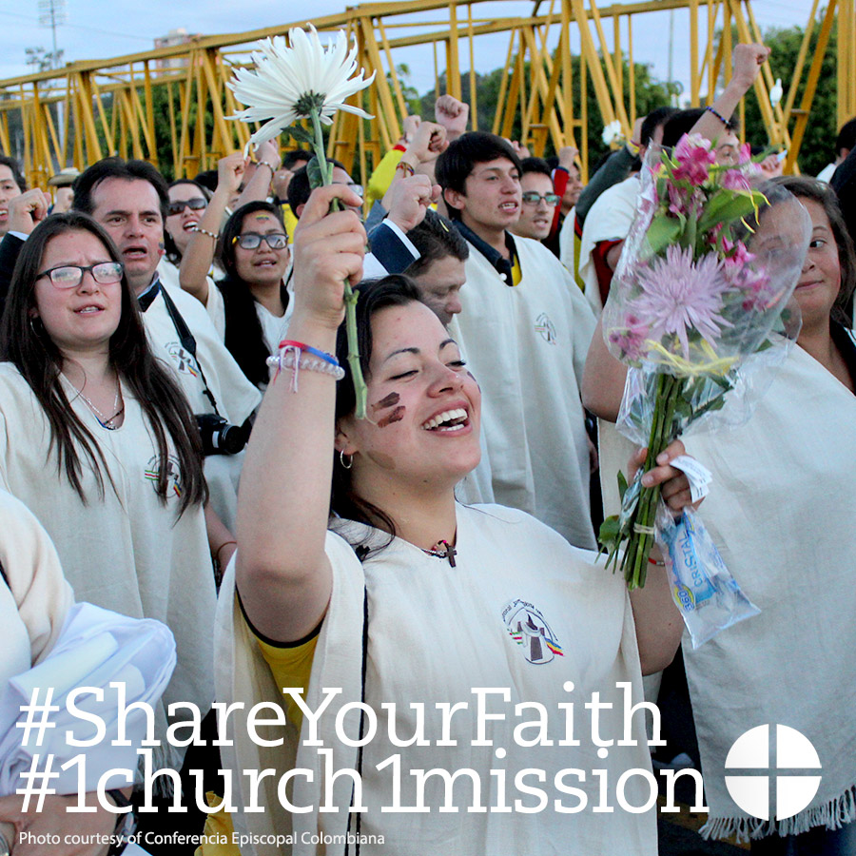
Facebook/Instagram:
The Collection for the Church in Latin America is an opportunity to #ShareYourFaith with our brothers and sisters in Latin America and the Caribbean. Please be generous to the collection at Mass and through your prayers! #1church1mission Learn more: www.usccb.org/latin-america

Post 4: Week of the Collection
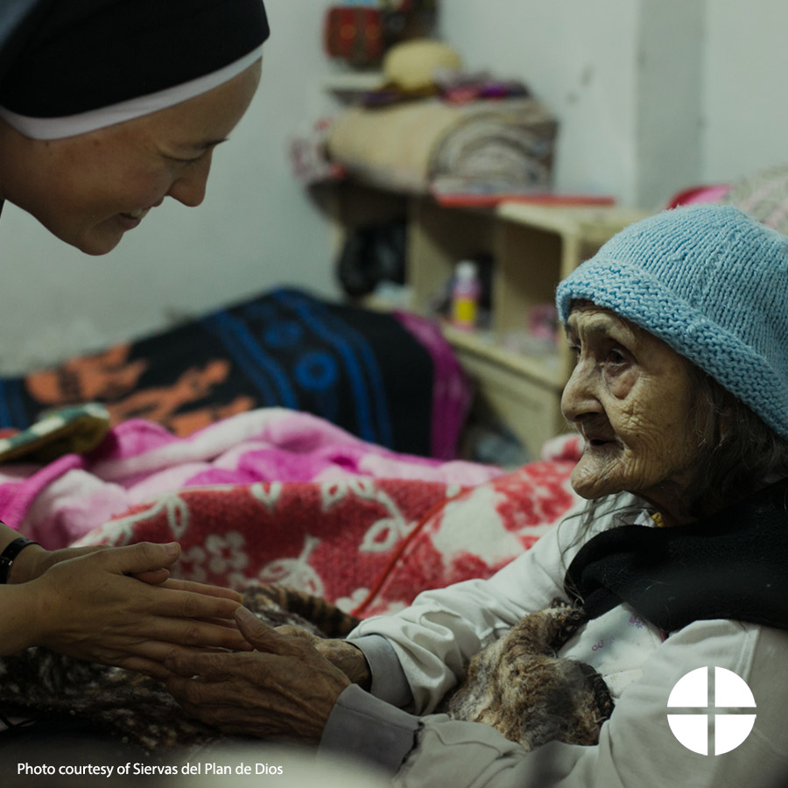
Facebook/Instagram/Twitter:
#ShareYourFaith and support the Collection for the Church in Latin America this weekend at Mass! www.usccb.org/latin-america #1church1mission

Post 5: Week of the Collection
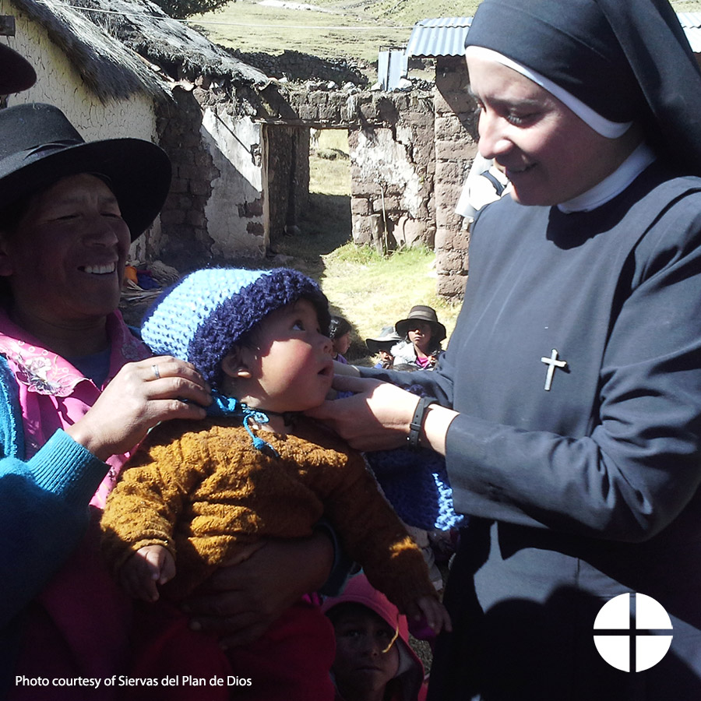
Facebook/Instagram:
This weekend, our second collection is for the Church in Latin America. Your generosity will support seminary and religious formation, family ministry, and lay leadership training so they can serve those in need in Latin America and the Caribbean. #ShareYourFaith #1church1mission www.usccb.org/latin-america
Twitter:
Our second collection this week is for the Church in Latin America. Please be generous! #ShareYourFaith http://goo.gl/b8FxQB

Post 6: Week of the Collection
The link in the posts leads to a video. Be sure to copy the whole link and the video will automatically be linked on Facebook and Twitter!

Facebook:
Bishop Eusebio Elizondo shares how donations to the Collection for the Church in Latin America helped one parish in El Salvador. This is one example of many! Support the collection at Mass this weekend and through your prayers. #ShareYourFaith #1church1mission https://goo.gl/Nxuopf
Twitter:
A message from Bishop Elizondo about the Church in Latin America. The Collection is this weekend! #ShareYourFaith https://goo.gl/Nxuopf

Post 7: Week of the Collection

Facebook:
Did you know your support to the Collection for the Church in Latin America helps people in over 20 countries? Check out this map and see where your donations go! #ShareYourFaith #1church1mission https://goo.gl/HH6dx3

Twitter:
DYK the Collection for the Church in Latin America helps people in over 20 countries? Check out this map: https://goo.gl/HH6dx3

Post 8: Weekend of the Collection
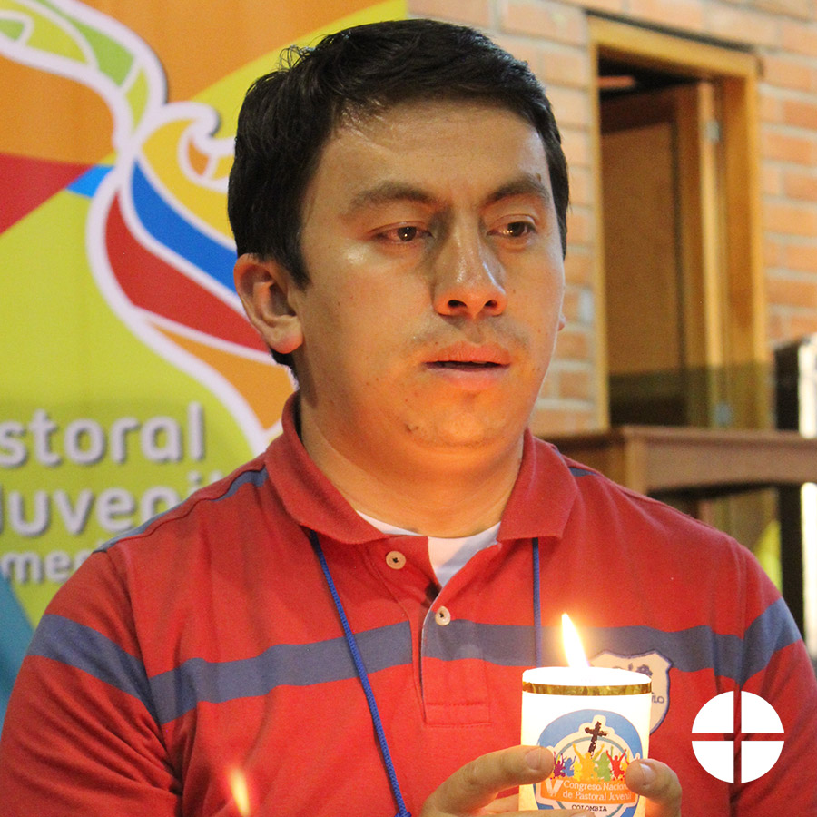
Facebook/Instagram:
Today is the Collection for the Church in Latin America! Your generosity will help people throughout Latin America and the Caribbean grow closer to Christ! #ShareYourFaith #1church1mission

Twitter:
Today is the Collection for the Church in Latin America. Please be generous! www.usccb.org/latin-america #ShareYourFaith

