Social Media Tool Kit

Facebook
- Did you know the Peter’s Pence Collection has its roots in ancient Christianity? Learn more about this collection and #WitnessCharity by supporting the collection this weekend at Mass! #1church1mission http://goo.gl/pNV1oi

- Contributions to the Peter’s Pence Collection support the charitable works of #PopeFrancis as he reaches out to victims of war and natural disaster. Support the collection at Mass! #WitnessCharity #1church1mission http://goo.gl/sDr2tE

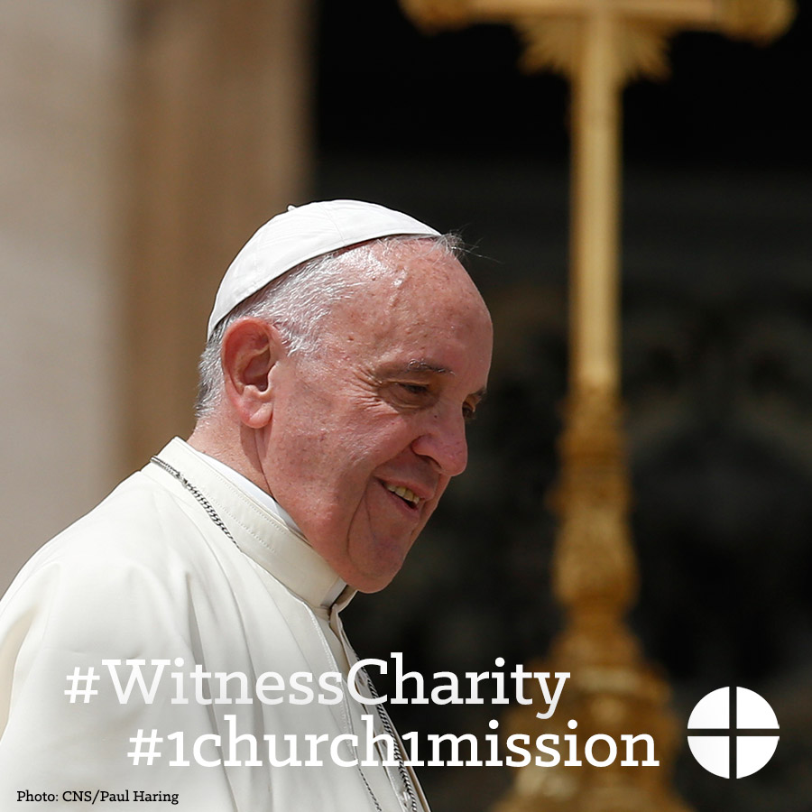

- Learn more about the Peter’s Pence Collection and support #PopeFrancis and his works! #WitnessCharity #1church1mission http://goo.gl/sDr2tE

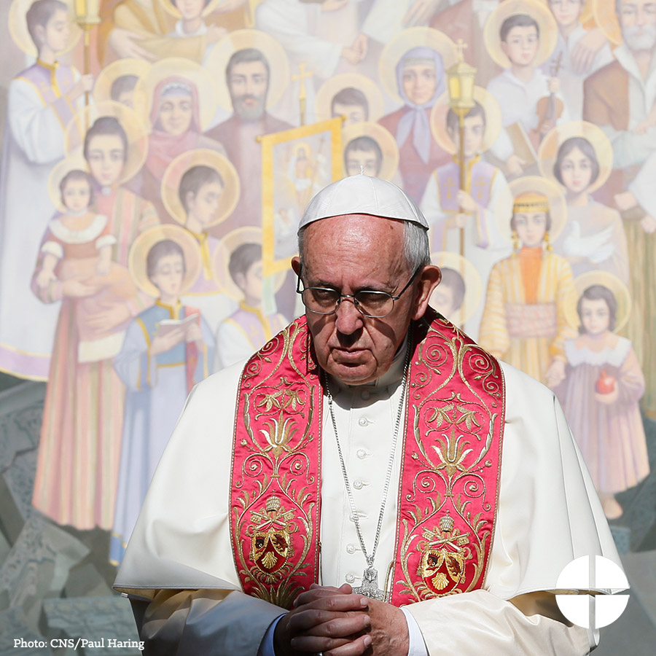

- This weekend is the Peter’s Pence Collection. Donate at Mass and support the charitable works of #PopeFrancis! #1church1mission http://goo.gl/sDr2tE

- Support for the Peter’s Pence Collection is support for #PopeFrancis and his works. Please be generous at Mass this weekend! #WitnessCharity #1church1mission http://goo.gl/sDr2tE

- Your support of the Peter’s Pence Collection goes directly to helping #PopeFrancis and his charitable works. Give at Mass to help spread his message of mercy! #WitnessCharity #1church1mission http://goo.gl/sDr2tE

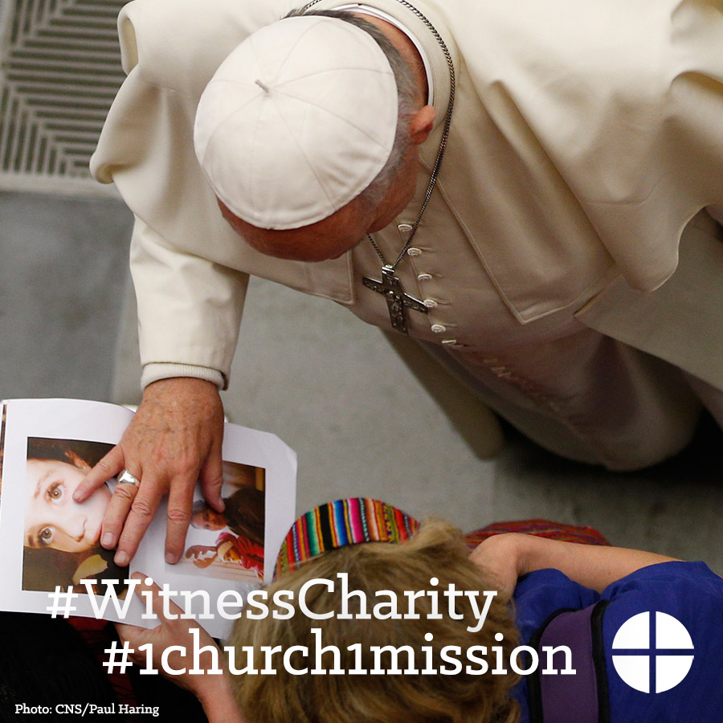

Twitter
- DYK the Peter’s Pence Collection has roots in ancient Christianity? #WitnessCharity http://goo.gl/pNV1oi
- Peter's Pence Collection helps #PopeFrancis serve victims of war & natural disaster #WitnessCharity http://goo.gl/sDr2tE
- Learn about the Peter’s Pence Collection and support #PopeFrancis! #WitnessCharity http://goo.gl/sDr2tE

- This weekend is the Peter’s Pence Collection. Donate at Mass and support the works of #PopeFrancis! http://goo.gl/sDr2tE
- Support the Peter’s Pence Collection and help #PopeFrancis spread his message of mercy! #WitnessCharity http://goo.gl/sDr2tE
- 2nd collection this weekend is for Peter's Pence. Please be generous and help #PopeFrancis. #WitnessCharity. http://goo.gl/sDr2tE

Instagram
- This weekend, we will take the Peter’s Pence Collection. Your support goes directly to supporting #PopeFrancis and his charitable works. Give at Mass and help Francis spread his message of mercy! #WitnessCharity #1church1mission
- Do you love following #PopeFrancis as he travels the world to help the suffering? Support the Peter’s Pence Collection to help his message of mercy travel even further. #WitnessCharity #1church1mission

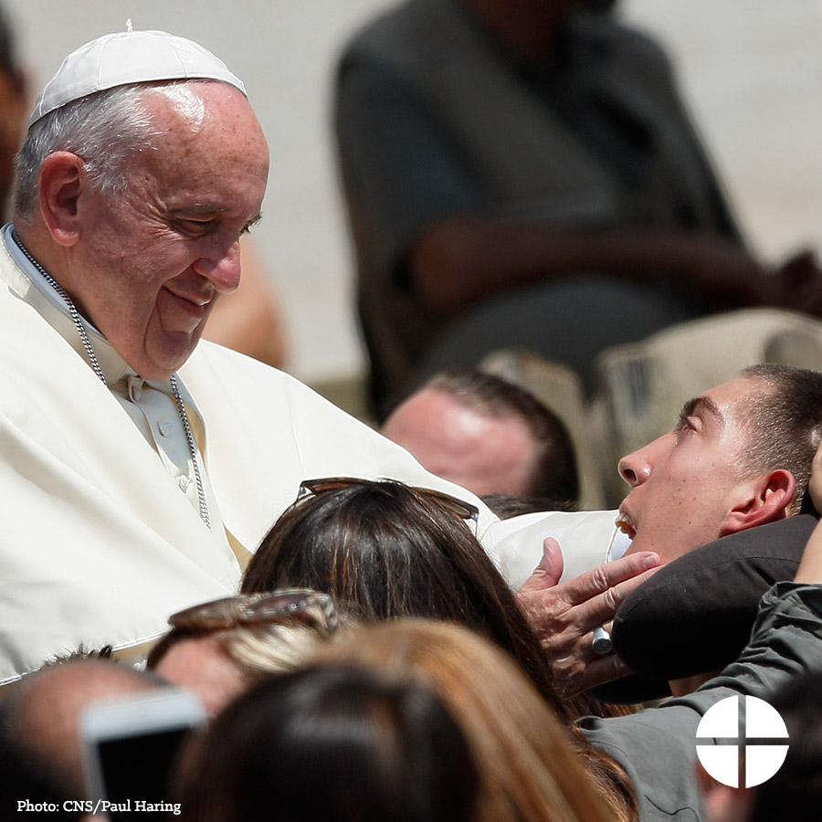

- Contributions to the Peter’s Pence Collection support the charitable works of #PopeFrancis as he reaches out to victims of war and natural disaster. Support the collection at Mass! #WitnessCharity #1church1mission
- This weekend is the Peter’s Pence Collection. Donate at Mass and support the charitable works of #PopeFrancis! #1church1mission

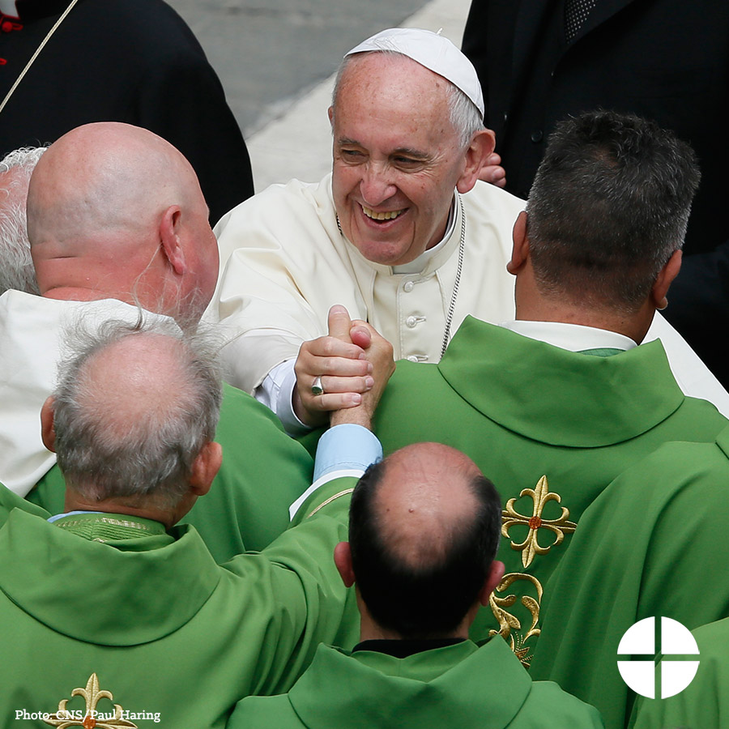

- Your support of the Peter’s Pence Collection goes directly to helping #PopeFrancis and his charitable works. Give at Mass to help spread his message of mercy! #WitnessCharity #1church1mission

