Social Media Tool Kit

Post 1: Before the Collection
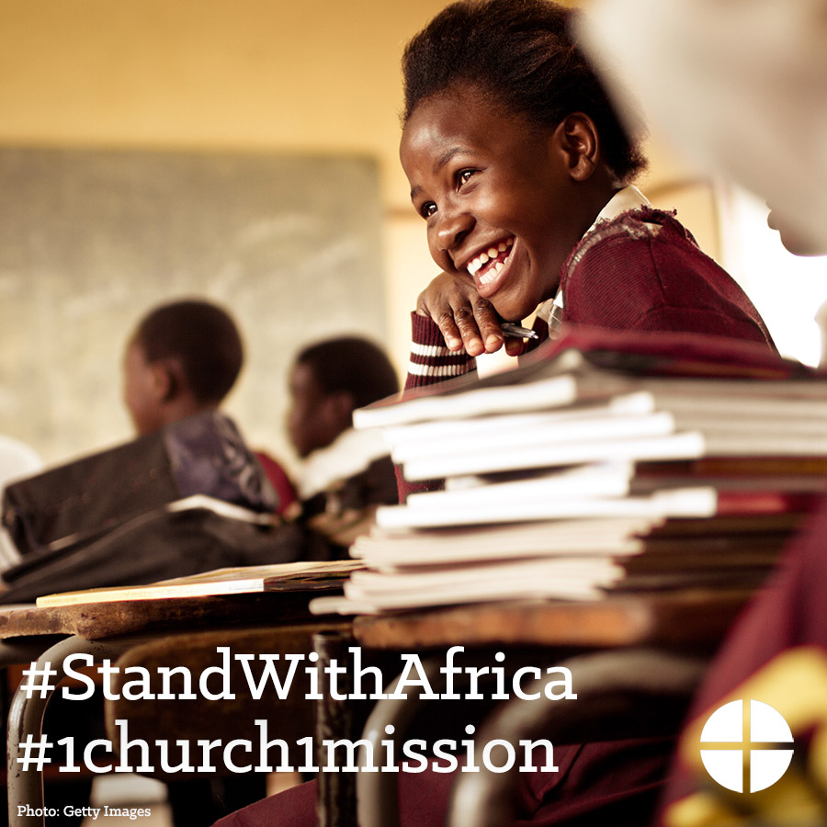
Facebook/Instagram:
The Solidarity Fund for the Church in Africa is an opportunity to support the faith of our African brothers and sisters. Please be generous to the collection at Mass! #StandWithAfrica #1church1mission www.usccb.org/africa

Twitter:
The Solidarity Fund for Africa supports the faith of our brothers and sisters. Please be generous to the collection! #StandWithAfrica

Post 2: Before the Collection
The link in the posts leads to a video. Please be sure to copy the whole link and the video will automatically be linked on Facebook and Twitter!

Facebook:
See how your gift to the Solidarity Fund for the Church in Africa has made a difference for young people in Uganda! #StandWithAfrica #1church1mision https://goo.gl/V00WNw

Twitter:
Your gift to the Solidarity Fund for the Church in Africa has made a difference in Uganda! #StandWithAfrica https://goo.gl/V00WNw

Post 3: Week of the Collection
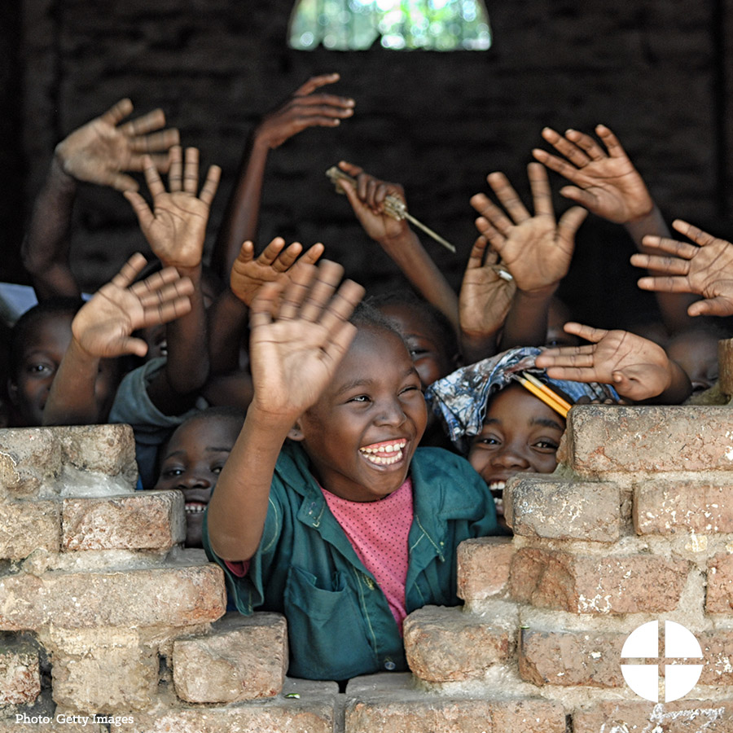

Facebook/Instagram:
Despite challenges like migration, disease, and poverty, the Church in Africa continues to grow rapidly. Our second collection this weekend will support the Church in Africa and the faithful there. #StandWithAfrica #1church1mission www.usccb.org/africa

Twitter:
The Solidarity Fund for Africa supports the faith of our brothers and sisters. Please be generous to the collection! #StandWithAfrica

Post 4: Week of the Collection
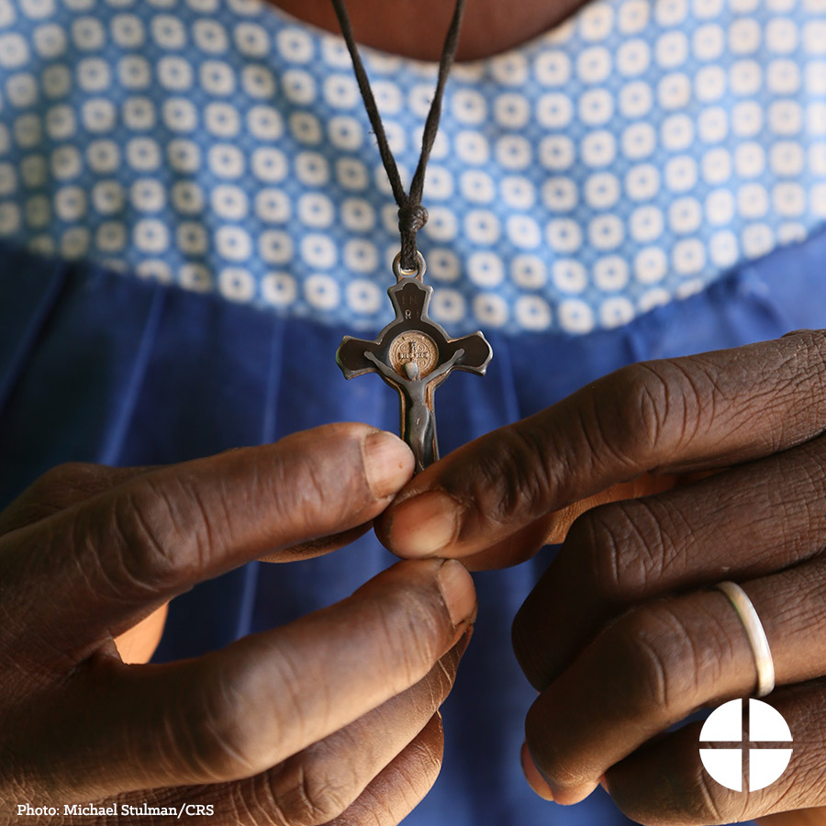

Facebook/Instagram:
Your support of the Solidarity Fund for the Church in Africa makes a real difference in the lives of the Catholic faithful across the African continent. Please be generous this weekend at Mass! #StandWithAfrica #1church1mission www.usccb.org/africa

Twitter:
Support to the Solidarity Fund for Africa makes a real difference in many lives. Please be generous at Mass! www.usccb.org/africa

Post 5: Week of the Collection
The link in the posts leads to a video. Please be sure to copy the whole link and the video will automatically be linked on Facebook and Twitter!
Facebook:
Your support to the Solidarity Fund for the Church in Africa helps pastoral projects in Africa, like this pro-life conference in Ghana. Please be generous to the collection this weekend! #StandWithAfrica #1church1mission https://goo.gl/1BlhPj

Twitter:
Solidarity Fund for the Church in Africa helps pastoral projects like this pro-life conference in Ghana. Watch: https://goo.gl/1BlhPj

Post 6: Week of the Collection
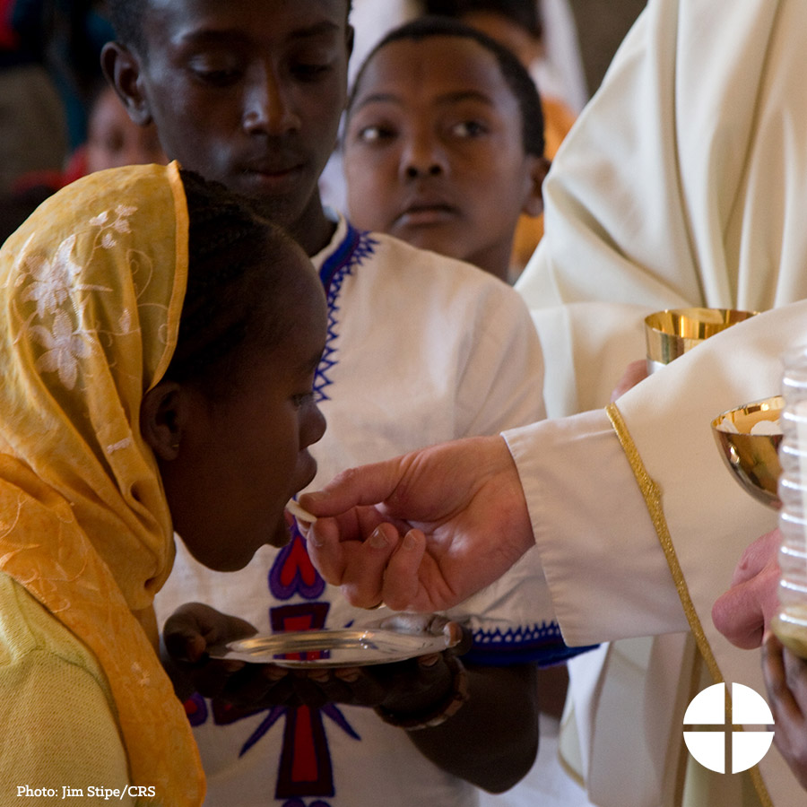

Facebook/Instagram:
#StandWithAfrica and support the Solidarity Fund for the Church in Africa! Our second collection this weekend will support pastoral outreach to Catholics there. #1church1mission www.usccb.org/africa

Twitter:
Our second collection this weekend will support the pastoral outreach to Catholics throughout Africa. #StandWithAfrica

Post 7: Day of Collection
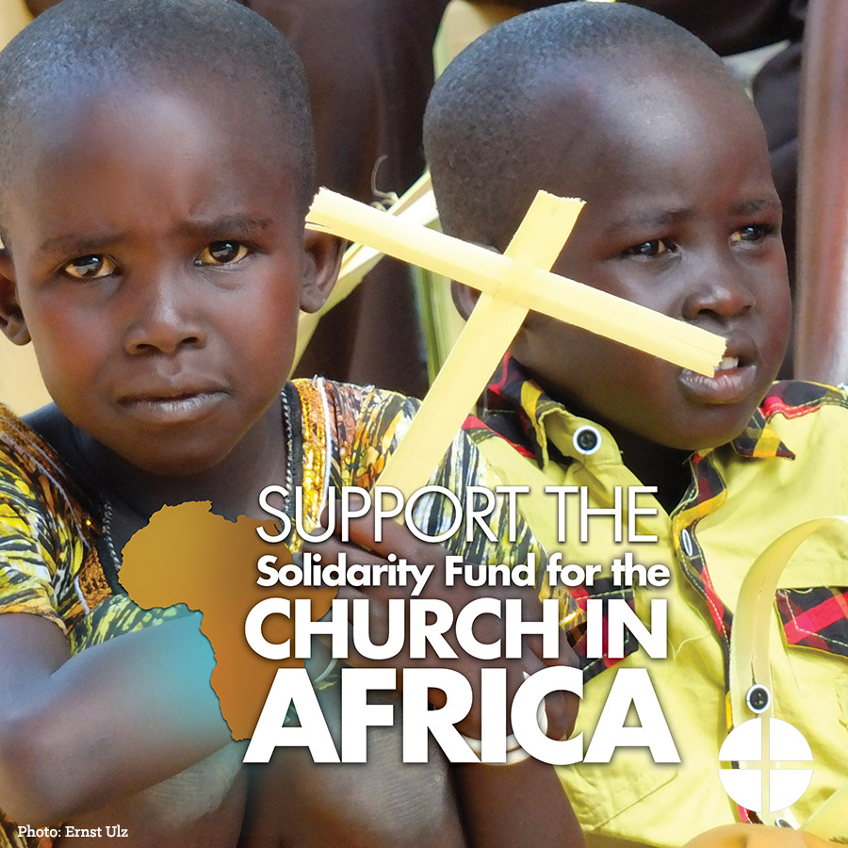
Facebook/Instagram:
Our second collection this weekend is for the Solidarity Fund for the Church in Africa. Funds collected support schools, evangelization and outreach projects, and the education of clergy and religious. Please be generous and #StandWithAfrica #1church1mission www.usccb.org/africa

Twitter:
Our second collection this weekend is for the Solidarity Fund for the Church in Africa. Please be generous! www.usccb.org/africa

