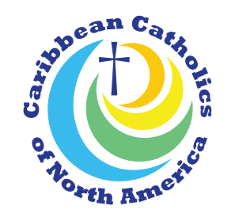

Dear Friends,

It is my distinct pleasure to introduce you to Caribbean Catholics of North America, Inc., CCNA. This organization emerged in response to the statement of the United States Conference of Catholic Bishops (USCCB), WELCOMING THE STRANGER AMONG US: UNITY IN DIVERSITY. The document was published in 2000.

From the year 2002, with the help of a Caribbean National Consultant and a representative from the Office of Cultural Diversity in the Church, Caribbean Catholics learned that the Bishops’ invitation was a stimulus to create for the CCNA greater visibility for themselves in the Church. Later it was discovered that although small groups of Caribbean Catholics were already coming together to share their experiences, to enjoy fellowship, and to strengthen their faith, they were not yet connected to a National Organization. On the other hand, there were others whom we were able to bring together for the first time.

In October 2003, the Office of Cultural Diversity in the Church invited sixteen Caribbean Catholics from seven countries to participate in a two-day seminar in Washington, D.C. This seminar gave birth to CCNA. To establish CCNA as a recognized national organization and to become fully incorporated, we formed an executive committee. After much diligence, and with the generous assistance of the law firm of HALL, RENDER, KILLIAN, HEARH & LYMAN, PC, Caribbean Catholics of North America was incorporated as a non-profit organization effective September, 2006. A board of directors was subsequently established.

In an attempt to introduce this newly formed organization to Caribbean Catholics living in North America, Sr. Joan Angela Edwards, SSM, president of CCNA, visited several dioceses in order to recruit members, to establish groups, and to promote CCNA. Some of the dioceses visited included Hartford, Connecticut; Boston, Massachusetts; Brooklyn, Queens and Rochester, New York; Miami and Ft. Lauderdale, Florida; Greater Washington, D.C.; Atlanta, Georgia; Philadelphia, Pennsylvania; Milwaukee, Wisconsin; and Houston and Baytown, Texas.

MISSION STATEMENT

Caribbean Catholics of North America, Inc., through spiritual development, outreach, advocacy and cultural preservation, seeks to assist Caribbean people and the wider church in recognizing the necessity for active Caribbean involvement to create the full expression of the Catholic Church in the United States of America. CCNA, Inc. is the national umbrella organization for the local and regional Caribbean Apostolate.

For more information, contact:
Sr. Joan Angela Edwards, SSM
President,
Caribbean Catholics of North America, Inc. (CCNA)
(301) 598-0380

