Social Media Tool Kit
The links in these posts lead to videos. Be sure to copy the whole link for each post. The video will automatically be linked on Facebook and Twitter! Follow the USCCB on Twitter, Facebook, and Instagram to stay connected! Comment and share news and ideas.

Post 1: Before the Collection
Facebook/Twitter:
Check out how you helped translate the Catechism into the Mayan language Q’eqchi’ through the Collection for the Church in Latin America! #ShareYourFaith #1church1mission https://goo.gl/ZTq2zZ
Post 2: Before the Collection
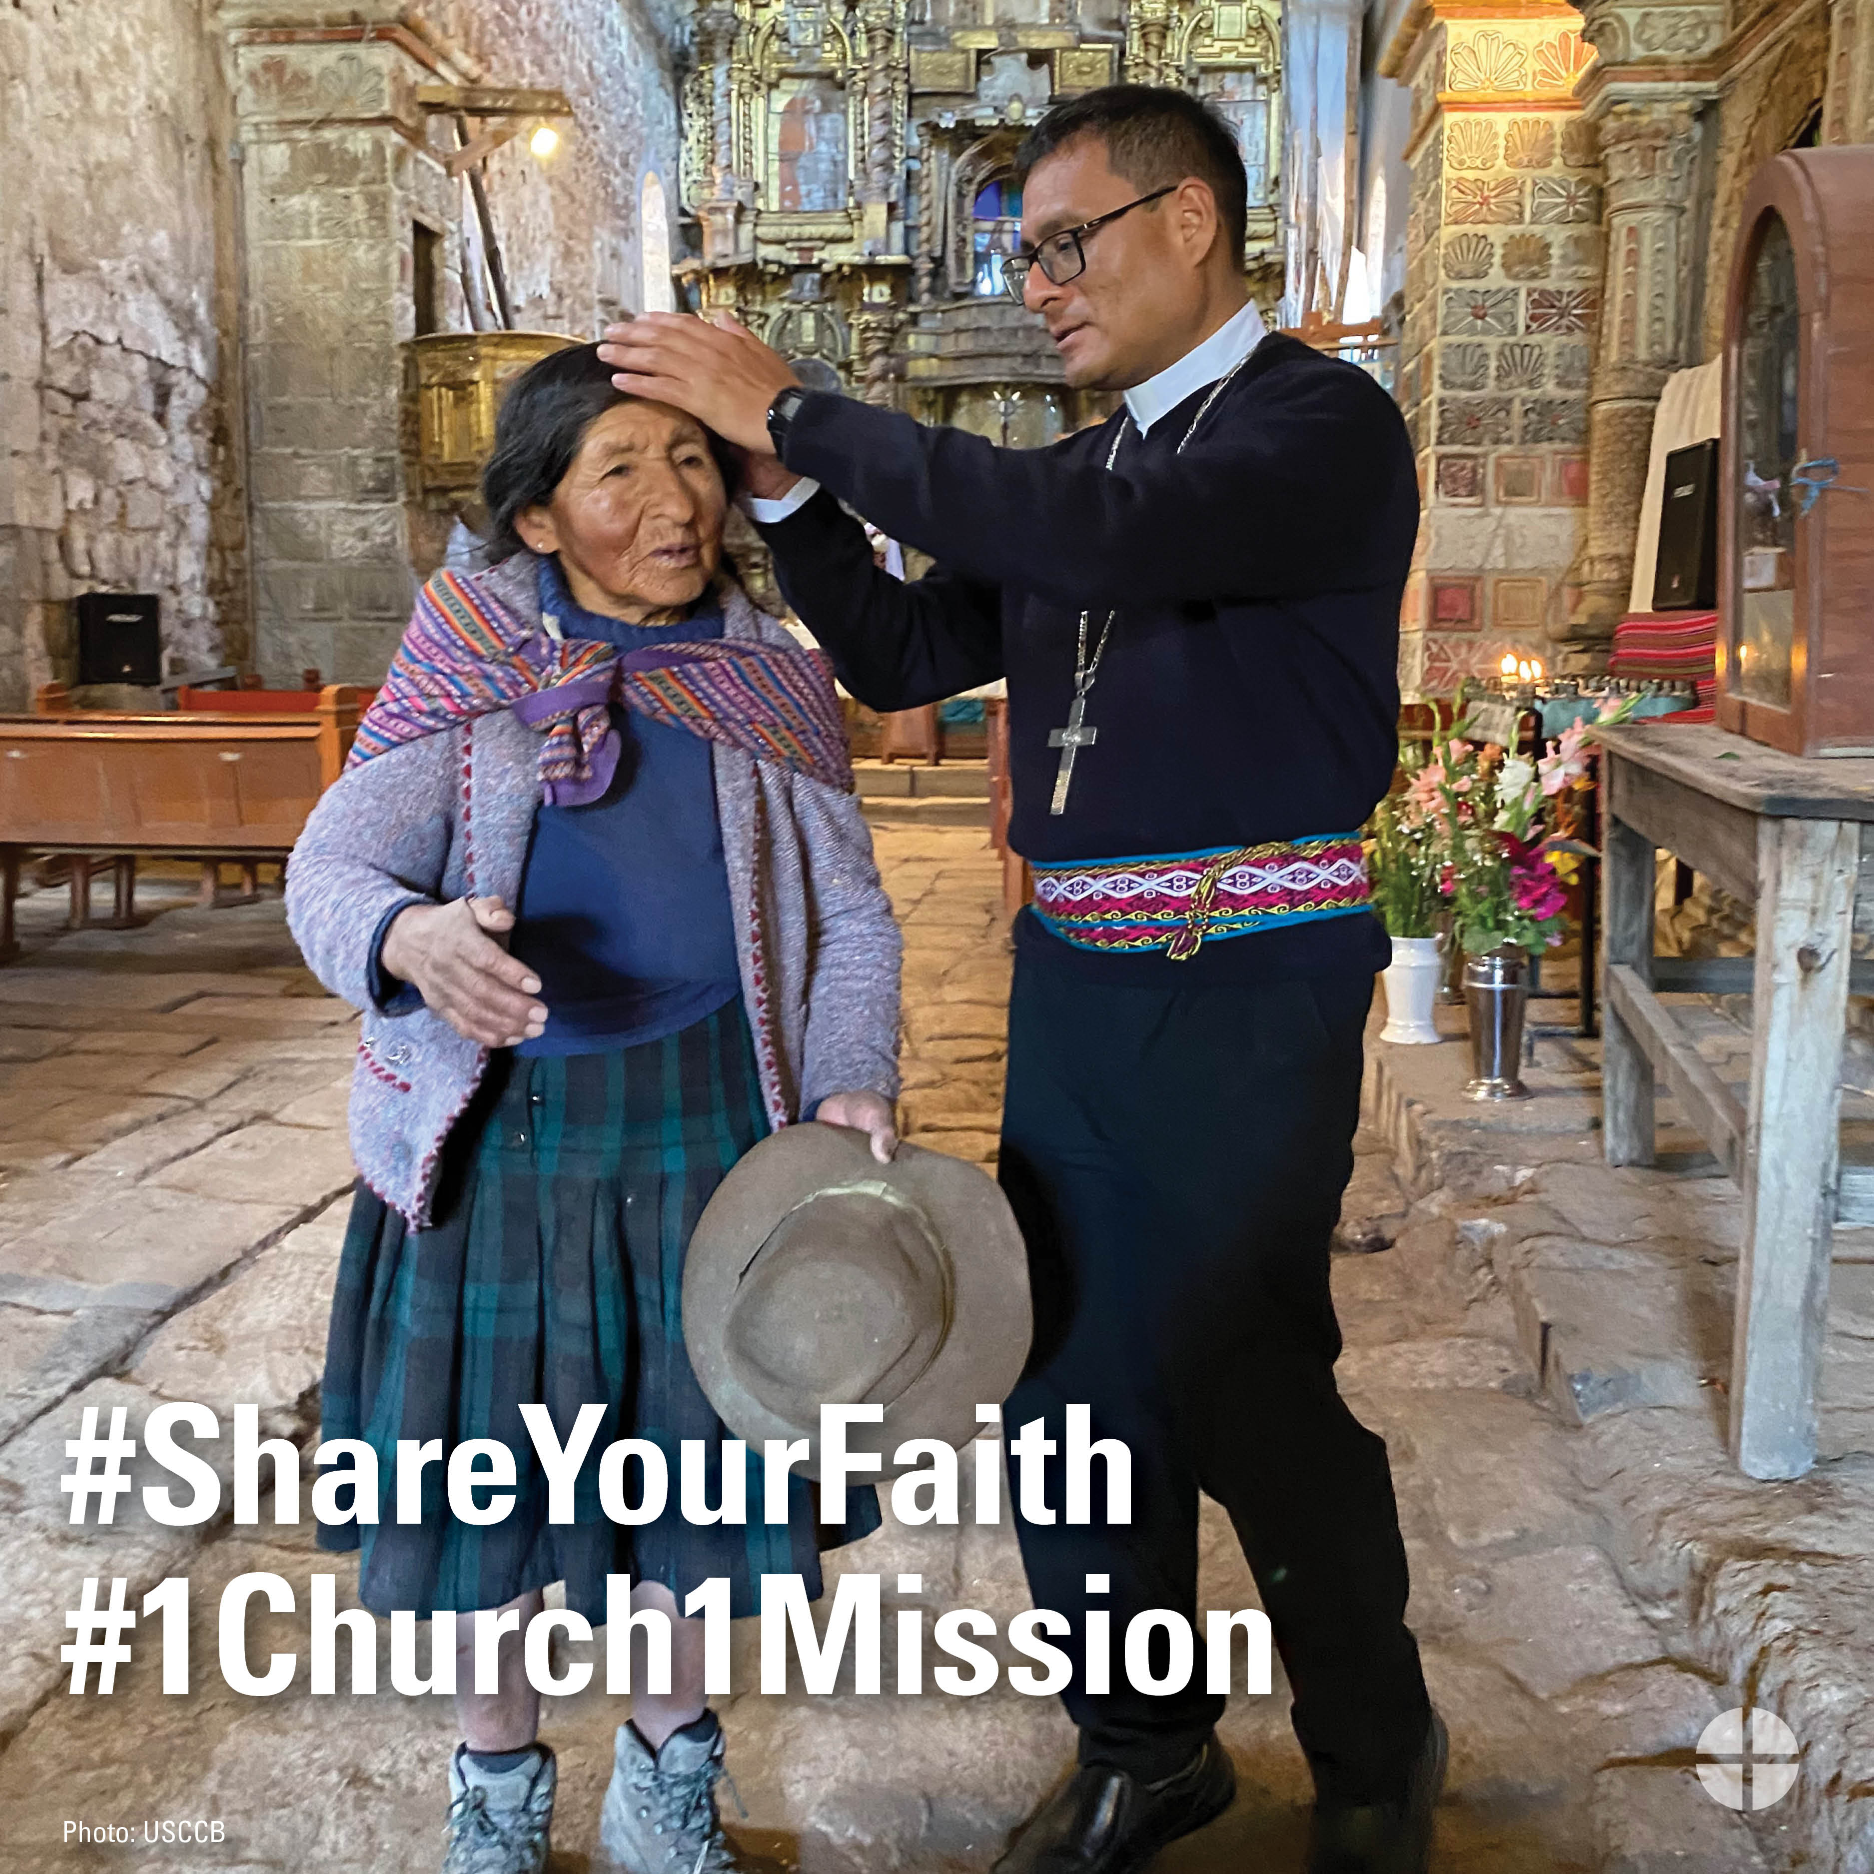

Facebook/Twitter/Instagram:
For over 50 years, the Collection for the Church in Latin America has provided a way to join in solidarity with our brothers and sisters in Latin America and the Caribbean. #ShareYourFaith #1church1mission www.usccb.org/latin-america
Post 3: Before the Collection
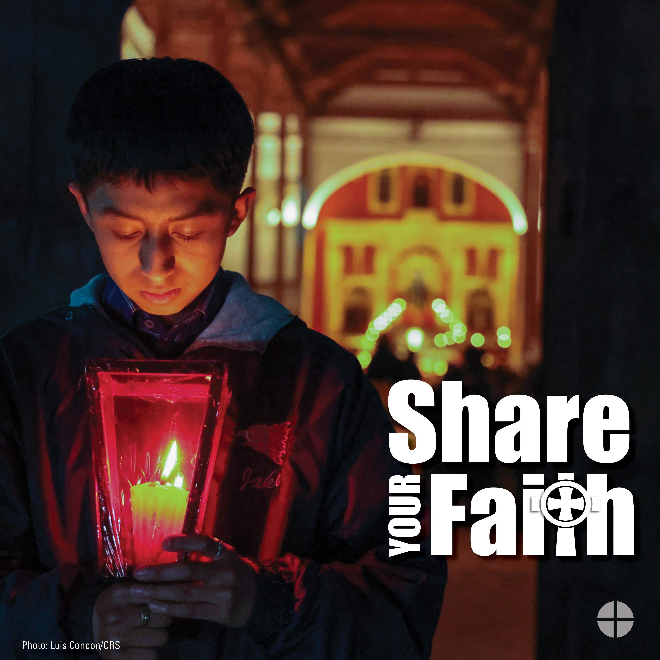
Facebook/Twitter/Instagram:
The Collection for the Church in Latin America is an opportunity to #ShareYourFaith with our brothers and sisters in Latin America and the Caribbean. Please be generous to the collection. #1church1mission www.usccb.org/latin-america

Post 4: Week of the Collection
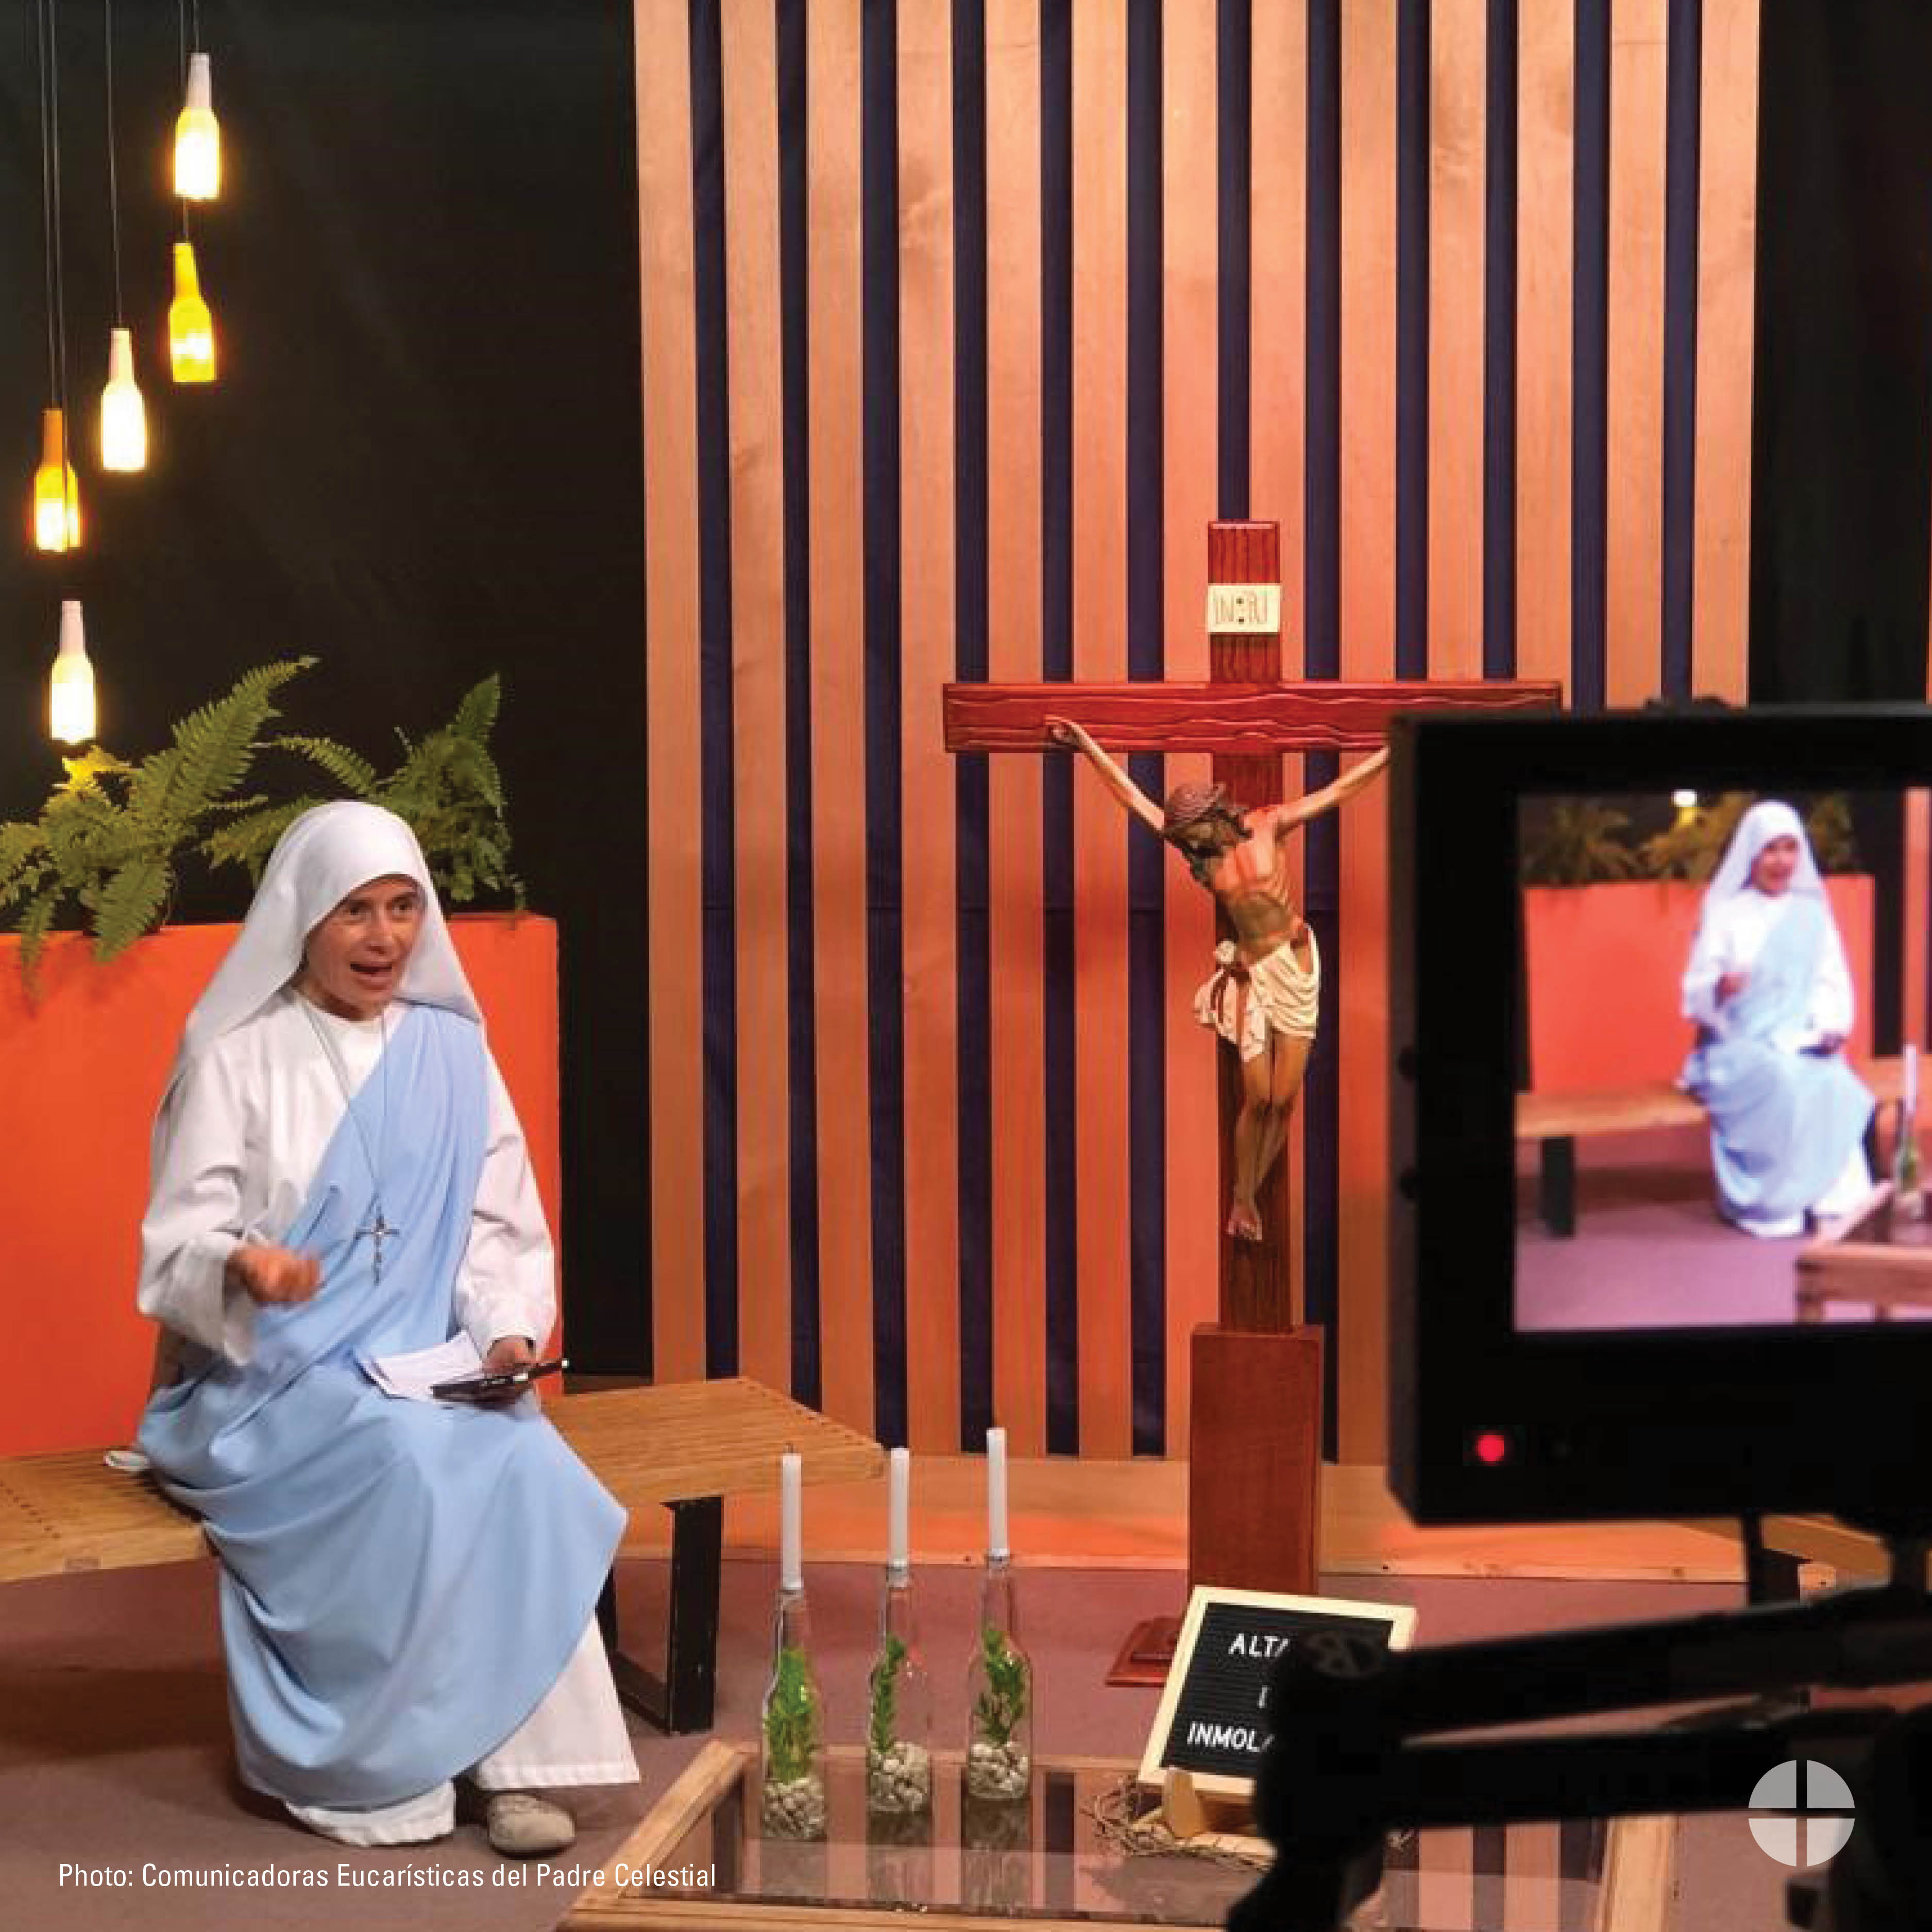
Facebook/Instagram/Twitter:
#ShareYourFaith and support the Collection for the Church in Latin America this weekend at Mass! #iGiveCatholicTogether also accepts funds for the collection—usccb.igivecatholictogether.org. #1church1mission www.usccb.org/latin-america

Post 5: Week of the Collection
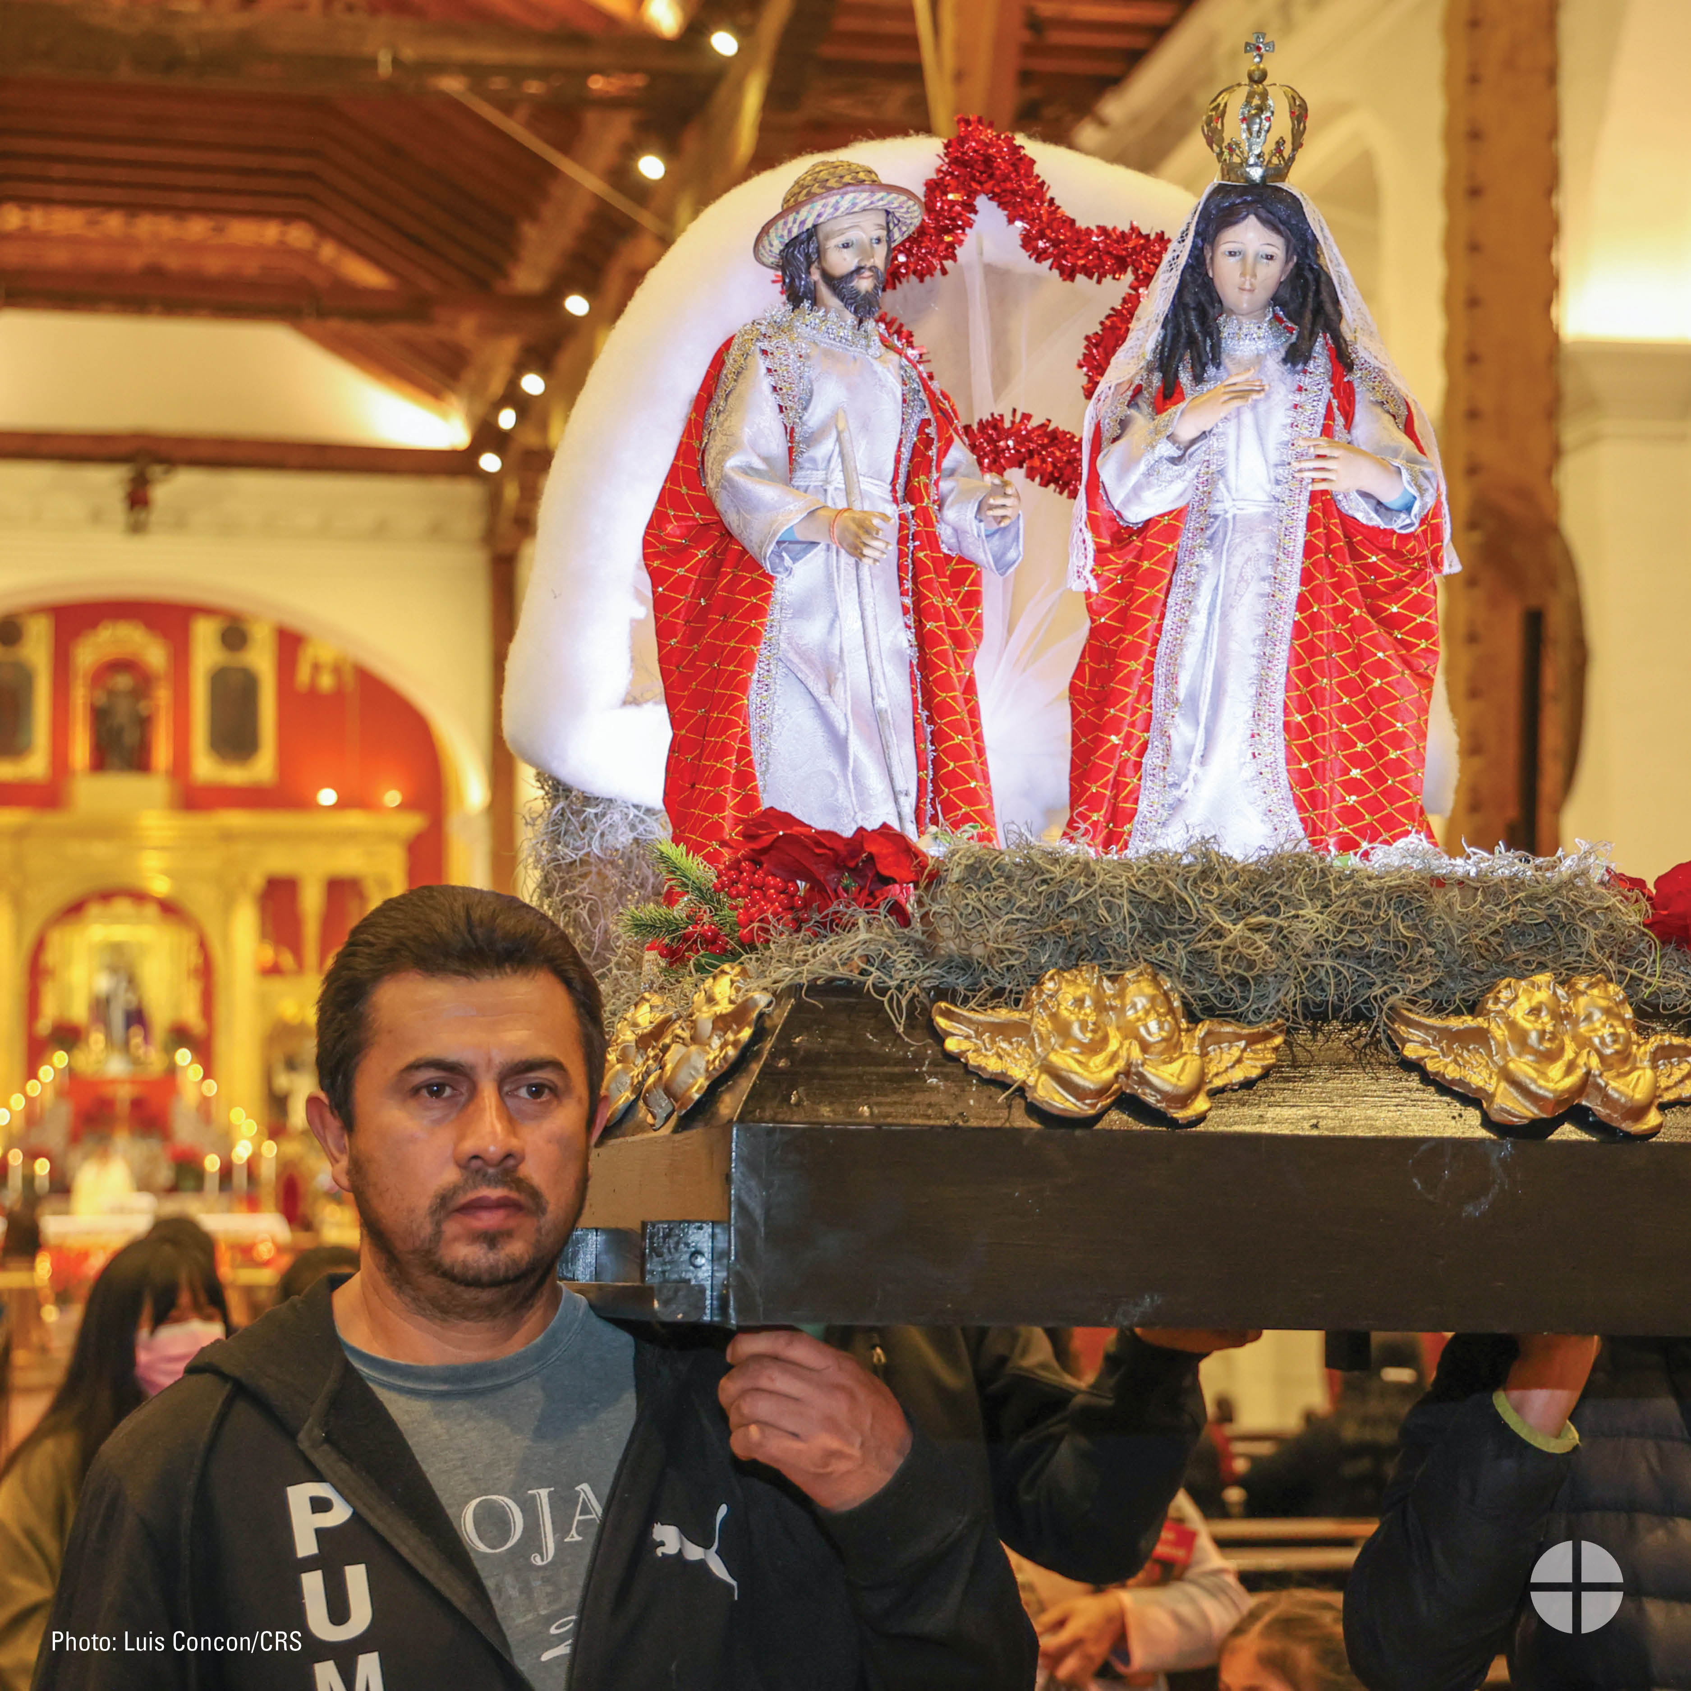
Facebook/Twitter/Instagram:
This weekend our special collection supports the Church in Latin America. Your generosity makes a difference for our brothers and sisters in Latin America and the Caribbean. #ShareYourFaith #1church1mission www.usccb.org/latin-america

Post 6: Week of the Collection
Facebook/Twitter/Instagram:
Learn how Catholics in the United States share the faith with the Church in Latin America. Support the special collection at Mass this weekend and through your prayers. #ShareYourFaith #1church1mission
https://youtu.be/7P18f4YRdao
Spanish video link: https://youtu.be/I6A3JSwQYWg

Post 7: Weekend of the Collection
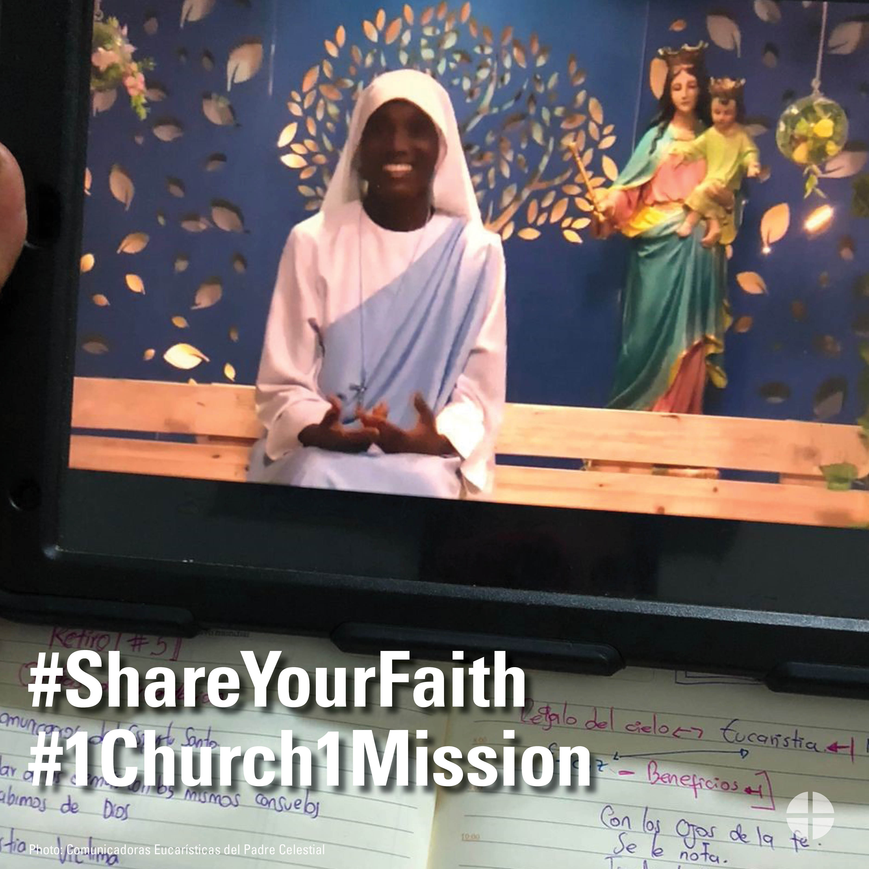
Facebook/Twitter/Instagram:
Today we take up the Collection for the Church in Latin America. Your generosity helps people throughout Latin America and the Caribbean grow closer to Christ. #ShareYourFaith #1church1mission www.usccb.org/latin-america

