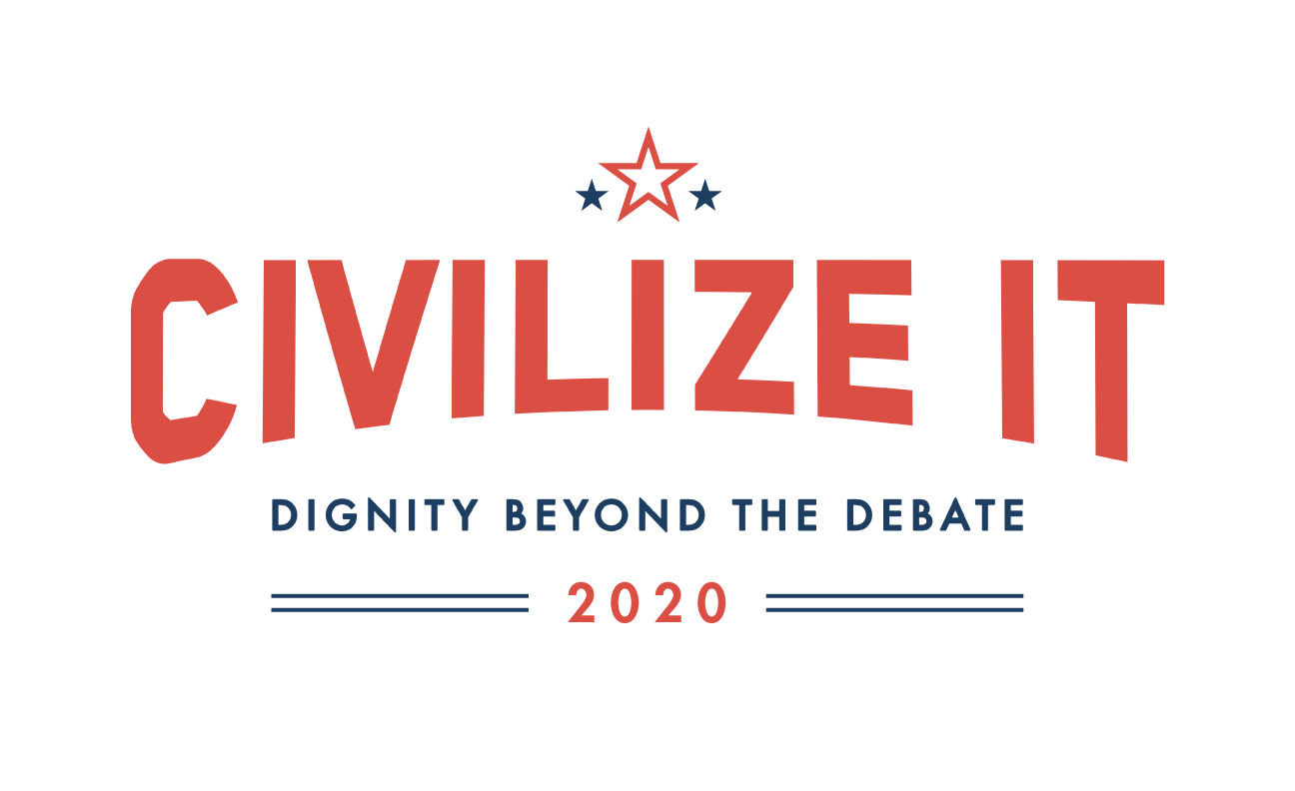

Promotion Tools
November 2019 – November 2020

Table of Contents

- Promotional Language………………………………………………………....3
- Local Engagement Tools………………………………………...…………….4
- Sample Messaging and Tools….………………………………………........5

Section I. Promotional Language
Short Promotional Blurb
What does it mean to love our neighbors in the midst of such a divisive climate? Catholics are called to bring the best of ourselves and our faith to the public square—and yet today, many shy away from such involvement because our national and local conversations are filled with anger and harsh language, often directed at people themselves. As Catholics, we must model a better way. We invite you to model love for neighbor by pledging to Civilize It and committing to civility, clarity, and compassion this election year. Civilize It: Dignity Beyond the Debate is a non-partisan call to focus on the dignity of all people, even those with whom we disagree, and to put faith in action. Make room in your heart for those with whom you disagree and pledge dignity beyond the debate today at CivilizeIt.org!
Bulletin Insert
Use this bulletin insert to encourage people in your diocese to pledge civility, clarity, and compassion this election year.
Sample Email Announcement

Dear [Name],
With another election cycle in full swing, we are faced with the difficult question of what it means to love our neighbors in the midst of such a divisive climate. We are called to bring the best of ourselves and our faith to the public square—and yet today, many shy away from such involvement because our national and local conversations are filled with anger and harsh language, often directed at people themselves.
When personal attacks replace honest debate, no one wins. This kind of attack, no matter the reason, only serves to further divide our communities. As Catholics, we must model a better way. In response to this need, the United States Conference of Catholic Bishops (USCCB) has launched a year-long campaign calling for civility throughout this election year. Civilize It: Dignity Beyond the Debate invites Catholics to pledge civility, clarity, and compassion in the public square and to call on others to do the same.
[Name of Diocese] is challenging Catholics to model love for neighbor through respect, and compassion during the 2020 election cycle and beyond. Put your faith into action and make room in your heart for those with whom you disagree. Pledge dignity beyond the debate today at CivilizeIt.org!

Section II. Local Engagement Tools

Hard Copy Pledge

Looking to bring Civilize It to a parish or community event? Download the hard copy of the pledge and bring the challenge of civility offline!

Testimonial Template
Host a community or parish event around civility and love of neighbor. Encourage people to join Civilize It and pledge civility, clarity, and compassion this election year. Let us know how it goes! Use this two question reflection with those in your faith community and share the responses with us; your diocese may be featured in future promotions of Civilize It.
- Why are you pledging to Civilize It this election year?
- What is one concrete step you will take to show dignity beyond the debate?

Photo Release
Send us pictures of members of your faith community pledging to Civilize It this election year. Fill out this photo release and send it along with any photos of how your diocese is promoting civility.
Section III. Sample Messaging & Tools

Sample Social Media Messaging

Facebook and Instagram – Tag us! @WeAreSaltandLight & @USCCB
- What does it mean to love our neighbors in the midst of such a divisive climate? This election year commit to dignity beyond the debate with #CivilizeIt: CivilizeIt.org. #CivilizeIt2020
- We are called to bring the best of ourselves and our faith to the public square—and yet today, many shy away from such involvement because our national and local conversations are filled with anger and harsh language, often directed at people themselves. As Catholics, we must model a better way. #CivilizeIt this election year by pledging civility, clarity, and compassion: CivilizeIt.org #CivilizeIt2020
- #CivilizeIt is a non-partisan call to focus on the dignity of all people, even when we disagree, and to put faith in action by bearing witness to a better way forward. Make room in your heart for those with whom you disagree and pledge dignity beyond the debate today at CivilizeIt.org! #CivilizeIt2020
- When personal attacks replace honest debate, no one wins. This kind of attack, no matter the reason, only serves to further divide our communities. As Catholics, we must model a better way. How can you model love for neighbors through clarity, civility, and compassion during the 2020 election cycle? Put your faith into action and pledge dignity beyond the debate today at CivilizeIt.org! #CivilizeIt #CivilizeIt2020
Twitter – Tag us! @WeAreSaltLight & @USCCB
- Bring the best of yourself and your faith to the public square by honoring the human dignity of all you encounter, even those with whom you disagree. Pledge to #CivilizeIt today: CivilizeIt.org! #CivilizeIt2020
- Pledge dignity beyond the debate this election year. Join #CivilizeIt2020 and commit to civility, clarity, and compassion this election year: CivilizeIt.org. #CivilizeIt
- Will you pledge dignity beyond the debate? #CivilizeIt this election year: CivilizeIt.org #CivilizeIt2020
- Put your faith into action and make room in your heart for those with whom you disagree. Sign the #CivilizeIt pledge today! CivilizeIt.org #CivilizeIt2020
- When personal attacks replace honest debate, no one wins. Model a better way with #CivilizeIt and promote civility, clarity, and compassion in your community: CivilizeIt.org #CivilizeIt2020
- As Catholics, we are called to encounter others, even those with whom we disagree, with an open heart and well-formed conscience. #CivilizeIt and bring your best self and your faith to the public square: CivilizeIt.org! #CivilizeIt2020

Sample Social Media Graphics
To save graphics, right click each one and select “save as picture”

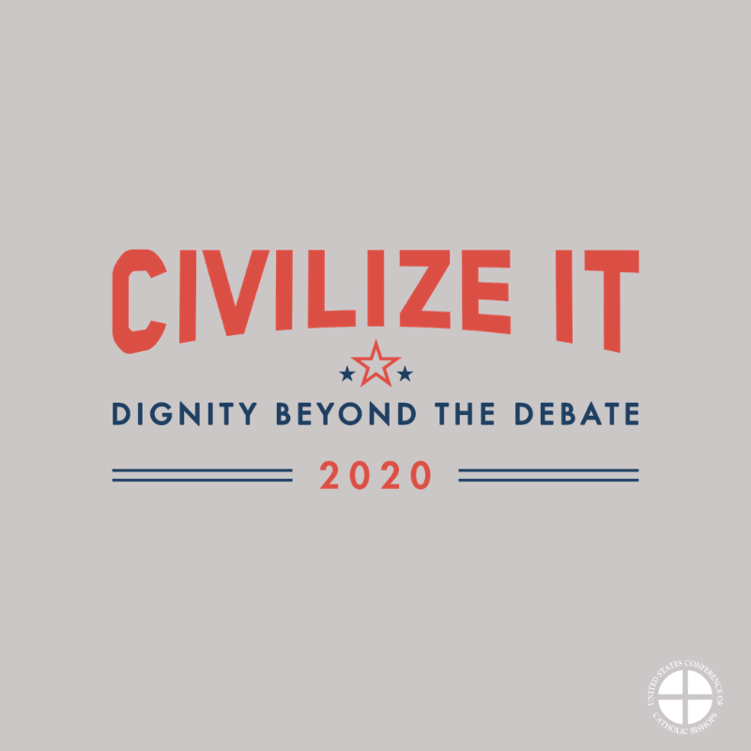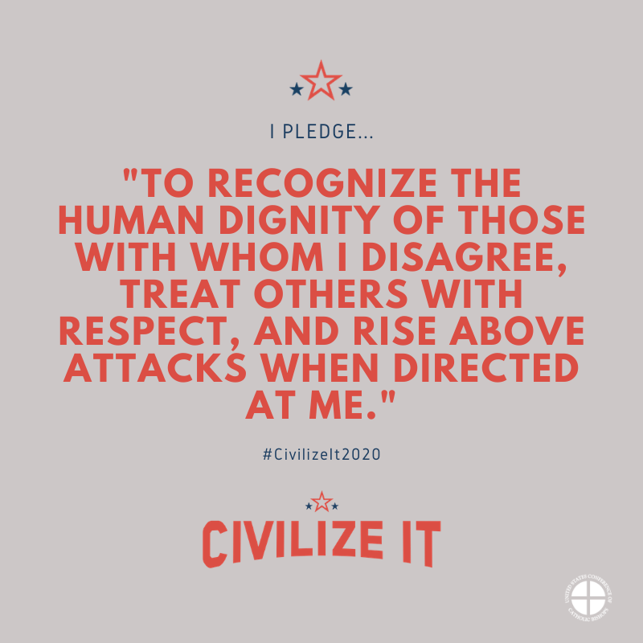

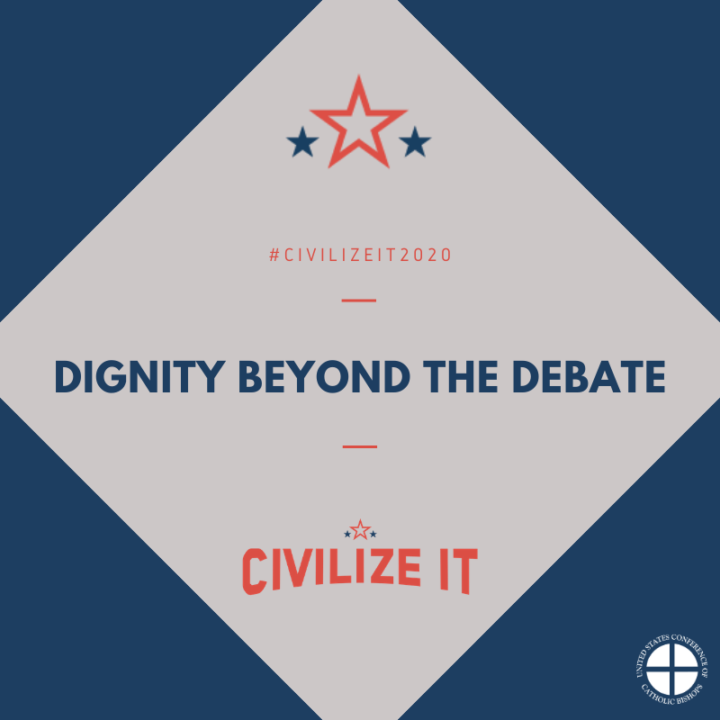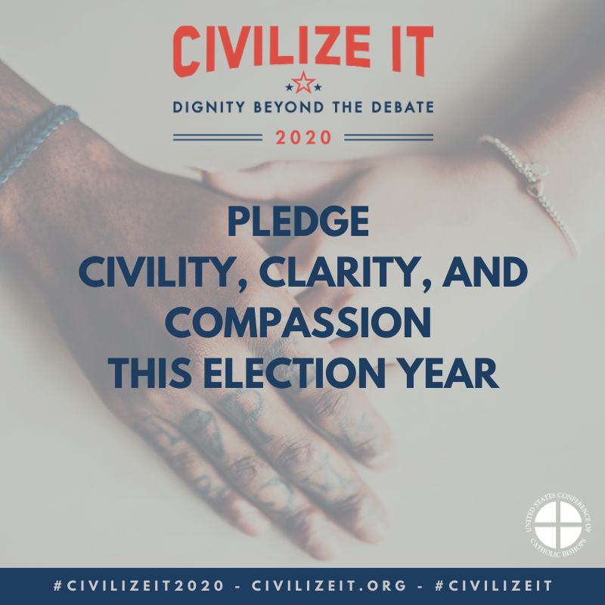
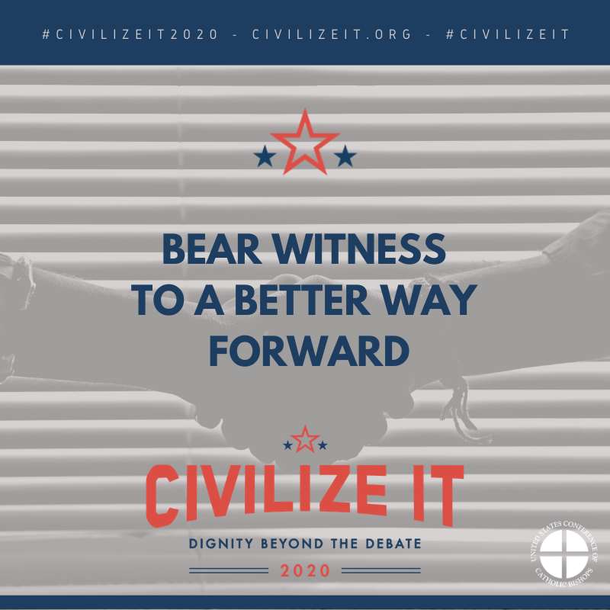

Social Media Banners
To save graphics, right click each one and select “save as picture”

Facebook:

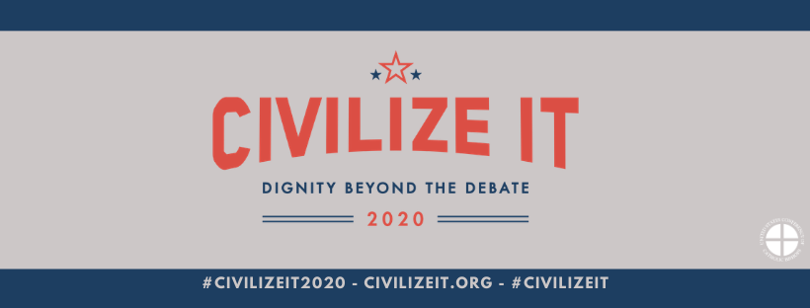

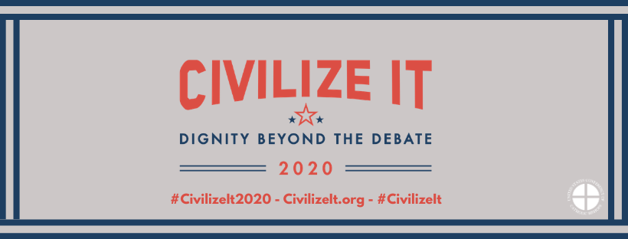

Twitter:

