**Word of Life: May 2021**

*Recommended dates are provided, but you are welcome to use these materials at any time!*

**Featured this Month…**

**May 9, 2021: Mother’s Day**

Mother’s Day is a wonderful opportunity to highlight the beautiful vocation of motherhood and the gift of life.

Our [Mother’s Day action guide](https://www.usccb.org/resources/respect-life-action-guide-mothers-day) features homily considerations, intercessions, at-home activity ideas, and more to assist with honoring and praying for mothers in your parish community.

A [webinar recording](https://youtu.be/1QQdhfON3Ww) of USCCB staff walking through the materials, as well as [the presentation slides](https://www.usccb.org/resources/respect-life-action-guide-mothers-day-webinar-slides), are available.

\**You’re welcome to use one component of the action guide or the whole thing—whatever’s helpful!*

**May 31, 2021: Feast of the Visitation of the Blessed Virgin Mary**

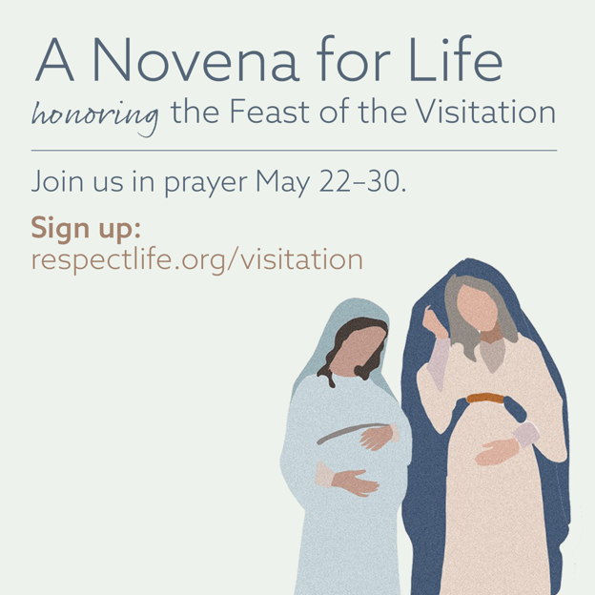On May 31st, the Church celebrates the Feast of the Visitation of the Blessed Virgin Mary. This feast commemorates the Blessed Mother’s visit to her cousin Elizabeth and the encounter of Jesus and St. John the Baptist while in the wombs of their mothers. Join us in praying [A Novena for Life](https://www.respectlife.org/visitation) in honor of this special feast day.

**Suggested Date for Graphic/Announcement:** Weekend of May 15-16, 2021

[**Download Graphic**](https://www.usccb.org/resources/visitation-novena-life-graphics)

**Sample Announcement:**

*Join A Novena for Life honoring the Feast of the Visitation. Sign up at* [***respectlife.org/visitation***](http://www.respectlife.org/visitation)*!*

**Word of Life – May 2021**

**Intercessions for Life**

|  |  |
| --- | --- |
| **May 2nd**  For persons with disabilities:  May their lives always be recognized  as worth protecting and fighting for  in all circumstances;  *We pray to the Lord:* | **Fifth Sunday of Easter** |
| **May 9th**  For all mothers: That they may be encouraged and supported  as they live out this special vocation; *We pray to the Lord:* | **Sixth Sunday of Easter** *(Mother’s Day, which is not a liturgical holiday but is often recognized at Mass)* |
| **May 16th**  For all Christians:  That our example may give witness to  the precious gift of human life in this world and  the invitation to eternal life in the next;  *We pray to the Lord:* | **Solemnity of the Ascension of the Lord**  **(or the Seventh Sunday of Easter where applicable)** |
| **May 23rd**  May the Holy Spirit strengthen God’s people  to embrace and protect  the precious gift of human life;  *We pray to the Lord:* | **Pentecost Sunday** |
| **May 30th**  May society come to a deeper understanding  and respect for the human person,  who is created, redeemed, and made holy  by the gracious action of the Trinity, Father, Son, and Holy Spirit;  *We pray to the Lord:* | **The Solemnity of the Most Holy Trinity** |

**Word of Life – May 2021**

**Bulletin Quotes**

|  |  |
| --- | --- |
| **May 2nd**  “Even the weakest and most vulnerable, the sick, the old, the unborn and the poor, are masterpieces of God’s creation, made in his own image, destined to live forever, and deserving of the utmost reverence and respect.”  USCCB Respect Life flyer quoting Pope Francis’ “Day for Life Greeting”  © 2013 Libreria Editrice Vaticana. Used with permission. All rights reserved. | [Download](http://www.usccb.org/about/pro-life-activities/respect-life-program/upload/Flyer-RLP2014-Color.pdf) |
| **May 9th**  “O Blessed Mother, you received the good news of the incarnation of Christ, your Son, with faith and trust. Grant your protection to all pregnant mothers facing difficulties.”  USCCB Secretariat of Pro-Life Activities,  “A Prayer for Pregnant Mothers” | [View, Download,  or Order Prayer Cards](https://www.walkingwithmoms.com/prayer-for-pregnant-mothers) |
| **May 16th**  “Everyone is in need of reassurance, and if we, who have touched ‘the Word of life’ (1 *Jn* 1:1) do not give it, who will? How beautiful it is to be Christians who offer consolation, who bear the burdens of others and who offer encouragement: messengers of life in a time of death!”  Pope Francis, [2020 Easter Vigil Homily](http://w2.vatican.va/content/francesco/en/homilies/2020/documents/papa-francesco_20200411_omelia-vegliapasquale.html)  © 2020 Libreria Editricea Vaticana. Used with permission. All rights reserved. | |
| **May 23rd**  “The Lord says to us, ‘Do not fear: I am with you’ (Isaiah 41:10). He speaks these words not as one who merely observes our pain, but as one who experienced immense suffering. And the very wounds that bear witness to his suffering indicate the essence of our identity and worth: we are loved by God. Reflecting on the healed wounds of the Risen Christ, we see that even our most difficult trials can be the place where God manifests his victory. He makes all things beautiful. He makes all things new.”  USCCB Secretariat of Pro-Life Activities  “Be Not Afraid” NABRE © 2010 CCD. Used with permission. | [Read](https://www.respectlife.org/be-not-afraid) | [Download](https://www.usccb.org/about/pro-life-activities/respect-life-program/2017/upload/rlp-17-reflection-flyer-single-english-color.pdf) |
| **May 30th**  “In modern times, children in their mothers’ wombs and those approaching the end of their lives are certainly among the ‘least of these’ in our world’s estimation. Practices such as abortion and assisted suicide tragically reject the truth that human life is always to be cherished and defended with loving concern. … Through the intercession of Our Lady of Guadalupe, may Our Lord grant us the grace to truly and courageously live his Gospel of life.”  USCCB Secretariat of Pro-Life Activities  “Live the Gospel of Life”  NABRE © 2010 CCD. Used with permission. | [Read](https://www.respectlife.org/reflection) | [Download](https://www.usccb.org/resources/respect-life-program-reflection-2020-2021) |

**Word of Life – May 2021**

**Bulletin Art**

*You are welcome to use these images, provided they are not altered in any way, other than the size. Thank you!*

**Sunday, May 2nd or Sunday, May 9th, 2021**

*(The date depends on whether you implement the sample activity in-person or as an at-home activity.)*

[**Download Image**](https://www.usccb.org/resources/respect-life-action-guide-mothers-day-activity-graphic)

**Spiritual Bouqet Activity Instructions:** Select “Activity (with at-home option)” from the list of documents on [this page](https://www.usccb.org/resources/respect-life-action-guide-mothers-day).

**Sunday, May 16th, 2021**

*(The Feast of the Visitation of the Blessed Virgin Mary is Monday, May 31st.)*

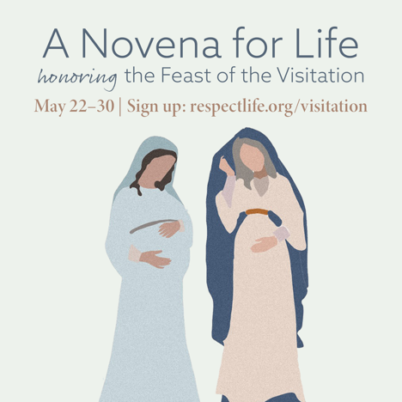

[**Download Image(s)**](https://www.usccb.org/resources/visitation-novena-life-graphics)

**Sample Announcement:**

*Join A Novena for Life honoring the Feast of the Visitation. Sign up at* [***respectlife.org/visitation***](http://www.respectlife.org/visitation)*!*