Option 1
[Hyperlink graphic to www.notaxpayerabortion.com.]

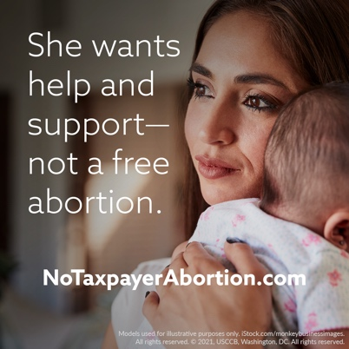

Option 2 (with or without a graphic)
The Hyde amendment is SUPPORTED by low-income women, with 55% of low-income people saying they specifically support the Hyde amendment. Tell Congress not to take it away: www.notaxpayerabortion.com.

Option 3 (with or without a graphic)
Some powerful Members of Congress want taxpayer dollars to pay for abortion for poor women.
To offer a woman a government-funded abortion, but not the resources she needs to care for her child, is not “choice” but coercion.
Government money would be better spent supporting women in crisis pregnancies and struggling new mothers than paying to end the lives of their children.
Tell Congress to save the Hyde amendment: www.notaxpayerabortion.com.

Graphics: https://www.usccb.org/resources/respect-life-graphics-no-taxpayer-abortion
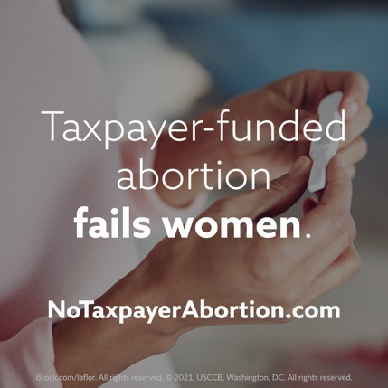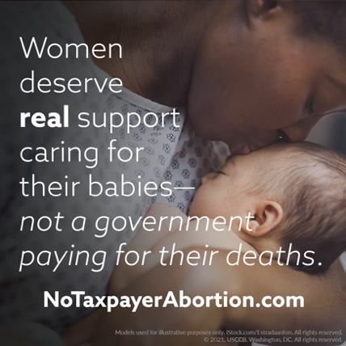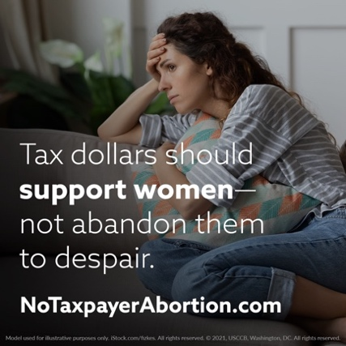

Option 4

[Hyperlink graphic to www.notaxpayerabortion.com.]

Option 5 (with or without a graphic)

Stop your tax dollars from paying for abortion! Tell Congress not to take innocent lives. www.notaxpayerabortion.com

Option 6 (with or without a graphic)

Don’t let our government force you to pay for the deaths of unborn children.

President Biden wants to take away the Hyde Amendment. Powerful Members of Congress are doing everything they can to make that happen.

Without the Hyde Amendment and pro-life policies, billions of taxpayer dollars could be used to pay for abortion in the United States and throughout the world.

Sign the petition at www.notaxpayerabortion.com!

Graphics: https://www.usccb.org/resources/no-taxpayer-abortion-graphics
