Social Media Tool Kit

Post 1: Before the Collection
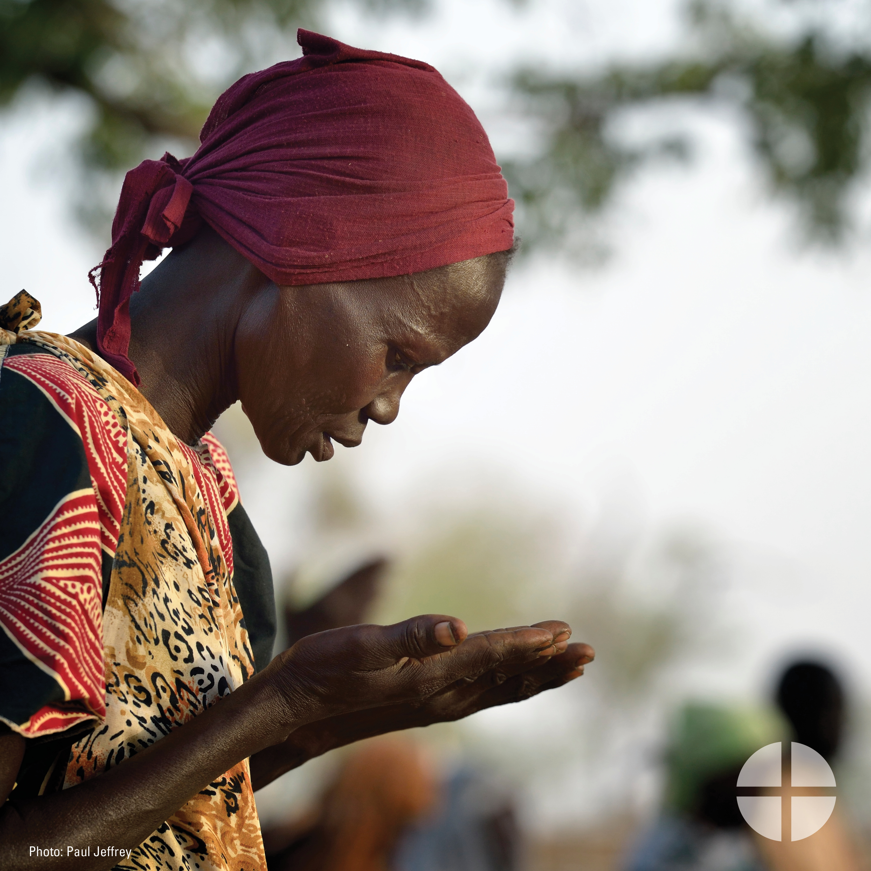
Facebook/Instagram/Twitter:
The Solidarity Fund for the Church in Africa is an opportunity for you to support the faith of our African brothers and sisters. Please be generous to the collection at Mass! #StandWithAfrica #1church1mission www.usccb.org/africa

Post 2: Before the Collection
The link in the posts leads to a video. Please be sure to copy the whole link, and the video will automatically be linked on Facebook and Twitter!

Facebook/Twitter:
See how your gift to the Solidarity Fund for the Church in Africa has made a difference for young people in Uganda! #StandWithAfrica #1church1mision https://goo.gl/V00WNw

Post 3: Week of the Collection
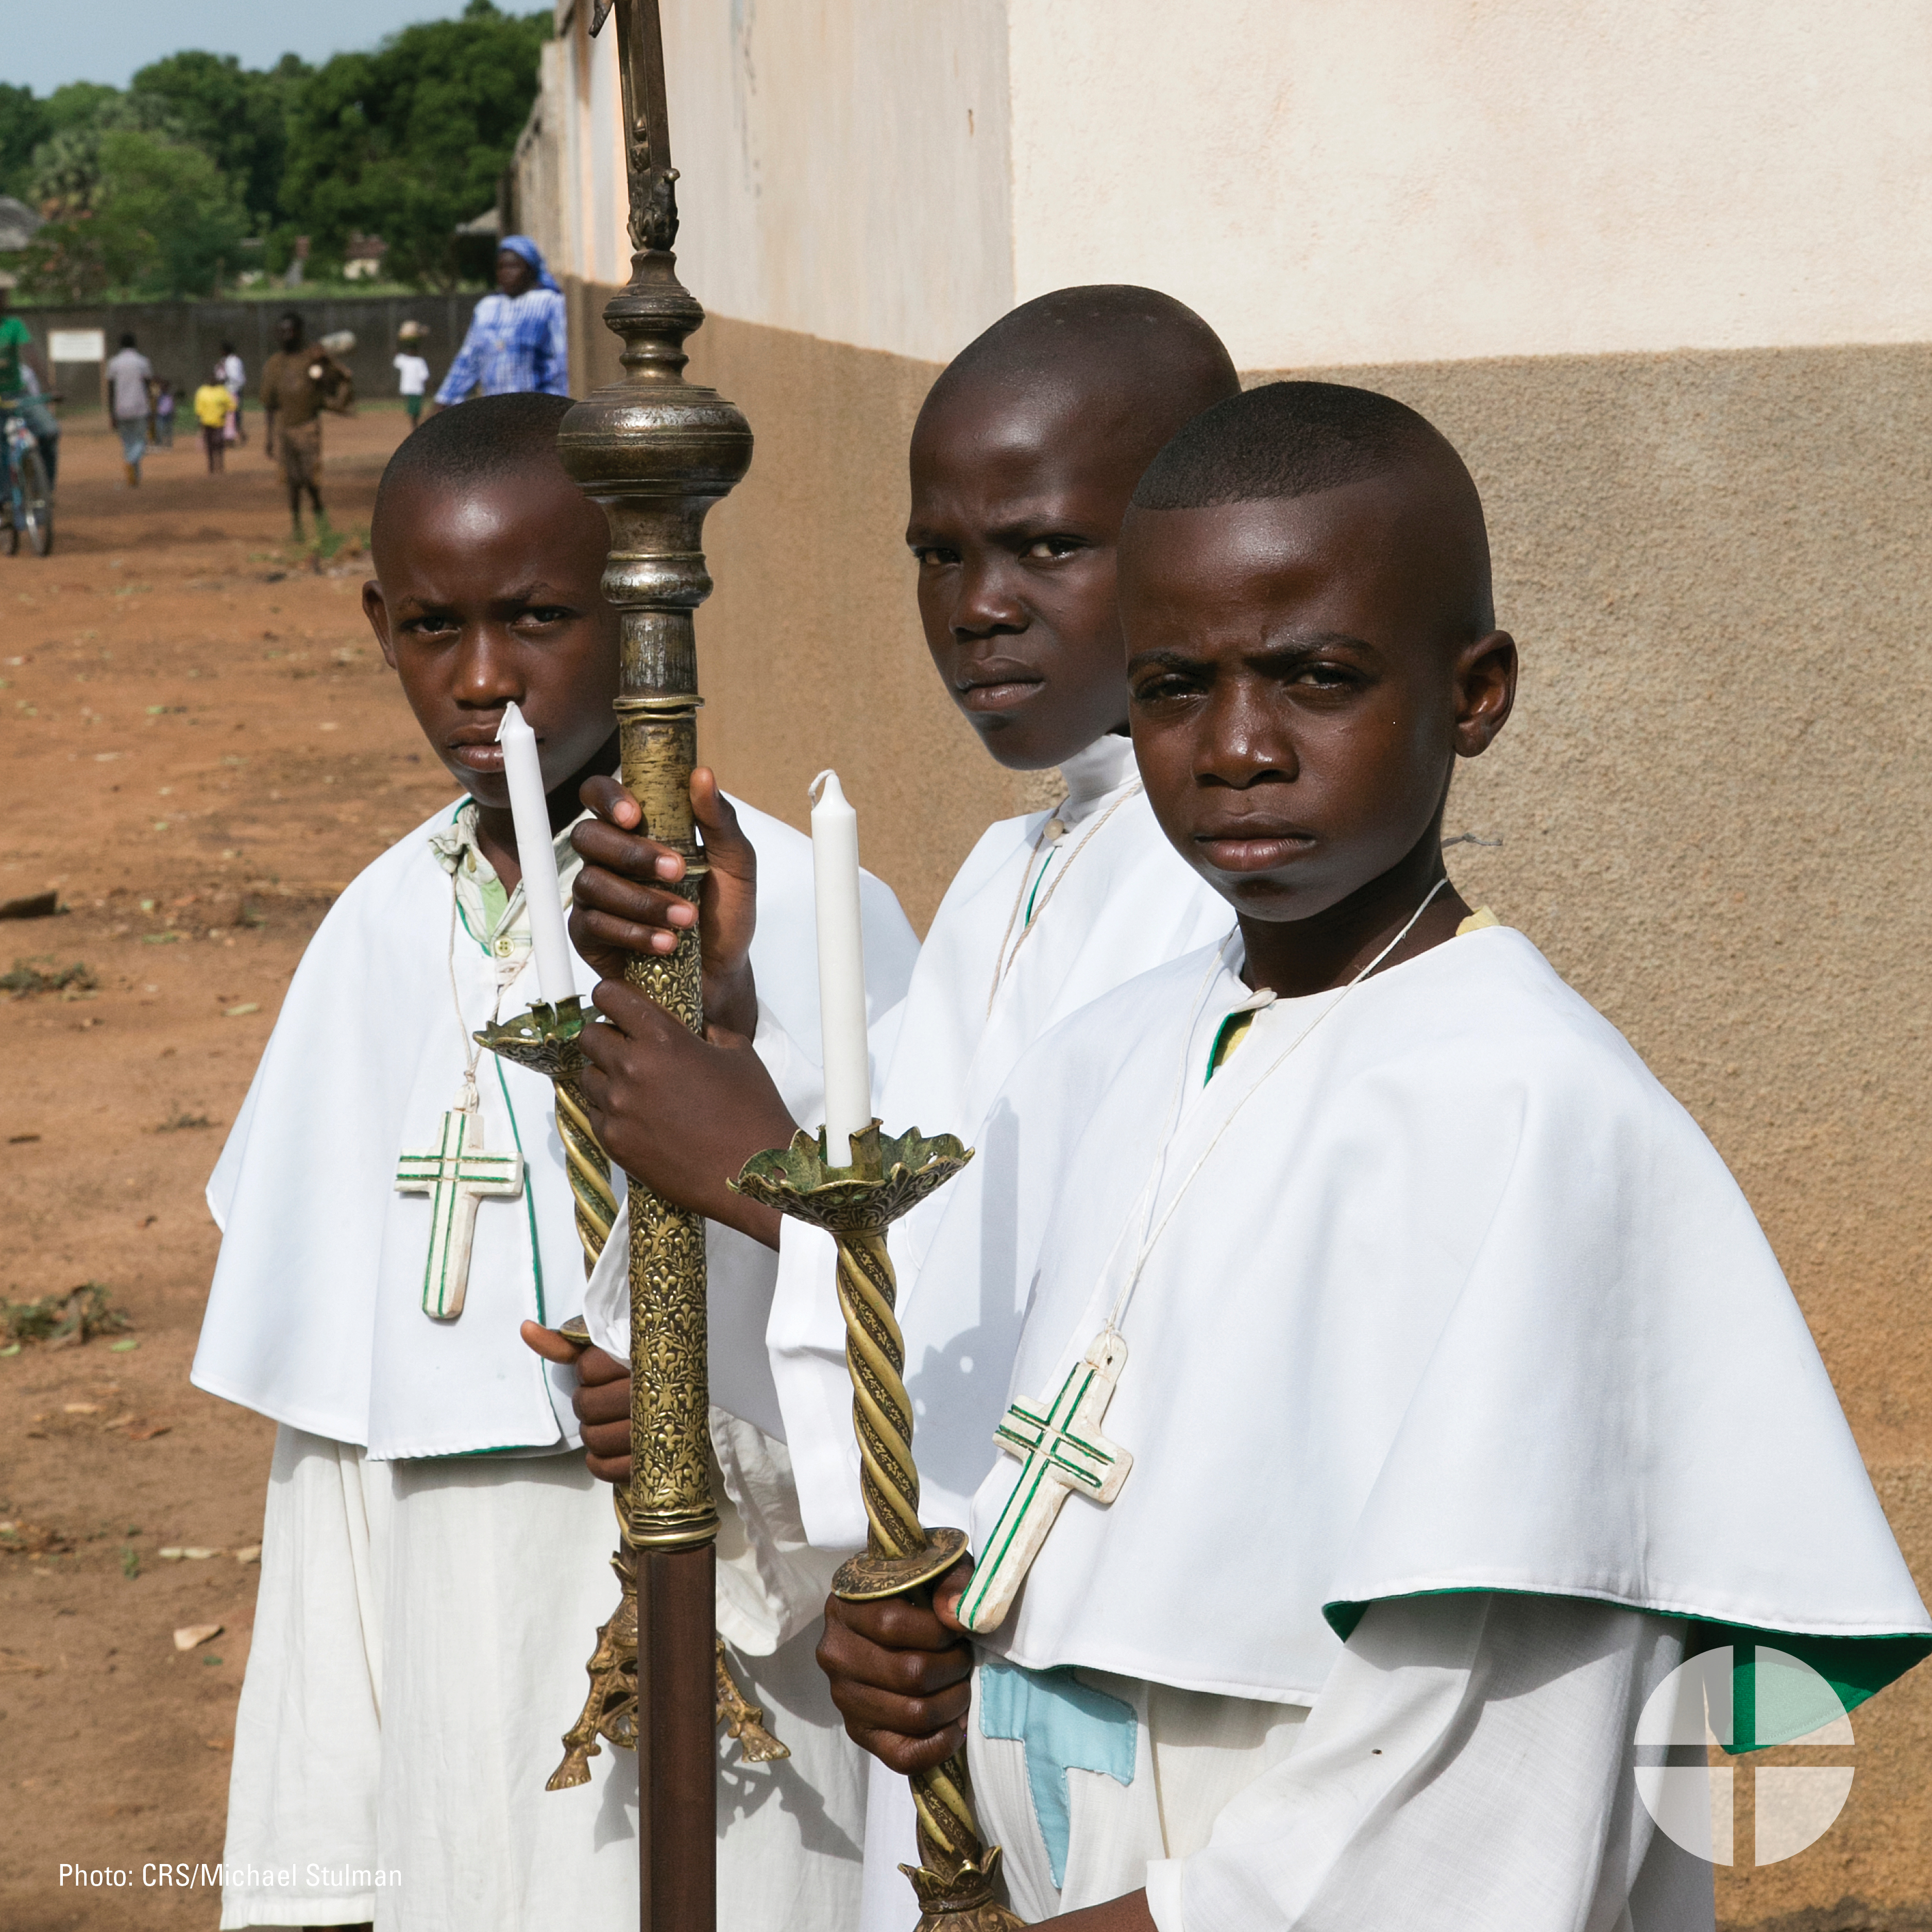

Facebook/Instagram/Twitter:
Despite many challenges, the Church in Africa is growing! Our special collection this weekend supports the Church in Africa and the faithful there. #StandWithAfrica #1church1mission www.usccb.org/africa

Post 4: Week of the Collection
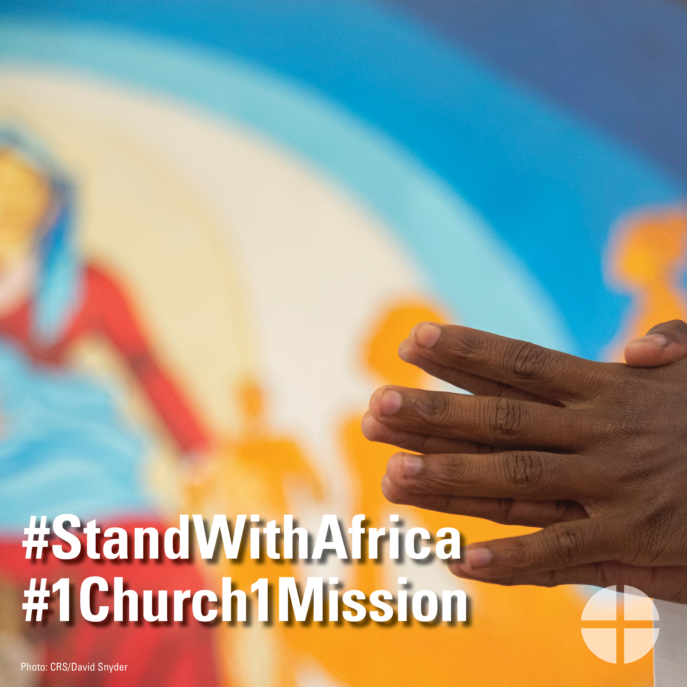

Facebook/Instagram/Twitter:
Support the Solidarity Fund for the Church in Africa. Make a real difference in the lives of Catholics there. Please be generous this weekend at Mass! #StandWithAfrica #1church1mission www.usccb.org/africa

Post 5: Week of the Collection
The link in the posts leads to a video. Please be sure to copy the whole link, and the video will automatically be linked on Facebook and Twitter!
Facebook/Twitter:
Your support to the Solidarity Fund for the Church in Africa supports projects like this pro-life conference in Ghana. Please be generous to the collection this weekend! #StandWithAfrica #1church1mission https://goo.gl/1BlhPj

Post 6: Week of the Collection

Facebook/Instagram/Twitter:
#StandWithAfrica and support the Solidarity Fund for the Church in Africa! Our special collection this weekend supports pastoral outreach to Catholics there. #StandWithAfrica #1church1mission www.usccb.org/africa

Post 7: Day of Collection
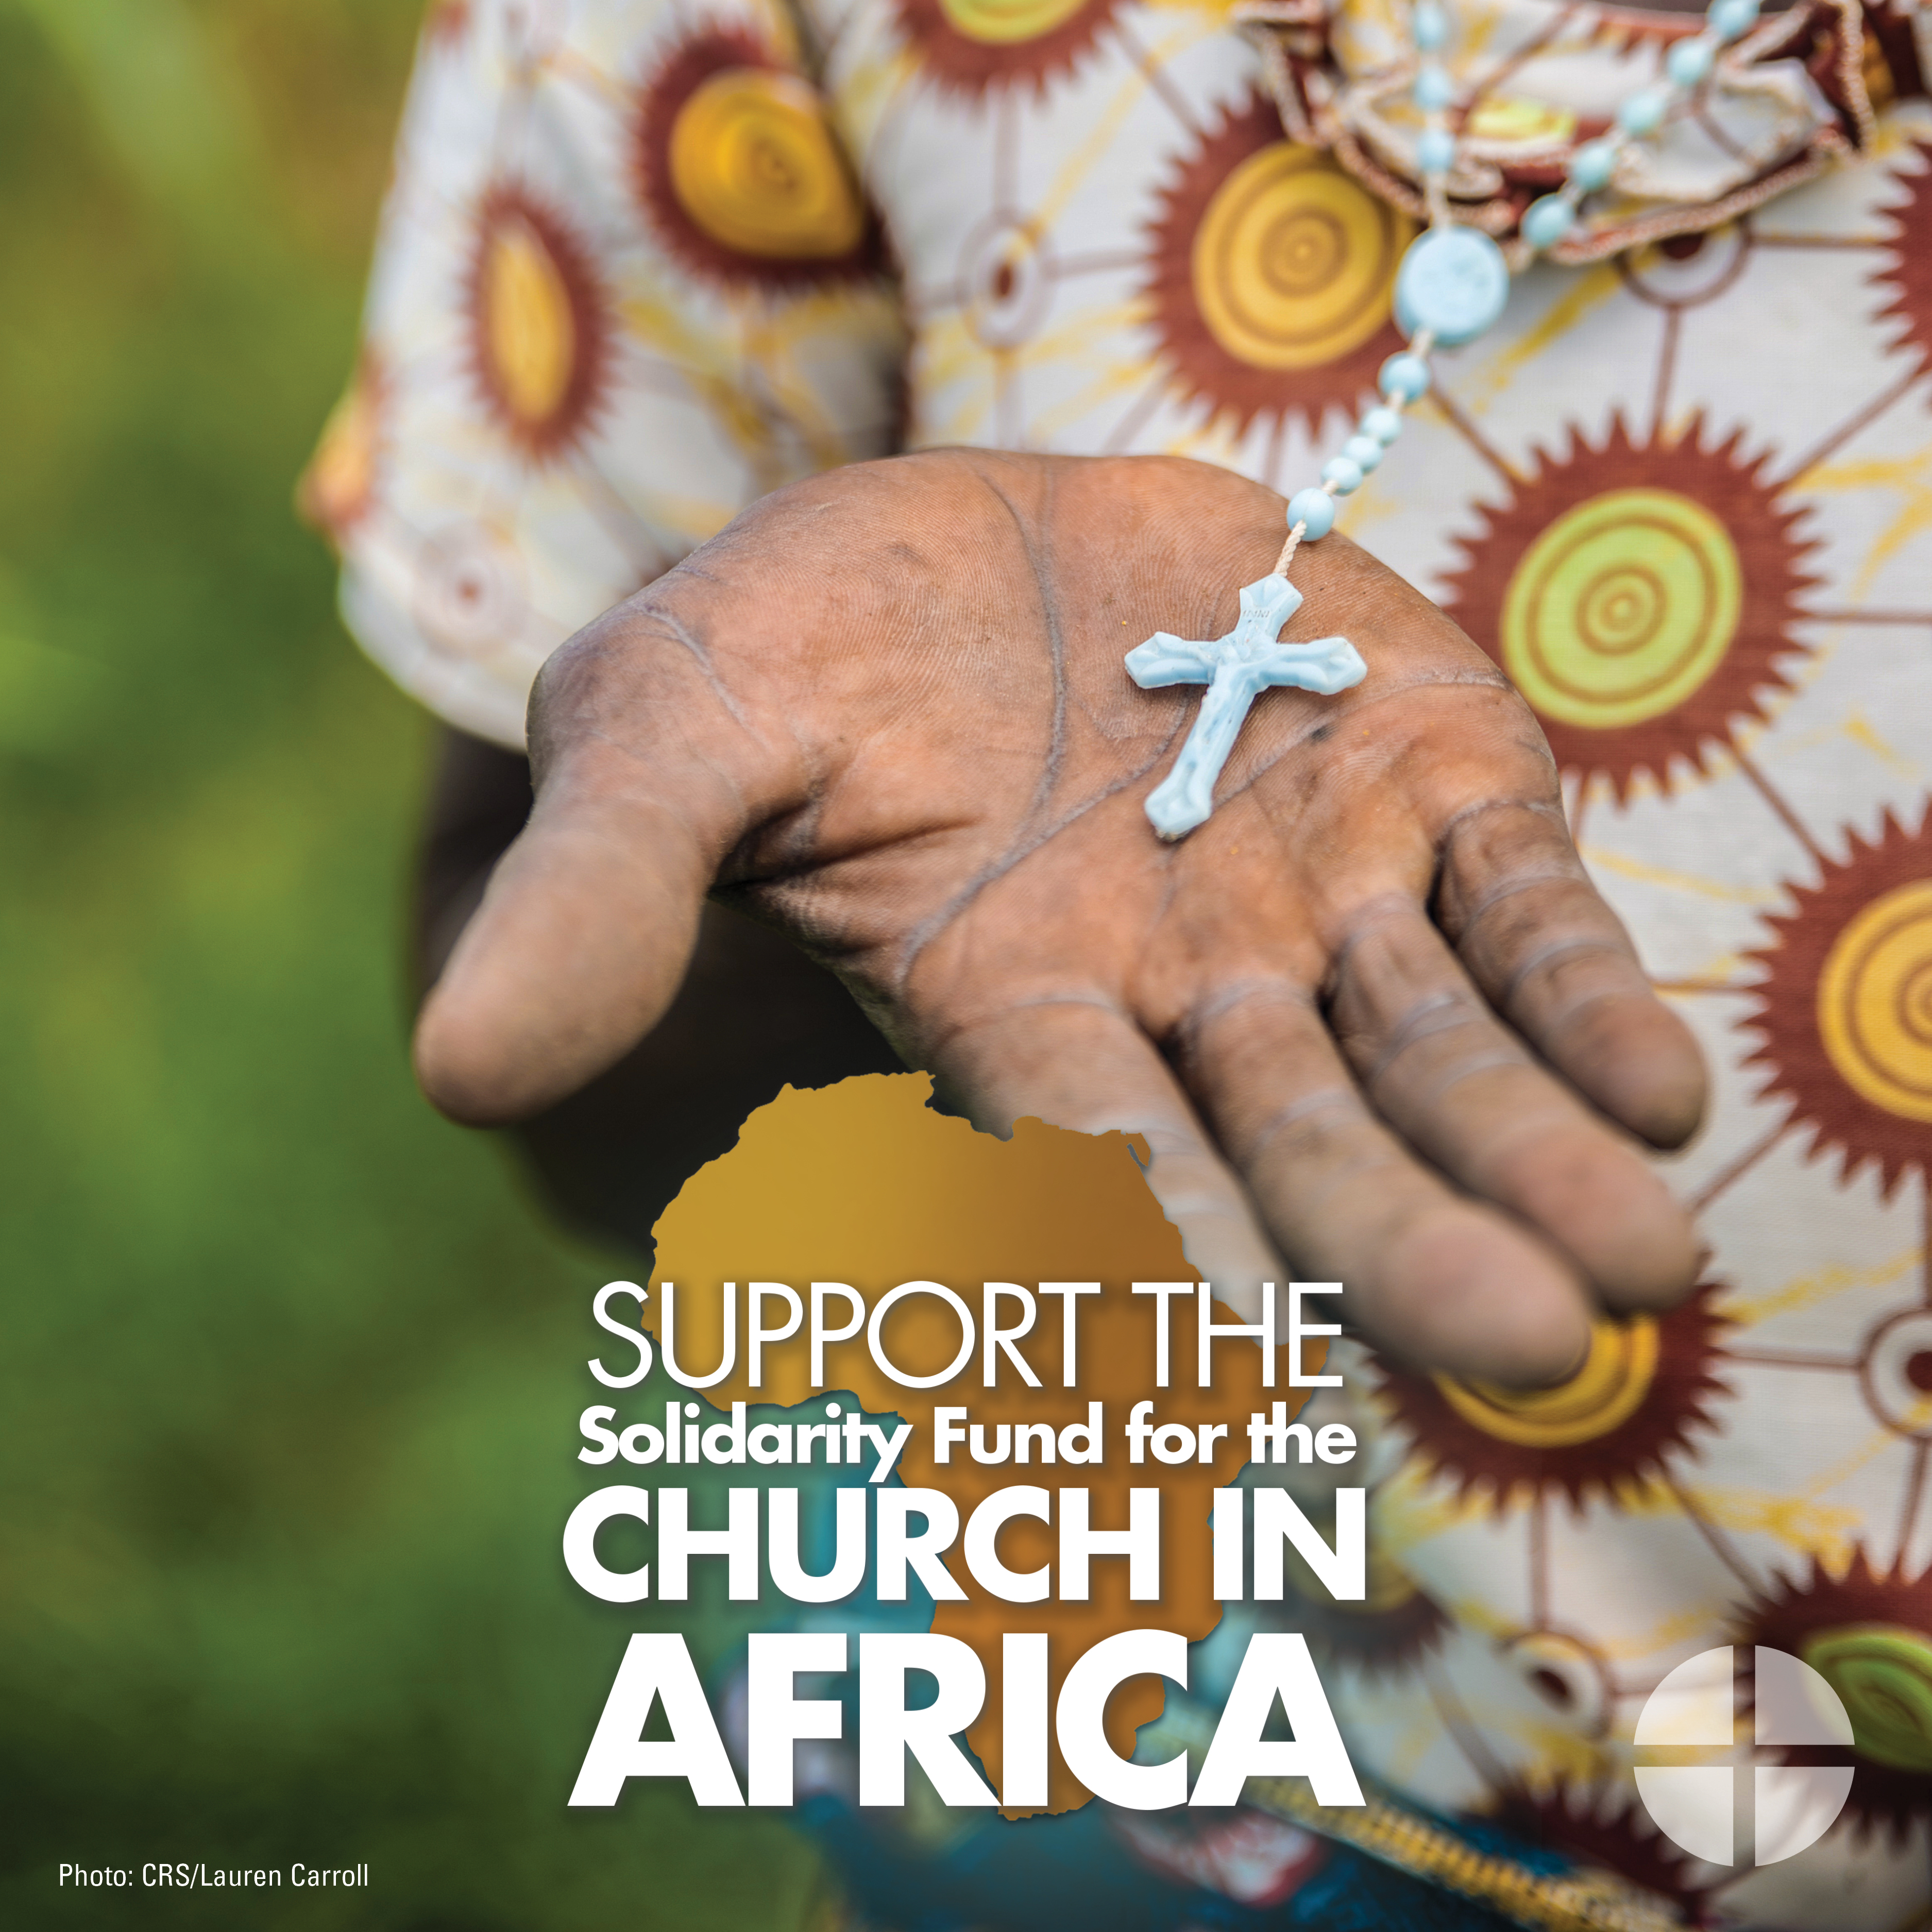
Facebook/Instagram/Twitter:
Our special collection this weekend supports the Solidarity Fund for the Church in Africa. Please be generous and #StandWithAfrica #1church1mission www.usccb.org/africa

