Word of Life: October 2023
Recommended dates are provided, but you are welcome to use these materials at any time!
Respect Life Month 2023: Radical Solidarity

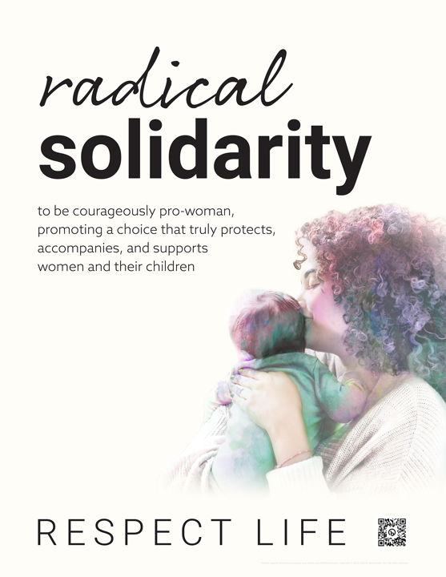
2023 Respect Life Month resources have been developed to assist you in helping parishioners understand and value the gift of human life and become engaged with building a culture that cherishes every human life.
A variety of materials are available to order in print or to download online.
Visit respectlife.org/respect-life-month!
Featured Resources
- Poster (Order)
- Prayer Card (Order)
- Novena
- Respect Life Month Action Guide
(a sample timeline, action ideas & more!)
- Respect Life Reflection
- Graphics

Sample Pulpit Announcements

Option 1 (October 7-8)

Join Catholics nationwide praying a special Respect Life Month novena October 13th through the 21st. See the bulletin for more information.

Option 2 (any weekend in October)

Every October, we celebrate Respect Life Month. We consider more deeply why every human life is valuable and reflect on how to build a culture that protects life from conception to natural death. See the bulletin for more information.

Sample Bulletin Announcements
Option 1 (October 7-8)
Join thousands of Catholics praying a Respect Life Month novena Friday, October 13 – Sunday, October 21. Get daily prayers, reflections, and more. Sign up at respectlife.org!

Option 2 (any weekend in October)
It’s Respect Life Month!
Join Catholics nationwide in celebrating Respect Life Month. Visit respectlife.org/celebrate.

Word of Life – October 2023
Intercessions for Life
October 1st  For all Catholics:  On this Respect Life Sunday,  may we resolve anew  to protect the gift of every human life  and serve moms in need of assistance;  We pray to the Lord: | Twenty-sixth Sunday  in Ordinary Time  (Also observed in the U.S. as  Respect Life Sunday)
October 8th  May God grant us the wisdom and courage  to lovingly protect His gift of human life  at every stage, in sickness and in health;  We pray to the Lord: | Twenty-seventh Sunday  in Ordinary Time
October 15th  That the life of every person,  from conception to natural death,  will be protected in our laws  and cherished in our hearts;  We pray to the Lord: | Twenty-eighth Sunday  in Ordinary Time
October 22nd  For women and men suffering after abortion:  May the Church’s abortion healing ministry,  Project Rachel, help them find peace and healing through God’s endless mercy;  We pray to the Lord: | Twenty-ninth Sunday  in Ordinary Time
October 29th  For those nearing the end of life:  May they receive care that respects their dignity and protects their lives  as they place their hope  in the promise of eternal life;  We pray to the Lord: | Thirtieth Sunday  in Ordinary Time

Word of Life – October 2023
Bulletin Quotes
October 1st  “Radical solidarity compels us to come alongside vulnerable mothers in profound friendship, compassion, and support for both them and their preborn children. It requires us to address the fundamental challenges that lead an expectant mother to believe she is unable to welcome the child God has entrusted to her. We must do all we can to provide mothers, children, and families with the support they need to flourish. This cannot be accomplished by laws or policy alone, but requires the continual transformation of our own hearts.”  USCCB Secretariat of Pro-Life Activities  Respect Life Reflection: “Radical Solidarity” (respectlife.org/radical-solidarity-reflection) | 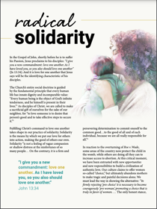  Download | Read Online
October 8th  “An old Irish proverb says, ‘It is in the shelter of each other that the people live.’ Indeed, we are created to depend upon one another and walk together in suffering. But when family members or friends approach life's end, we may not know how best to ‘shelter’ them. Here are some concrete ways we can compassionately care for them: usccb.org/end-of-life-care.”  USCCB Secretariat of Pro-Life Activities  Caring for Loved Ones at Life’s End | 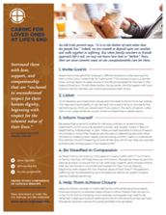  Download
October 15th  “O Blessed Mother, at the angel’s word you went in haste to the aid of your cousin Elizabeth. Although pregnant yourself, you placed her needs before your own. By your example of radical solidarity, teach us to reverence and protect those in need, without conditions or expectations.”  USCCB Secretariat of Pro-Life Activities  “Prayer for Radical Solidarity" (respectlife.org/prayer-for-radical-solidarity) | 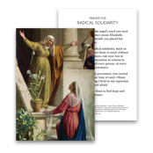  Order | Download
October 22nd  “I would now like to say a special word to women who have had an abortion. The Church is aware of the many factors which may have influenced your decision, and she does not doubt that in many cases it was a painful and even shattering decision. The wound in your heart may not yet have healed. …But do not give in to discouragement and do not lose hope. …The Father of mercies is ready to give you his forgiveness and his peace in the Sacrament of Reconciliation.”  Pope Saint John Paul II, Evangelium vitae, no. 99. © 1995, Libreria Editrice Vaticana.  Used with permission. All rights reserved. | 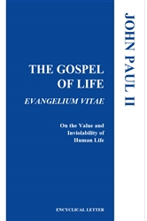  Read Online
October 29th  “Hope is always possible. To those who care for the sick, the scene of the Cross provides a way of understanding that even when it seems that there is nothing more to do there remains much to do, because ‘remaining’ by the side of the sick is a sign of love and of the hope that it contains. Healed by Jesus, we become men and women called to proclaim his healing power and provide care for our neighbors, until the very end.”  USCCB Secretariat of Pro-Life Activities  “The Witness of the Good Samaritan: Palliative Care and Hospice” | 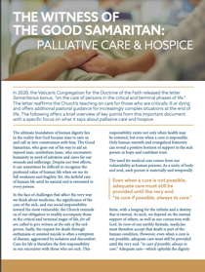  Download

Word of Life – October 2023

Bulletin Art
You are welcome to use these and other downloadable images from the online Respect Life image gallery, provided they are not altered in any way, other than the size. Thank you!

Sunday, October 1st, 2023
Featuring Reflection: “Radical Solidarity”
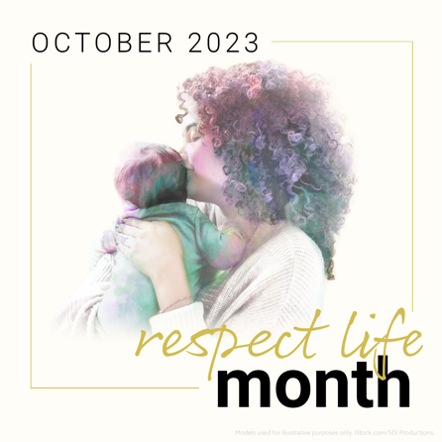
- Respect Life Reflection
- Image

View our full image gallery online for additional sizes and formats of artwork for Respect Life Month.

Sunday, October 22nd, 2023
Featuring “Healing within Marriage from an Abortion”
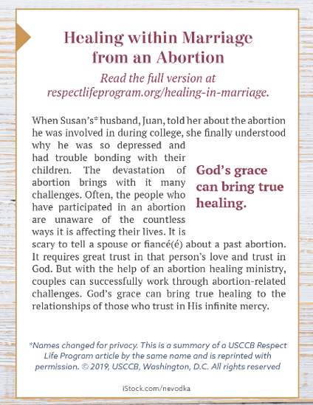
- Bulletin Box (color): English | Spanish
- Bulletin Box (grayscale): English | Spanish
- Bulletin Box (text-only): Download

