Word of Life: December 2023
Recommended dates are provided, but you are welcome to use these materials at any time!
Featured this Month…
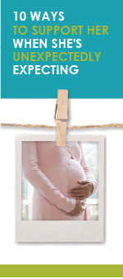
Advent
The season of Advent is a time of anticipation that directs our hearts and minds to preparing for the celebration of the Lord’s birth on Christmas and for Christ’s second coming at the end of time. During this time of preparation and expectant waiting, we also remember expectant mothers who are preparing for the birth of their children. This Advent season, consider highlighting the article “10 Ways to Support Her When She’s Unexpectedly Expecting.” (It is available in a variety of formats at the bottom of this webpage.)

Solemnity of the Immaculate Conception of the Blessed Virgin Mary
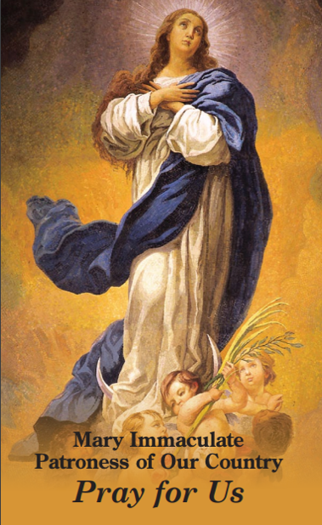
Patronal feast day of the United States of America (December 8, 2023)
On December 8, the Church celebrates the Solemnity of the Immaculate Conception of the Blessed Virgin Mary. (This feast is a holy day of obligation for dioceses in the United States.) On this feast, we celebrate Mary’s conception free from the stain of Original Sin, and we recognize that Mary’s life began the moment she was conceived in the womb of St. Anne. So, too, does every human life begin at the moment of fertilization, when it is lovingly knit together by God the Father.
The Immaculate Conception is sometimes confused with the Annunciation. This bulletin insert can be used to help differentiate these two important celebrations. On this solemnity, consider praying Pope Francis’ Prayer for the Immaculate Conception: “We are in need of your immaculate gaze, to rediscover the ability to look upon persons and things with respect and awareness.”

Word of Life – December 2023
Intercessions for Life
December 3rd  For all the faithful:  May the Lord help us build a culture of life  in vigilant expectation of his return;  We pray to the Lord: | First Sunday of Advent
December 8th  For women who are unexpectedly pregnant:  May they be filled with trust in God’s providence  and lovingly welcome the gift of their child;  We pray to the Lord: | Solemnity of the Immaculate Conception of the Blessed Virgin Mary
December 10th  May God help us prepare the way of the Lord  by acting with tenderness and compassion,  especially toward the most vulnerable among us;  We pray to the Lord: | Second Sunday of Advent
December 17th  For all victims of human trafficking:  May they find hope and healing  in the Lord who proclaims liberty to captives  and release to prisoners;  We pray to the Lord: | Third Sunday of Advent
December 24th  Inspired by the example of the Blessed Mother,  may we, like Mary, have the courage  to say “yes” to God’s gift of human life;  We pray to the Lord:  December 25th  For all Christians:  May the birth of Our Lord Jesus Christ  awaken in our hearts wonder  at the precious gift of every child;  We pray to the Lord:  December 31st  For all families:  As the domestic Church,  may they pursue holiness,  pass on the faith, and persevere in love;  We pray to the Lord: | Fourth Sunday of Advent  The Nativity of the Lord (Christmas)  Feast of the Holy Family of Jesus, Mary and Joseph

Word of Life – December 2023

Bulletin Quotes
December 3rd  “The Gospel of Life recognizes the full range of threats against human life, from poverty and malnutrition to murder and war. Particular emphasis, however, is placed on threats to life at its beginning and end—precisely when it is most in need of protection. In modern times, children in their mothers’ wombs and those approaching the end of their lives are certainly among the ‘least of these’ in our world’s estimation.”  USCCB Secretariat of Pro-Life Activities  respectlife.org/live-the-gospel-of-life | 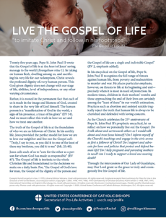  Download
December 10th  “Perhaps one of your friends has become pregnant unexpectedly. As someone who has been there, I encourage you to support your friend in her new journey of being a mother.” Learn how at respectlife.org/support-her.  USCCB Secretariat of Pro-Life Activities  “10 Ways to Support Her When She’s Unexpectedly Expecting” | 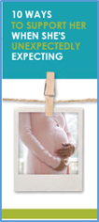  Order | Download
December 17th  “O St. Bakhita, assist all those who are trapped in a state of slavery;  Intercede with God on their behalf so that they will be released from their chains of captivity. Those whom man enslaves, let God set free.”  USCCB, “Prayer to St. Josephine Bakhita” | 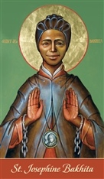  Download
December 24th  “O Blessed Mother, at the angel’s word you went in haste to the aid of your cousin Elizabeth. Although pregnant yourself, you placed her needs before your own. By your example of radical solidarity, teach us to reverence and protect those in need, without conditions or expectations… Obtain for us the grace to bring Christ to any expectant mother who is alone and afraid.”  USCCB Secretariat of Pro-Life Activities  Prayer for Radical Solidarity (www.respectlife.org/prayer-for-radical-solidarity) | 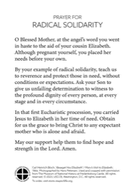  Download | Order
December 31st  “Dearest St Joseph… Help us to faithfully commit ourselves to the service and defense of human life —especially where it is vulnerable or threatened. Obtain for us the grace to do the will of God in all things.”  USCCB Secretariat of Pro-Life Activities  A Prayer to St. Joseph, Defender of Life (www.respectlife.org/prayer-to-st-joseph) | 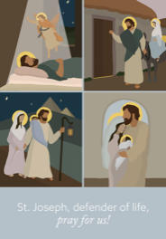  Download | Order

Word of Life - December 2023

Bulletin Art
You are welcome to use these and other downloadable images from the online Respect Life image gallery, provided they are not altered in any way, other than the size. Thank you!
Sunday, December 3rd, 2023
Featuring “Live the Gospel of Life”
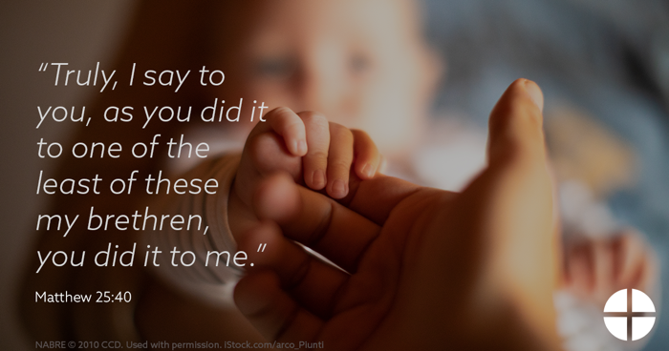
- Graphic
- Bulletin Insert

Sunday, December 10th, 2023
Featuring “10 Ways to Support Her When She’s Unexpectedly Expecting”
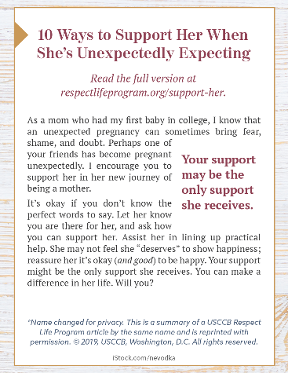
- Bulletin Box

Sunday, December 31st, 2023
Featuring Prayer for Radical Solidarity
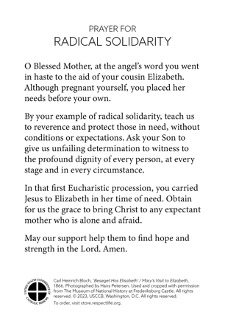
- Graphic

