Word of Life: February 2024
Recommended dates are provided, but you are welcome to use these materials at any time!
Featured this Month…
February 7–14, 2024: National Marriage Week
Sunday, February 11, 2024: World Marriage Day
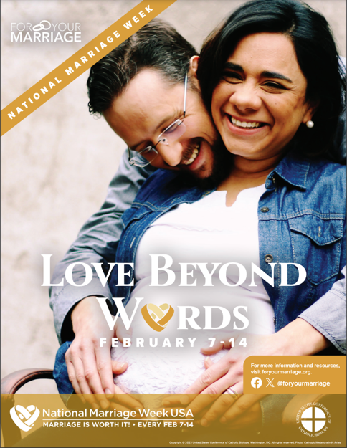
The upcoming observances of National Marriage Week (February 7-14, 2024) and World Marriage Day (Sunday, February 11, 2024) are opportunities to focus on building a culture of life and love by supporting and promoting marriage and the family.
The USCCB Secretariat of Laity, Marriage, Family Life and Youth offers many resources. The theme for 2024 is “Love Beyond Words.”
Resources include:
- Poster
- Preaching Resource
- Social Media Graphics: English | Spanish
- At-Home Couples Retreat
- And more!

Related Respect Life Resources
Seven Considerations while Navigating Infertility
Married Love and the Gift of Life
Healing within Marriage from an Abortion

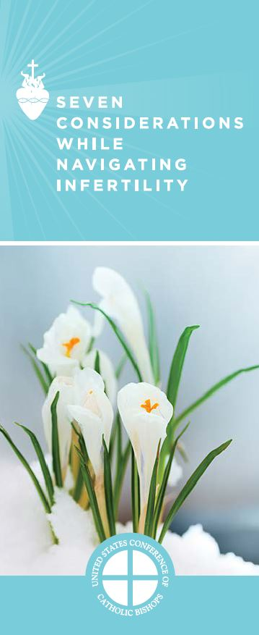

Word of Life – February 2024
Intercessions for Life
February 4th  For the sick, especially those nearing life’s end:  May they be cared for with tenderness and compassion  as they prepare to enter eternal life;  We pray to the Lord: | Fifth Sunday in Ordinary Time
February 11th  For all married couples:  May their openness to new life  bear witness to the generous love of God;  We pray to the Lord: | Sixth Sunday in Ordinary Time
February 18th  For married couples struggling with infertility:  May the Lord help them trust in His love  and sustain them with His peace;  We pray to the Lord: | First Sunday of Lent
February 25th  May every human person,  from conception to natural death,  be recognized as precious and beloved  in the eyes of the Lord;  We pray to the Lord: | Second Sunday of Lent

Word of Life – February 2024

Bulletin Quotes
February 4th  “A society is all the more human to the degree that it cares effectively for its most frail and suffering members, in a spirit of fraternal love. Let us strive to achieve this goal, so that no one will feel alone, excluded or abandoned.”  Pope Francis, Message for the 29th World Day of the Sick 2021  © 2020, Libreria Editrice Vaticana. Used with permission. All rights reserved. | 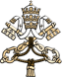
February 11th  “Married love differs from any other love in the world. By its nature, the love of husband and wife is so complete, so ordered to a lifetime of communion with God and each other, that it is open to creating a new human being they will love and care for together.”  USCCB, Married Love and the Gift of Life | Order | Read Online
February 18th  “We often assume parenthood happens easily after ‘I do,’ but for many married couples, it does not. For some, the joy of conception never happens. Others suffer repeated miscarriages. Still others experience secondary infertility… If you experience difficulty bringing a child into your family, know that you are not alone. God is with you, and his Church desires to walk with you… God has a beautiful plan for your life as a married couple.”  USCCB Secretariat of Pro-Life Activities  “Seven Considerations While Navigating Infertility”  respectlife.org/navigating-infertility | 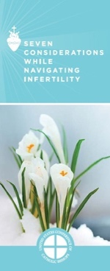  Order | Download
February 25th  “The essence of our identity is that we are created in God's image and likeness and loved by Him. Nothing can diminish the priceless worth of any human life. Every person is cherished.”  USCCB Secretariat of Pro-Life Activities  Respect Life Reflection: Cherished, Chosen, Sent  usccb.org/cherished-chosen-sent-reflection | 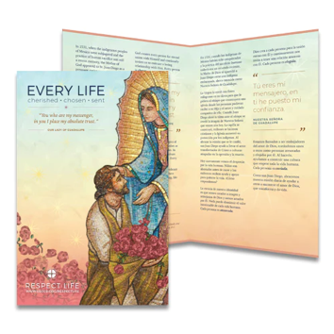  Order | Download

Word of Life – February 2024

Bulletin Art
You are welcome to use these and other downloadable images from the online Respect Life image gallery, provided they are not altered in any way, other than the size. Thank you!

Sunday, February 11, 2024
Graphic: English | Spanish
Additional Graphics: English | Spanish

Sunday, February 18, 2024
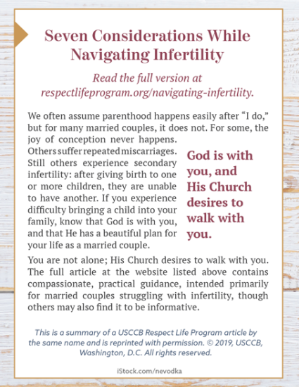
Full Article: English | Spanish
Bulletin Box: English | Spanish

Sunday, February 25, 2024
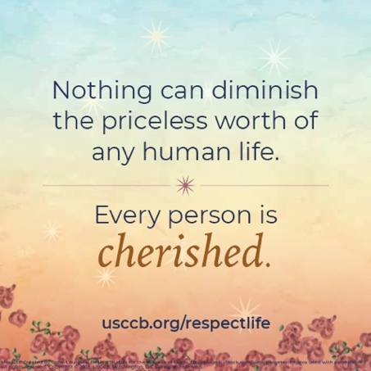
Reflection: English | Spanish
Image: English | Spanish

