Word of Life: April 2024
Recommended dates are provided, but you are welcome to use these materials at any time!
Featured this Month…
April 7, 2024: Sunday of Divine Mercy
On the Second Sunday of Easter, the Church celebrates the Sunday of Divine Mercy. It provides an important opportunity to share Christ’s message of mercy, especially with those who suffer because of their participation in one or more abortions. By the age of 45, as many as 1 in 3 women have had an abortion, and a similar number of men and family members have been involved. Many feel that abortion is “the unforgivable sin.” They need to hear that, through the Sacrament of Reconciliation, God forgives every sin of a repentant heart, even the sin of abortion. In fact, Jesus’ message to St. Faustina is that the greater the sinner, the greater the right to His mercy.
Prayer | Order
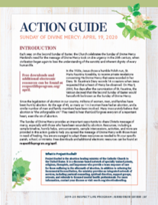
The Action Guide for the Sunday of Divine Mercy includes a sample timeline, simple steps, sample announcements, homily helps, and an activity to help you bring Christ’s message of mercy to your parish community.
Priests and deacons may find these homily considerations especially helpful for sharing God’s message of mercy with parishioners who long to hear that it applies to them, too.
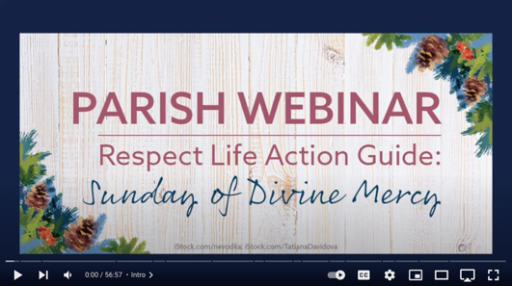
Visit respectlife.org/action-guides#sunday-of-divine-mercy and usccb.org/prolife/divine-mercy-sunday for additional resources.
This introductory webinar recording is for those who want to help their parish share Christ’s message of mercy, especially with those who suffer from participation in an abortion.
USCCB staff walk through the website and materials available, explaining how the tools above can help parishes spread the message of Divine Mercy with those most in need of healing.

Additional Resources on Abortion Healing
- Bridges of Mercy for Healing after Abortion (Available to order as a pamphlet or flyer.)
- Healing within Marriage from an Abortion (Order)
- Prayer Guide: Divine Mercy
- Divine Mercy in My Soul

Word of Life – April 2024
Intercessions for Life
April 7th  For those who have participated in an abortion  and feel they have committed an unforgiveable sin:  May they come to know the Lord’s limitless mercy,  and turn to Him for forgiveness and healing;  We pray to the Lord: | Second Sunday of Easter  (or Sunday of Divine Mercy)
April 14th  For all who work to build a culture of life:  May the hope of the Resurrection  renew and sustain them in their mission;  We pray to the Lord: | Third Sunday of Easter
April 21st  For those tempted to end their lives:  That through the grace of the Resurrection,  Christ will fill them with hope, belief in his love,  and the assurance that their lives are worth living;  We pray to the Lord: | Fourth Sunday of Easter
April 28th  For elected officials:  May they work to protect human life  from conception to natural death;  We pray to the Lord: | Fifth Sunday of Easter

Word of Life – April 2024
Bulletin Quotes

April 7th  If you or someone you know has had an abortion, be assured that it is never too late to seek God’s forgiveness in the Sacrament of Reconciliation. Additionally, other confidential, compassionate help is available. Select “Find Help” from the menu on www.hopeafterabortion.org to find the diocesan Project Rachel Ministry near you.  USCCB Secretariat of Pro-Life Activities, “Bridges of Mercy for Healing after Abortion”  www.usccb.org/bridges-of-mercy | 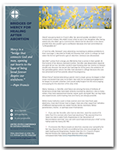  Order | Download
April 14th  “Like us, Christ entered the world through the womb of a woman. He willingly experienced the fullness of human suffering. He breathed his last on the Cross at Calvary in order that He might save us. Therefore, ‘God is the foundation of hope: not any god, but the God who has a human face and who has loved us to the end’ (Spe salvi 31).”  USCCB Secretariat of Pro-Life Activities  “Respect Life Reflection: Christ Our Hope in Every Season of Life” (citing Pope Benedict XVI, Spe salvi © 2007, Libreria Editrice Vaticana. Used with permission. All rights reserved.) | 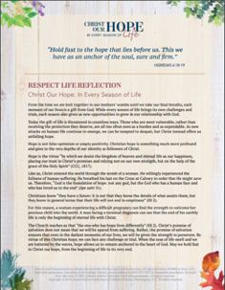  Download
April 21st  “Suicidal individuals—with or without a terminal illness—typically do not want to die; they want to escape what they perceive to be an intolerable situation, and they inaccurately believe that suicide is their only way out. The patient requesting assisted suicide is often asking, ‘Does anyone want me to be alive, or care enough to talk me out of this request and support me through this difficult time?’”  USCCB Secretariat of Pro-Life Activities, “Every Suicide is Tragic”  usccb.org/every-suicide-tragic | 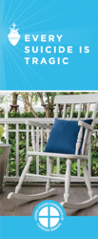  Order | Read Online
April 28th  “Virgin of Guadalupe, Patroness of unborn children, we implore your intercession for every child at risk of abortion. … Guide our public officials  to defend each and every human life through just laws. Inspire us all to bring our faith into public life, to speak for those who have no voice. We ask this in the name of your Son, Jesus Christ, who is Love and Mercy itself. Amen.”  USCCB Secretariat of Pro-Life Activities, “A Prayer to Our Lady of Guadalupe” | 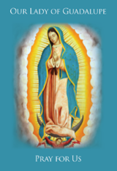  Order | Read Online

Word of Life – April 2024

Bulletin Art
You are welcome to use these, provided they are not altered in any way, other than the size. Thank you!

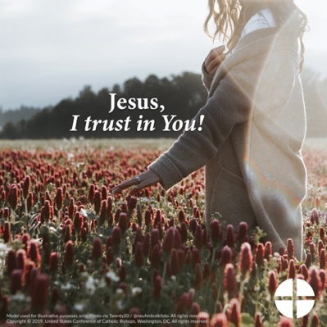

- Download Image: English | Spanish

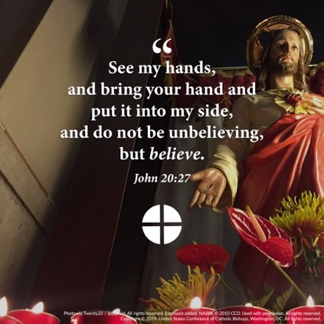
- Download Image: English | Spanish

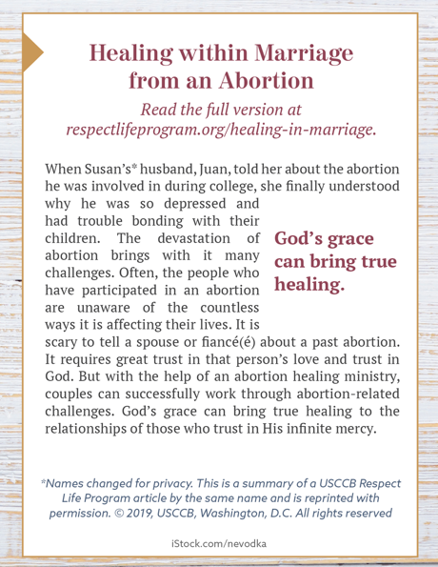
- Download Bulletin Box: English | Spanish

