Word of Life: May 2024
Recommended dates are provided, but you are welcome to use these materials at any time!
Featured this Month…
March 25 – June 2024: Nationwide Invitation to Prayer

On March 26, 2024 the U.S. Supreme Court heard oral arguments in a case that has the potential to make a major impact in the widespread accessibility of chemical abortion (abortion pills). Chemical abortions are now the most common form of abortion in the United States.
The USCCB Committee on Pro-Life Activities is inviting Catholics to offer a daily Prayer to St. Joseph, Defender of Life for the end of abortion and for the protection of women and pre-born children. The prayer and more information can be found at www.usccb.org/prolife/nationwide-invitation-prayer.

May 12, 2024: Mother’s Day
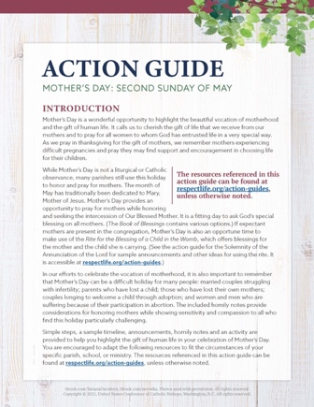
Mother’s Day is a wonderful opportunity to highlight the beautiful vocation of motherhood and the gift of life.
Our Mother’s Day action guide features homily considerations, intercessions, activity ideas that can be used in the parish or at home, and more to assist with honoring and praying for mothers in your parish community.
A webinar recording of USCCB staff walking through the materials, as well as the presentation slides from that webinar, are available.
*You’re welcome to use one component of the action guide or the whole thing—whatever’s helpful!

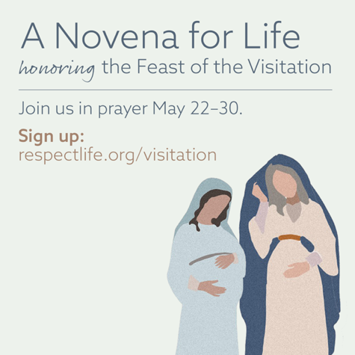
May 31, 2024: Feast of the Visitation of the Blessed Virgin Mary
On May 31st, the Church celebrates the Feast of the Visitation of the Blessed Virgin Mary. This feast commemorates the Blessed Mother’s visit to her cousin Elizabeth and the encounter of Jesus and St. John the Baptist while in the wombs of their mothers. Invite your parishioners to praye A Novena for Life in honor of this special feast day.
Suggested Date for Graphic/Announcement: Weekends of May 11-12 and May 18-19, 2024
Download Graphic
Sample Announcement:
Pray a Novena for Life in honor of the Feast of the Visitation. Sign up at respectlife.org/visitation!
Word of Life – May 2024

Intercessions for Life
May 5th  For all Christians:  May our example give witness to  the precious gift of human life and  our responsibility to protect it until its natural end;  We pray to the Lord: | Sixth Sunday of Easter
May 12th  May our parish community come together  to become a place of welcome and assistance  for all mothers in need;  We pray to the Lord: | Solemnity of the Ascension of the Lord  (or the Seventh Sunday of Easter where applicable)  (Mother’s Day is not a liturgical feast but is often recognized at Mass.)
May 19th  May the Holy Spirit strengthen God’s people  to embrace and protect  the precious gift of human life;  We pray to the Lord: | Pentecost Sunday
May 26th  May we more deeply respect  the gift of each person,  who is created and called to holiness  by the gracious action of the Trinity;  We pray to the Lord: | Solemnity of the Most Holy Trinity

Word of Life – May 2024
Bulletin Quotes
May 5^{h}  “The Lord says to us, ‘Do not fear: I am with you’ (Isaiah 41:10). He speaks these words not as one who merely observes our pain, but as one who experienced immense suffering. And the very wounds that bear witness to his suffering indicate the essence of our identity and worth: we are loved by God. Reflecting on the healed wounds of the Risen Christ, we see that even our most difficult trials can be the place where God manifests his victory. He makes all things beautiful. He makes all things new.”  USCCB Secretariat of Pro-Life Activities, “Be Not Afraid”  NABRE © 2010 CCD. Used with permission. | 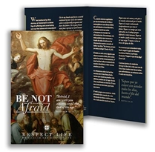  Order | Download
May 12th  “Radical solidarity compels us to come alongside vulnerable mothers in profound friendship, compassion, and support for both them and their preborn children. It requires us to address the fundamental challenges that lead an expectant mother to believe she is unable to welcome the child God has entrusted to her. We must do all we can to provide mothers, children, and families with the support they need to flourish. This cannot be accomplished by laws or policy alone, but requires the continual transformation of our own hearts, recognizing in every person the face of Christ, and placing their needs before our own.”  USCCB Secretariat of Pro-Life Activities, “Radical Solidarity” | 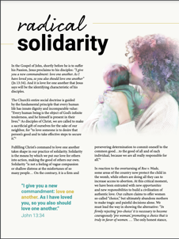  Read Online | Download
May 19th  “Without a foundational, practical formation, it is difficult for our consciences to guide us well in concrete situations. As Catholics, we have the immense gift of the teaching authority of the Catholic Church and can turn to it for help forming our consciences. For example, learning about Christian moral principles, reading the Catechism of the Catholic Church, or researching what the Church says about a challenging teaching will help us grow in knowledge of the truth.”  USCCB Secretariat of Pro-Life Activities, “Understanding Conscience” | 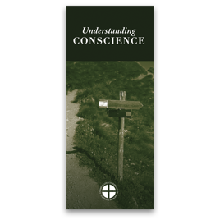  Order | Download
May 26th  “Even the weakest and most vulnerable, the sick, the old, the unborn and the poor, are masterpieces of God’s creation, made in his own image, destined to live forever, and deserving of the utmost reverence and respect.”  USCCB Respect Life flyer quoting Pope Francis’ “Day for Life Greeting”  © 2013 Libreria Editrice Vaticana. Used with permission. All rights reserved. | Order | Download

Word of Life – May 2024
Bulletin Art
You are welcome to use these images, provided they are not altered in any way, other than the size. Thank you!

Sunday, May 12th, 2024
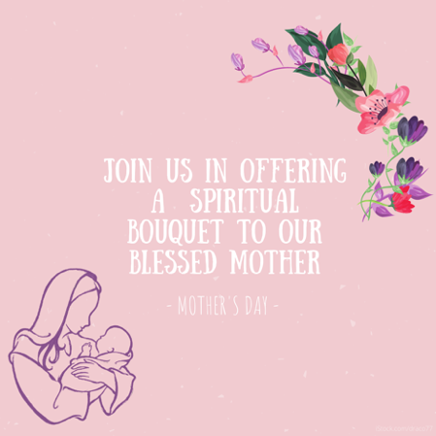
Download Image

Spiritual Bouqet Activity Instructions: Select “Activity (with at-home option)” from the list of documents on this page.

Sunday, May 19th, 2024
(The novena begins Wednesday, May 22, and the Feast of the Visitation of the Blessed Virgin Mary is Friday, May 31.)

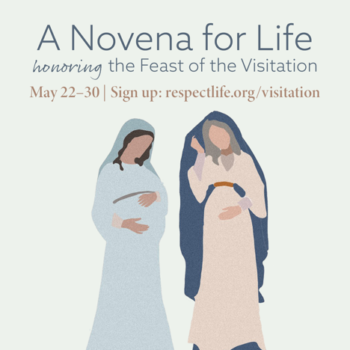
Download Image(s)

Sample Announcement:
Join a Novena for Life honoring the Feast of the Visitation. Sign up at respectlife.org/visitation!

Sunday, May 26th, 2024
Download: English | Spanish

