Word of Life: June 2024
Recommended dates are provided, but you are welcome to use these materials at any time!
Featured this Month…
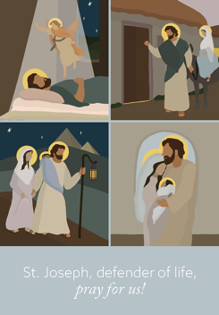
Nationwide Invitation to Prayer
March 25, 2024 – June 2024
On March 26, 2024 the U.S. Supreme Court heard oral arguments in a case that has the potential to make a major impact in the widespread accessibility of chemical abortion (abortion pills). Chemical abortions are now the most common form of abortion in the United States.

The USCCB Committee on Pro-Life Activities is inviting Catholics to offer a daily Prayer to St. Joseph, Defender of Life for the end of abortion and for the protection of women and pre-born children. The prayer and more information can be found at www.usccb.org/prolife/nationwide-invitation-prayer.

Father’s Day Action Guide
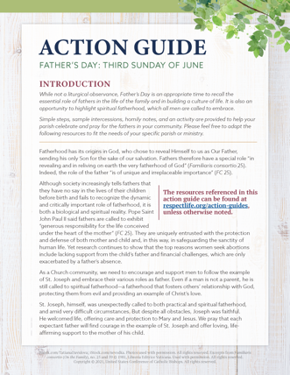
June 16, 2024
The Father’s Day Action Guide includes simple steps, sample intercessions, homily helps, and an activity to help your parish honor fathers and highlight their importance in building a culture of life. The activity can be done together as a parish or at home.

A previously recorded webinar explains the resources available. Please feel free to adapt the resources to fit the needs of your specific parish or ministry.
- Webinar Recording
- Action Guide (English | Spanish)
- Supplemental Resources
Religious Freedom Week
June 22–29, 2024
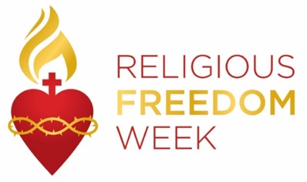
Religious Freedom Week 2024 takes place June 22–29. The Week begins with the Feast of Sts. John Fisher and Thomas More, ends with the Solemnity of Sts. Peter and Paul, and includes the Solemnity of the Nativity of St. John the Baptist. Resources will be made available to help the faithful pray, reflect on, and take action for religious liberty, both here in this country and abroad. They will be made available at usccb.org/ReligiousFreedomWeek.
Word of Life – June 2024
Intercessions for Life
June 2nd  May the worthy reception of Jesus in the Eucharist  strengthen our commitment  to protect the gift of human life  from conception to natural death;  We pray to the Lord: | The Solemnity of the Most Holy Body and Blood of Christ (Corpus Christi)
June 9th  For our nation:  May we build a society  in which the legal protection of human life  is accompanied by profound care  for mothers and their children;  We pray to the Lord: | Tenth Sunday in Ordinary Time
June 16th  May expectant fathers lovingly support  the mothers of their children  in welcoming new life;  We pray to the Lord: | Eleventh Sunday in Ordinary Time  (Father’s Day is not a liturgical feast but is often recognized at Mass.)
June 23rd  For religious liberty:  That all may have the freedom  to follow God’s commands  and protect his gift of human life;  We pray to the Lord: | Twelfth Sunday in Ordinary Time
June 30th  For those suffering after abortion:  May they know that the Lord desires to bring healing,  and turn to Him for His mercy and peace;  We pray to the Lord: | Thirteenth Sunday in Ordinary Time

Word of Life – June 2024

Bulletin Quotes

June 2nd  “Christ’s blood reveals to man that his greatness, and therefore his vocation, consists in the sincere gift of self. …It is from the blood of Christ that all draw the strength to commit themselves to promoting life. It is precisely this blood that is the most powerful source of hope, indeed it is the foundation of the absolute certitude that in God’s plan life will be victorious.”  Pope Saint John Paul II, Evangelium vitae © 1995, Libreria Editrice Vaticana. | 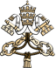  Read Online
June 9th  “Dearest St. Joseph… Help us to faithfully commit ourselves to the service and defense of human life —especially where it is vulnerable or threatened. Obtain for us the grace to do the will of God in all things. Amen.”  USCCB Secretariat of Pro-Life Activities, “Prayer to St. Joseph, Defender of Life” | 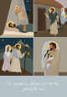  Read Online | Order
June 16th  “Through our prayers and through the intercession of St. Joseph, patron of fathers, may fathers come to know the irreplaceable role they hold in the lives of their children, and the responsibility they share in welcoming God’s gift of new life!”  Most Reverend Shelton J. Fabre, Bishop of Houma-Thibodaux  “Fathers’ Irreplaceable Role in Welcoming Life” | Read Online | Download
June 23rd  “O God our Creator… we ask you to bless us in our vigilance for the gift of religious liberty. Give us the strength of mind and heart to readily defend our freedoms when they are threatened; give us courage in making our voices heard on behalf of the rights of your Church and the freedom of conscience of all people of faith.”  USCCB, “Prayer for the Protection of Religious Liberty” | 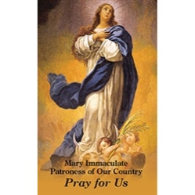  Download
June 30th  If you or someone you know has had an abortion, be assured that it is never too late to seek God’s forgiveness in the Sacrament of Reconciliation. Additionally, other confidential, compassionate help is available. Select “Find Help” from the menu on www.hopeafterabortion.org to find the diocesan Project Rachel Ministry near you.  USCCB Secretariat of Pro-Life Activities, “Bridges of Mercy for Healing after Abortion” | 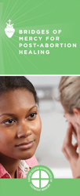  Order | Download

Word of Life – June 2024

Bulletin Art
You are welcome to use these, provided they are not altered in any way, other than the size. Thank you!

Sunday, June 2, 2024
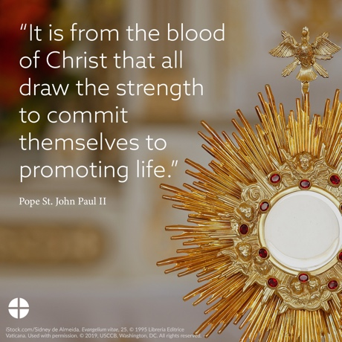
Download Image: English | Spanish

Sunday, June 9, 2024
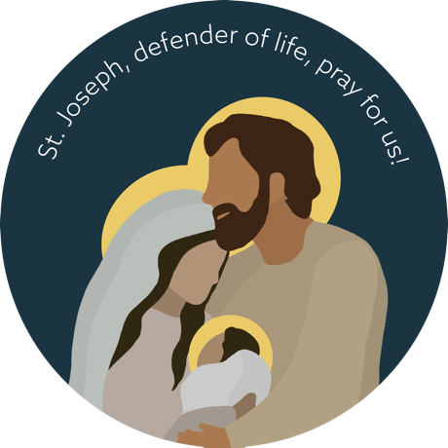
Download Image (Other graphics are available on the same webpages.): English | Spanish

Download Prayer Card

Sunday, June 16, 2024
Download Image (Other graphics are available on the same webpages.): English | Spanish

