Word of Life: July 2024
Recommended dates are provided, but you are welcome to use these materials at any time!

Featured this Month

National Eucharistic Revival: Year of Going Out on Mission
(July 21, 2024 – Pentecost 2025)
As tens of thousands of Catholics gather for the National Eucharistic Congress in Indianapolis in July, we are reminded of the incredible gift of our Eucharistic Lord. The last day of the congress, July 21, 2024, marks the entrance into the third year of the National Eucharistic Revival, the Year of Going Out on Mission. Learn more and find resources at www.eucharisticrevival.org.

National NFP Awareness Week: July 21-27, 2024
The dates of Natural Family Planning Awareness Week highlight the anniversary of the papal encyclical Humanae vitae (July 25) and the feast of Saints Joachim and Anne (July 26), the parents of the Blessed Mother.
Couples’ stories, sample intercessions, homily notes, and more can be found online.
The 2024 poster is available to download or order.

Memorial of Saints Joachim and Anne: July 26, 2024
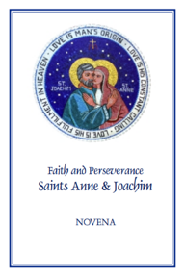
The Memorial of Saints Joachim and Anne, Parents of the Blessed Virgin Mary, is celebrated on July 26. They are powerful intercessors for married couples, expectant mothers, and married couples who are having difficulty conceiving, as well as people who are aging. Copies of the “Faith and Perseverance” novena to Saints Anne and Joachim are available for download or purchase. You can pray the novena from July 17-25 in preparation for their feast day.
Download: English | Spanish
Ordering information is available here.

Word of Life – July 2024
Intercessions for Life
July 7th  For our nation:  May our laws protect  every person’s right to life,  from conception to natural death;  We pray to the Lord: | Fourteenth Sunday in Ordinary Time
July 14th  For families considering adoption:  May the Lord guide and bless their journeys  and grant them peace along the way;  We pray to the Lord: | Fifteenth Sunday in Ordinary Time
July 21st  May married couples embrace their call  to total, faithful, and fruitful love  with openness to new life;  We pray to the Lord: | Sixteenth Sunday in Ordinary Time
July 28th  For all those nearing death:  That their faith will grow ever stronger,  as they prepare in hope  to share eternal life with Christ;  We pray to the Lord: | Seventeenth Sunday in Ordinary Time

Word of Life – July 2024

Bulletin Quotes
July 7th  “O God our Creator… through the power and working of your Holy Spirit, you call us to live out our faith in the midst of the world, bringing the light and the saving truth of the Gospel to every corner of society.”  United States Conference of Catholic Bishops  “Prayer for Religious Liberty” | 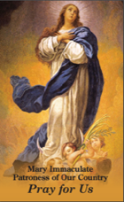  Download
July 14th  “Adopting Andrew has made us more aware of God's power and of his love for us. We realize that he always has a perfect plan for our lives.” Read more at www.bit.ly/AdoptionLoveStory.  USCCB Secretariat of Pro-Life Activities  “An Adoption Love Story” | Order | Download
July 21st  “Married love differs from any other love in the world. By its nature, the love of husband and wife is so complete, so ordered to a lifetime of communion with God and each other, that it is open to creating a new human being they will love and care for together.”  United States Conference of Catholic Bishops  “Married Love and the Gift of Life” | Read Online | Download
July 28th  “Because of our belief and hope in the Resurrection, we can face death not with fear, but with preparation…. We prepare for eternal life by choosing to love and follow God now, in our daily lives and decisions.” Read more at www.respectlife.org/end-of-life-considerations.  USCCB Secretariat of Pro-Life Activities  “Catholic Considerations for Our Earthly Passing” | 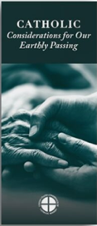  Order | Download

Word of Life - July 2024

Bulletin Art
You are welcome to use these, provided they are not altered in any way, other than the size. Thank you!

Sunday, July 14th, 2024
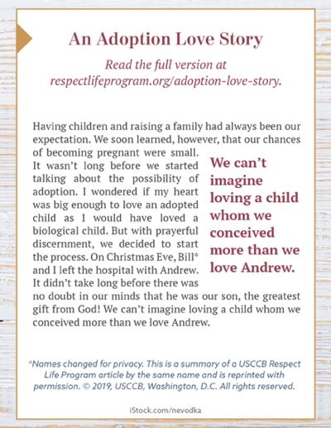
Download: English | Spanish

Sunday, July 28th, 2024
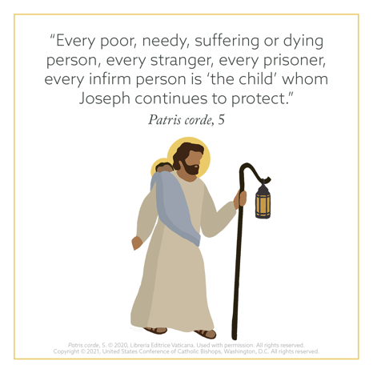
Download: English | Spanish

