



INTERCEDE

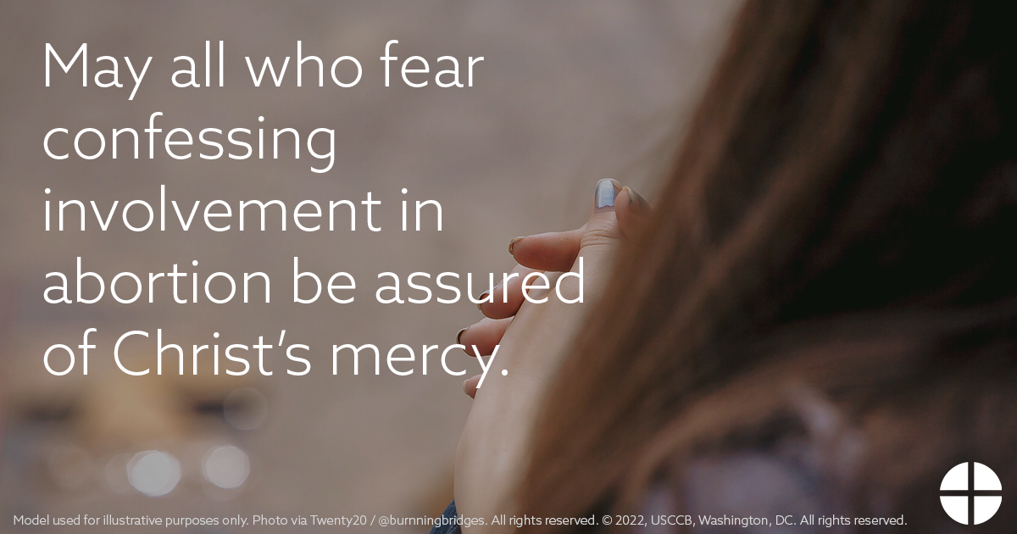

PRAY

*Our Father, 3 Hail Marys, Glory Be*

REFLECT

On Good Friday, when we observe our Lord’s Passion and Crucifixion, we remember how He bore our sins and the sins of the whole world as He suffered on our behalf. A week after celebrating His Resurrection, we celebrate Divine Mercy Sunday, remembering the message He so ardently instructed St. Faustina to spread: His endless mercy and forgiveness. God longs for us to return to Him and to allow His mercy to wash away our sins. He has a prepared place in His merciful heart for each of us, and no sin is bigger than His power to forgive. He desires all of us to come to Him just as we are and receive healing through the Sacrament of Reconciliation. The words Christ revealed to St. Faustina, He also speaks to us: “*Lay your head on my shoulder, rest and regain your strength. I am always with you*” (*Diary,* no.848).

Excerpts from Kowalska, Maria Faustina. *Diary of Saint Maria Faustina Kowalska: Divine Mercy in My Soul*. Stockbridge, MA: Marian Press, 2000. Used with permission of the Marian Fathers of the Immaculate Conception of the B.V.M.

ACT *(choose one)*

* Pray the Chaplet of Divine Mercy at 3:00 pm (the Hour of Mercy), with the intention of healing for all suffering from involvement in abortion. *How to pray:* [usccb.org/divine-mercy-chaplet](http://www.usccb.org/beliefs-and-teachings/how-we-teach/new-evangelization/year-of-faith/how-to-pray-the-chaplet-of-divine-mercy.cfm)
* Jesus spoke to St. Faustina, “*Reveal all the wounds of your heart. I will heal them*” (*Diary,* no. 1487). Seek Christ in the Sacrament of Reconciliation and allow His healing mercy to reach every hurt and hidden pain.
* Offer some other sacrifice, prayer, or act of penance that you feel called to do.

ONE STEP FURTHER

Learn about St. Faustina, the Apostle of Mercy, and the message of Christ’s mercy that she conveyed to mankind: [usccb.org/divine-mercy](https://www.usccb.org/prolife/divine-mercy-sunday#origin).